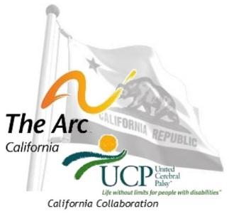
Sponsorship Opportunities:
8th Annual Developmental Disabilities Public Policy Conference
At the Holiday Inn Capitol Plaza, 300 J Street, Sacramento, CA, hosted by:

The Arc and United Cerebral Palsy
California Collaboration

Help support The Arc and UCP’s 8th Annual California Public Policy Conference, March 8, 9, and 10th 2015 through sponsorship contributions. Every year we organize a popular high quality public policy conference in Sacramento and maintain a very reasonable price thanks to the contributions from our sponsors. Almost half of our attendees are leadership and management level community providers, 20% are family members and self-advocates, 10% provide direct support professionals, and the rest are private and government systems professionals and policymakers. This year we have the following levels for sponsorship:

Conference Partner: $2500:
The conference sponsors will be invited to speak during the board of directors meeting on Sunday morning and will welcome attendees to the conference in the morning and at the reception following the conference. The Partner will be listed on the cover of the program and on the sponsor page of the program. In addition to promoting your business/service at an exhibit table, promotional materials will be included in the conference packet and the “Partner” is entitled to two tickets to attend the conference and all events at no cost.

Event Sponsor: $1500:
The event sponsors will sponsor one of the available events and choose which event on a “first come first serve” basis. Events include: Executive Directors meeting on Saturday night, Board of Directors Lunch on Sunday, Benefit Luncheon on Monday during the conference, or the closing reception on Monday. The Event Sponsor will be thanked during their sponsored event and listed on the sponsor page of the program. In addition to promoting your business/service at an exhibit table, promotional materials will be included in the conference packet and are entitled to two tickets to attend the conference and all events at no cost.

Exhibitor Sponsor: $500:
The exhibitor sponsor will be highlighted during the closing reception and listed on the sponsor page of the program. In addition to promoting your business/service at an exhibit table, promotional materials will be included in the conference packet and are entitled to one ticket to attend the conference and the benefit luncheon at no cost.

Contact:
Gwen Lopez (916) 552-6619, or gwen@thearcca.org,
c/o The Arc of California: 1225 8th Street, Suite 350, Sacramento, CA 95815
ONLINE Sponsorship Registration:
Sponsorship Designations:
- Conference Partner: CA Supported Living Network, AT&T, Fred Jones & Kathleen Reed
- Sunday Morning Session (Saturday CCE): The Arc San Diego
- Sunday Keynote Lunch (Laura Brackin, PhD):The Arc Ventura
- Sunday Afternoon Session: Fred Jones & Kathleen Reed
- Sunday Reception (Speakers Unplugged):
- Monday Morning Session: Therap
- Monday Keynote Lunch (Santi Rogers): UCP of the North Bay
- Monday Breakouts: CSLN
- Monday Afternoon Closing Session: AT&T
- Monday Reception:

