“Four Evers” by Kevin D. Evers
Mark 10:13-16 (ESV)
13 And they were bringing children to him that he might touch them, and the disciples rebuked them. 14 But when Jesus saw it, he was indignant and said to them, “Let the children come to me; do not hinder them, for to such belongs the kingdom of God. 15 Truly, I say to you, whoever does not receive the kingdom of God like a child shall not enter it.” 16 And he took them in his arms and blessed them, laying his hands on them.
As I read this scripture from the New Testament, I think of the privilege I have of being a father of four beautiful children. Our children have blessed my wife, Carla, and I beyond measure. Children are God’s gift to us. Jesus knew this even on His way to the cross, as we read in this passage from Mark, Jesus made time to stop and love them and bless them.
When I had the opportunity to join the Florida United Methodist Children’s Home and work within their Open Hearts Family Services as the Community Outreach Coordinator, I was overjoyed to share my passion for children in foster care. Years ago when Carla and I lived in St. Louis, MO, we struggled to have biological children. After years of unsuccessful medical procedures, Carla’s co-worker introduced us to the idea of becoming foster parents through the Division of Children and Family Services of Missouri.
After much prayer and support from family and friends, we decided to enroll in the 9 week training program to become licensed Foster Parents. We completed additional classes for prospective adoptive parents. We had decided that not only did we want to be licensed Foster Parents but also approved as Adoptive Parents.
Our foster sons, Kyle and Chad, biological brothers, moved into our house 3 months after we completed our classes. We were Foster Parents for 6 months and officially became a forever family in March 2000. Much to our surprise, in December of 2000, our biological son, Christopher, was born and then in 2002,our biological daughter, Chloe, was born. God made our family in a special way, a “Four Evers” family.
All children deserve to be safe, healthy, loved, and have their needs met. Children deserve to have adults in their lives, to be their advocates and be their voice when they cannot speak for themselves. Children deserve to be able to learn to trust others, especially adults. These are the roles of a Foster Parent. Jesus told His disciples “Do not hinder them (the children)”. God calls each of us to take care of the children in our communities and to stand in the gap for them. Billy Graham once said, “The greatest legacy one can pass on to one’s children and grandchildren is not money or other material things accumulated in one’s life, but rather a legacy of character and faith”. The faith you can bring into a child’s life is simply priceless and the difference you can make in the life of a child will be a blessing no matter how long that child is a part of your home.
If you would like more information on the next steps to becoming a Open Hearts Foster Parent, would like a guest speaker to come to your church or group gathering, please contact Kevin D. Evers, Community Development Coordinator, at 386-837-1114 or at kevin.evers@fumch.org.
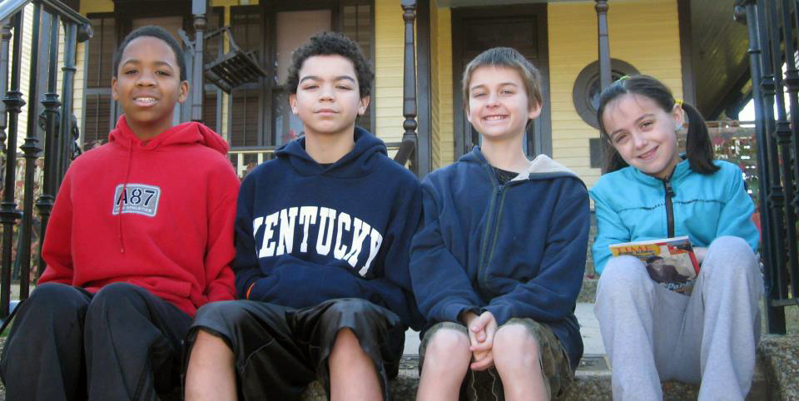
The “Four Evers”, Kyle, Chad, Christopher, and Chloe sitting on the front steps of the birth place of Dr. Martin Luther King Jr. in Atlanta, GA.

