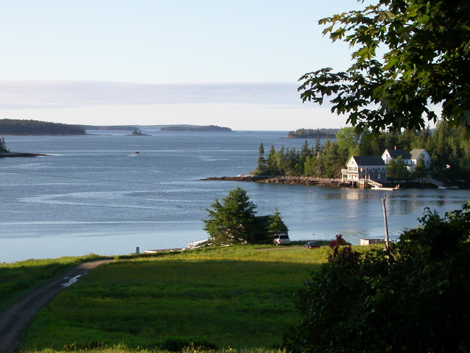

HOG ISLAND AUDUBON CAMP, IN MUSCONGUS BAY, MAINE

Sharing Nature: An Educator's Week (July 19-24, 2015)

Join environmental educators from around the country for a dynamic and fun-filled residential program on Audubon's famed Hog Island, in the scenic mid-coast area of Maine. Designed for both science and non-science educators, this session will generate exciting ideas for creating and incorporating environmental education activities into your curriculum and teaching. Our inspiring and experienced instructors will share their favorite approaches, methods, and activities for engaging you, and your students, with nature.

Workshops using techniques in field biology, art, music, photography, theater, journaling, and other disciplines will be presented, as well as a host of classic Audubon Camp field trips. We’ll visit the nearby restored Atlantic Puffin and seabird colony, as well as explore Hog Island’s magnificent spruce forest, its rich intertidal zones, a local bog, etc. This is a week out-of-doors in a beautiful place!

Great networking opportunities, delicious gourmet-style home-cooking, and the experience of living on a 330 acre wildlife sanctuary island will make this a memorable and cherished experience.

Instructors include field biologist/nature wizard Ted Gilman (CT); artist/journal maker Sherrie York (CO); educator/musician Trudy Phillips (PA); elementary science educator/musician Craig Newberger (PA); environmental educator “Puffin Pete” Salmansohn (ME); Phil Kahler, middle and high school science teacher, representing Cornell’s Lab of Ornithology (OR) ; Dr. Jerry Skinner, biology and natural history professor (PA); a photography skills instructor; and guest Dr. Steve Kress, director of Audubon’s Puffin Project. Continuing Education Credits (4.5) are available. Scholarship monies may also available.

Check out our extensive website: hogisland.audubon.org
Scholarships are available.

Contact camp Registrar – Eva Matthews at (607) 257 7308 for more information. Or email hogisland@audubon.org

