STATE OF NEW YORK
DEPARTMENT OF TRANSPORTATION
ALBANY, NEW YORK 12232

At the Office of the Department of Transportation in the City of Albany on January 29, 2015

PRESENT:

William B. Leonard, Director
Office of Modal Safety and Security

CASE 27647 - In the matter of motor carrier compliance with regulations pertaining to hours of service for operators of motor trucks, pursuant to 17 NYCRR 820.6.

APPLICATION OF NEW YORK PROPANE GAS ASSOCIATION, EMPIRE STATE ENERGY ASSOCIATION, AND NEW YORK STATE MOTOR TRUCK ASSOCIATION FOR EXCEPTION TO CERTAIN PROVISIONS OF 17 NYCRR 820.6

The New York Propane Gas Association, Empire State Energy Association and New York State Motor Truck Association having requested the Department of Transportation to modify certain provisions of 17 NYCRR 820.6, due to below normal temperatures throughout New York, causing a spike in demand for propane and distillate fuels and a shortage of product availability resulting in slower loading at transport racks and therefore long delivery lines causing an increase delay in delivery time for fuels used for heating purposes for homes and businesses.

It has been determined that action is necessary to address this emergency situation which could result in a threat to public health and safety and that certain rules should be temporarily modified in order to ensure adequate delivery of propane, distillate fuels; including home heating oil, diesel fuel, kerosene, and jet-fuel; biofuels and residual fuels used for heating application, as transportation fuels, and for power generation and additional products necessary for the continued operations of power plants throughout New York State. Therefore, it is

ORDERED:

The following hours of service regulations are modified with respect to the intrastate transportation of propane, distillate fuels and products necessary for the continued operations of power plants performed by motor carriers effective at the beginning of January 28, 2015 and terminating at the end of February 07, 2015 unless otherwise ordered:

- That the hours of service rules pursuant to 17 NYCRR 820.6 are hereby suspended for drivers and motor carriers performing intrastate transportation transporting propane, distillate fuels; including home heating oil, diesel fuel, kerosene, and jet-fuel; biofuels and residual fuels used for heating application, as transportation fuels, and for power generation and additional products necessary for the continued operations of power plants throughout New York State, regardless of the number of carriers using the driver’s services.
- That no motor carrier operating under the terms of this order shall require or allow a fatigued or ill driver to operate a commercial motor vehicle. A driver who informs a motor carrier that he or she is not fit to drive shall be given a minimum of 10 consecutive off-duty hours before the driver may return to service.

- That all regulations pertaining to Commercial Driver License requirements, Controlled Substances and Alcohol Use and Testing requirements and Financial Responsibility requirements remain in force and effect for all motor carriers and drivers.

- That motor carriers that have an Out-of-Service Order in effect, or a suspension or revocation of a New York State Certificate as a motor carrier of property, are not eligible to take advantage of the relief from the regulation that this order provides.

By the Office of Modal Safety and Security
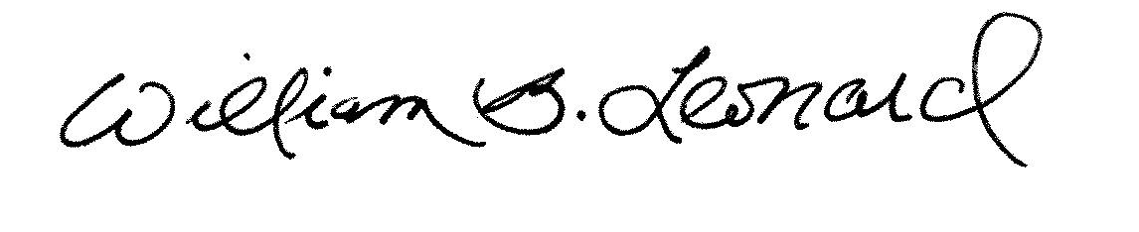
William B. Leonard, Director

