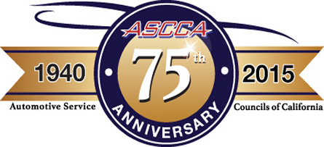

Automotive Service Councils
Of California

One Capitol Mall, Suite 320
Sacramento, California 95814
(916) 924-9054
(800) 810 4272
FAX (916) 444-7462
Additional Conference Info: www.ascca.com
Letter of Agreement
Chapter Raffle Ticket Sales Agreement for Automotive Service Councils of California (ASCCA) Summer Conference for an
4-channel 4425 PicoScope ADVANCED Diagnostic Kit Retail Value: $3127.00
Raffle Item Provided by: AESWave

Return Instructions for Raffle
Return Deadline: June 1, 2015
Rachel Hickerson
One Capitol Mall, Suite 320
Sacramento, CA 95814

Following are the terms and conditions under which the Automotive Service Councils of California (ASCCA) confers an “Approved” designation upon participating chapters.

ASCCA shall provide the following to participating chapters:
- 60 tickets (6 books of 10 tickets) = $1500 (each ticket $25)
- Tickets tracking sheet (emailed to contact)
- *Revenue share – For every ticket sold, the chapter gets to keep $5.00.
- ALL tickets (sold or un-sold) must be returned to ASCCA by June 1. The chapter will send back to ASCCA their tickets, along with the payment minus the $5.00 per ticket they earned along with the tracking sheet.

Participating chapters shall provide the following to ASCCA:
- CONTRIBUTIONS and TICKET STUBS (even unsold tickets) returned to Rachel Hickerson by June 1, 2015. If tickets aren’t returned by the June 1, 2015 deadline, the amount owed will go against your dues revenue.
- In lieu of sending cash, please provide a chapter check equal to the sum that you have collected.
- A careful log of how many tickets you have sold, so we can be sure to account for all of the contributions.

Thank you in advance for taking on the responsibility of distributing these raffle tickets.
Person responsible for tickets, please provide the following information:

_______Quantity of Tickets (sold in groups of 60)
_____________________________ ___________________________ ________________________
Name of Person (PRINT NAME) Position Chapter No.
__________________________________ _________________________ ______________________
Email Phone Fax
__________________________________________________________________________________
Address (for ticket shipping if not present at February’s Team Weekend)
_________________________________ ___________________________
Signature Date

