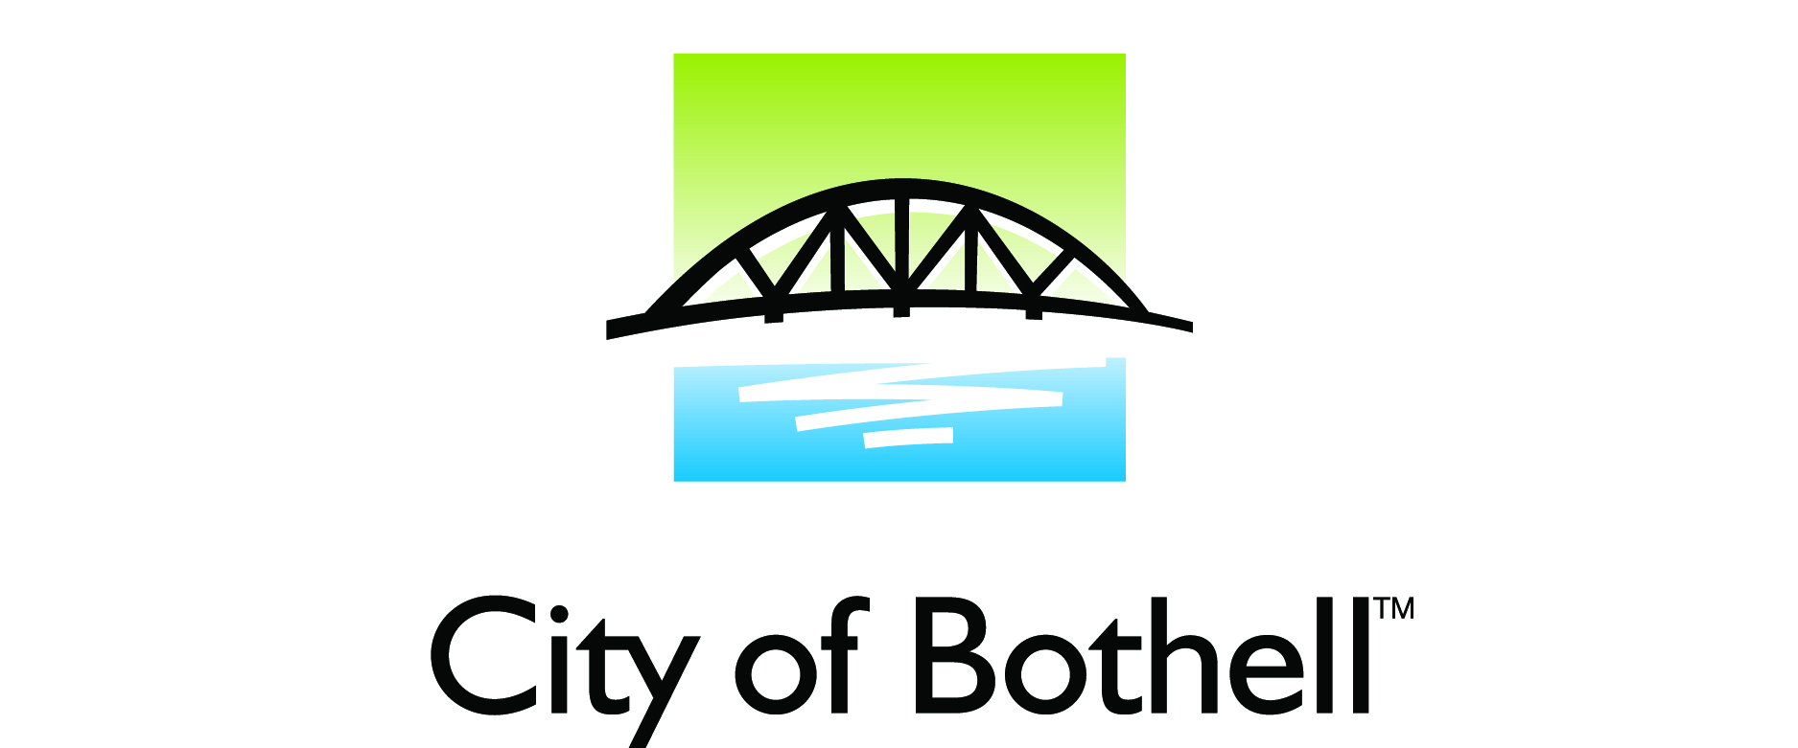

February 6, 2015

NEWS RELEASE Media Contacts Peter Troedsson, 425.486.3256

City of Bothell Looking for Applicants for AWC Center for Quality Communities Scholarship Fund

The City of Bothell is accepting applications for the AWC Center for Quality Communities Scholarship fund. Six of these $1250 scholarships are available through a statewide competitive process for students who are actively engaged in their city government and/or community and plan to attend post-secondary school in fall 2015.

To be eligible, a student must be graduating from high school, home school or receiving a GED in spring/summer 2015; live in Bothell; plan to continue their education at an accredited post-secondary institution in the 2015-2016 academic year on a half-time or more basis; and have been involved with a city government or with a community/school leadership activity.

Information and application materials can be obtained at the City’s website or cfqc.org. Completed applications are due to City Hall no later than March 3rd, 2015.

Applicants should submit completed materials to:

Bothell City Hall
attention: Peter Troedsson
18305 101st Avenue NE
Bothell, WA 98011

Or email to Peter.Troedsson@ci.bothell.wa .us

The Center for Quality Communities promotes municipal leadership development and civic engagement. The Center’s goal is to develop a broad public understanding of the important role of cities and towns play in Washington. The Center is a 501(c)(3) organization.
###

