I am always looking for books that elicit conversation about important or interesting topics for use at home and in the classroom. Here is my short list of health related books that make great conversation starters. They are all picture books, but some have been read to children ages 2-13. Who doesn’t’ love a good story with fun pictures?

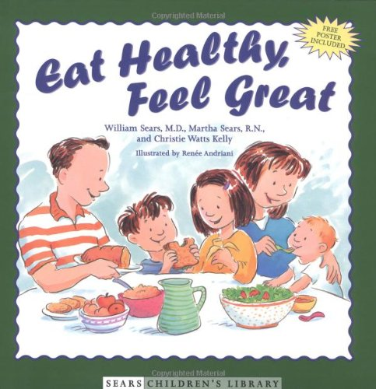 Eat Healthy, Feel Great By William Sears

[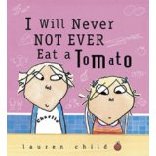](http://www.amazon.com/Will-Never-Ever-Tomato-Charlie/dp/0763621803/ref=sr_1_1?ie=UTF8&qid=1423944716&sr=8-1&keywords=i+will+never+not+ever+eat+a+tomato) I Will Never Not Ever Eat a Tomato By Lauren Childs

[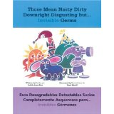](http://www.amazon.com/Disgusting-desagradables-detestables-completamente-asquerosos/dp/1884834310/ref=sr_1_1?ie=UTF8&qid=1423944804&sr=8-1&keywords=those+mean+nasty+dirty+downright+disgusting+but...invisible+germs)Those Mean Nasty Downright Disgusting…but Invisible Germs By Judith Ann Rice and Petronella Ytsma

[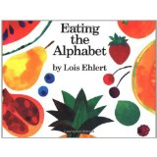](http://www.amazon.com/Eating-Alphabet-Lois-Ehlert/dp/015201036X/ref=sr_1_1?ie=UTF8&qid=1423945201&sr=8-1&keywords=eating+the+alphabet)Eating the Alphabet By Lois Ehlert

[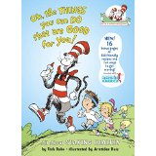](http://www.amazon.com/Things-You-Can-That-Good/dp/0375810986/ref=sr_1_1?ie=UTF8&qid=1423945741&sr=8-1&keywords=the+things+you+can+do+that+are+good+for+you)Oh, The Things You Can Do That Are Good For You: All About Staying Healthy By Tish Rabe

[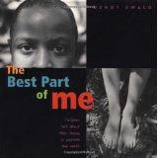](http://www.amazon.com/Best-Part-Me-Children-Pictures/dp/0316703060/ref=sr_1_1?ie=UTF8&qid=1423946401&sr=8-1&keywords=the+best+part+of+me) The Best Part of Me By Wendy Ewald

[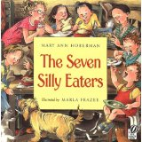](http://www.amazon.com/Seven-Silly-Eaters-Mary-Hoberman/dp/0152024409/ref=sr_1_1?ie=UTF8&qid=1423946626&sr=8-1&keywords=7+silly+eaters) The Seven Silly Eaters By Marla Frazee