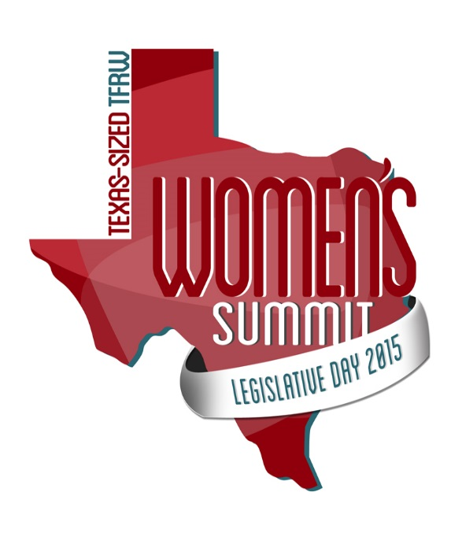

YOU ARE INVITED!

TFRW Legislative Day 2015
Women's Summit

Thursday, April 16, 2015
8:00am - 5:00pm
Austin, TX

Registration for the Summit ($70 plus tax) includes:
Luncheon with guest speaker Katie Kieffer, Author of "Let Me Be Clear: Barack Obama's War on Millennials and One Women's Case for Hope"
Afternoon Workshop: Women Overcoming Obstacles to Running for Elected Office; Policies that Make Texas the # 1 place to Live & Work; and Texas Border Security Today
More information at www.tfrw.org
Take the DCCRW Bus to Connect with Other Dallas Republican Women
Bus reservations ($35) boarding at 5:30am returning at 8:30pm includes breakfast and a box dinners.
More information at www.dccrw.org

