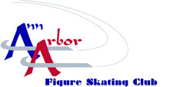 The Ann Arbor Figure Skating Club
Presents...

73rd Melody on Ice
“Let’s go to the Movies”

Directed & Produced by Melanie Bolhuis & Meredith Longoria

DVD ORDER FORM
$18 each
Order deadline – Thursday March 19th

NAME: __________________________________________
E-MAIL (or phone): __________________________________
# of DVD’s:___________________
Total @ $18 each _______________
CASH / CHECK / CREDIT CARD (circle one)
DATE ORDERED: __________________
CASH Receipt # / Check # / Credit Card Auth # ___________

