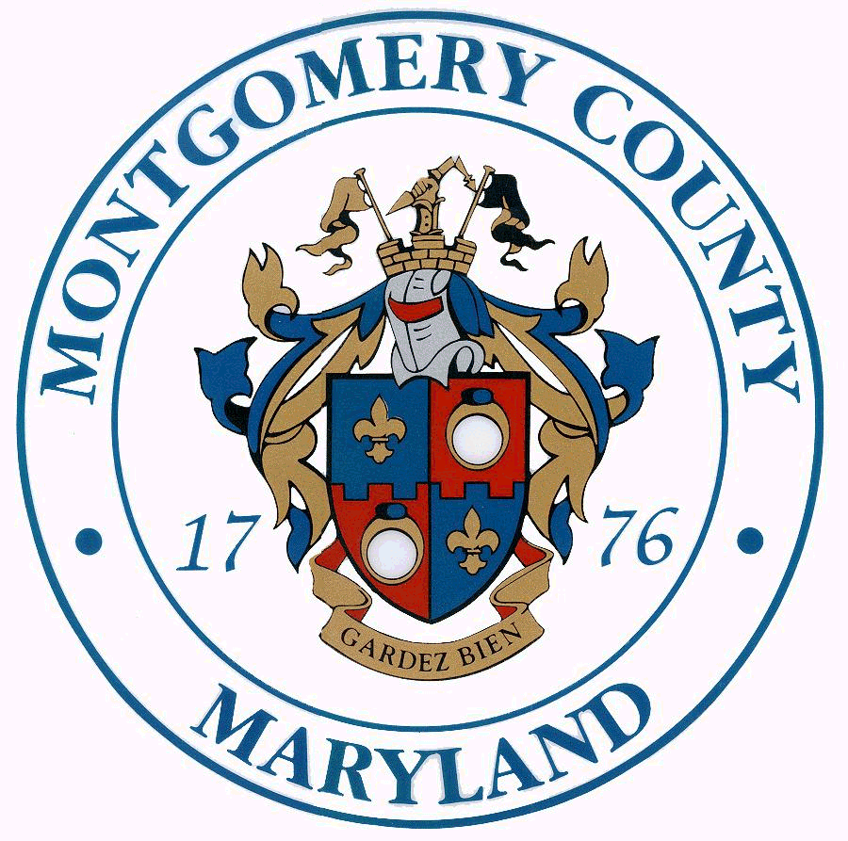 Isiah Leggett Ana L. van Balen
County Executive Director

2015 Mid-County Citizens Advisory Board Awards
Awards will be presented at the Wheaton/Kensington Chamber of Commerce annual gala

Outstanding Citizen of the Year
Recognizes a resident who has made an outstanding contribution to their community or larger mid-county area.

Outstanding Civic Association of the Year
Recognizes a civic group or nonprofit that has made a significant achievement to their community in mid-county.

Nominee’s Name: _________________________Nominee’s Affiliation/Title (if any): _______________________

Nominee’s Address: _________________________City:___________________ State: _____ Zip: ____________

Phone: ____________________ Email: ____________________________________

Brief Biography of Nominee:

Is there a specific accomplishment or activity that makes your nominee particularly qualified for this
award? Please describe.

Your Name: ______________________________ Affiliation/Title: ____________________

Address: ___________________________ City: ____________________ State: _____ Zip: ________

Phone: ____________________ Email: _____________________________________

NOMINATIONS DUE MARCH 2nd, 2014 - Please email questions and nominations to: midcounty.citizen@montgomerycountymd.gov

Prior Awardees of the Citizen of the Year Award
Tom Brown, President of the Wheaton Volunteer Rescue Squad
Susan DeFord, President of the Mid-County United Ministries
Susan Johnson, President Layhill South Civic Association: 2012
Janet Yu: 2011
Kris Kumaroo, President of the Greater Glenmont Civic Association: 2010
Eleanor Duckett: 2009
Cheryl Czekaj: 2008
Adam Pagnucco, Chair, Forest Estates Community Association: 2007
Max Bronstein: 2006
Prior Awardees of the Civic Association of the Year Award
First Book of Montgomery County: 2014
Community Partners of Aspen Hill/Wheaton: 2013
Montgomery Housing Partnership: 2012
Green Wheaton: 2011
Greater Glenmont Civic Association: 2010
McKenney Hills – Carol Knolls Civic Association: 2009
Wheaton Regional Park Neighborhood Association: 2008
Crossing Georgia Subcommittee, Forest Estates Community Association: 2007
Gaywood Garden Club: 2006

