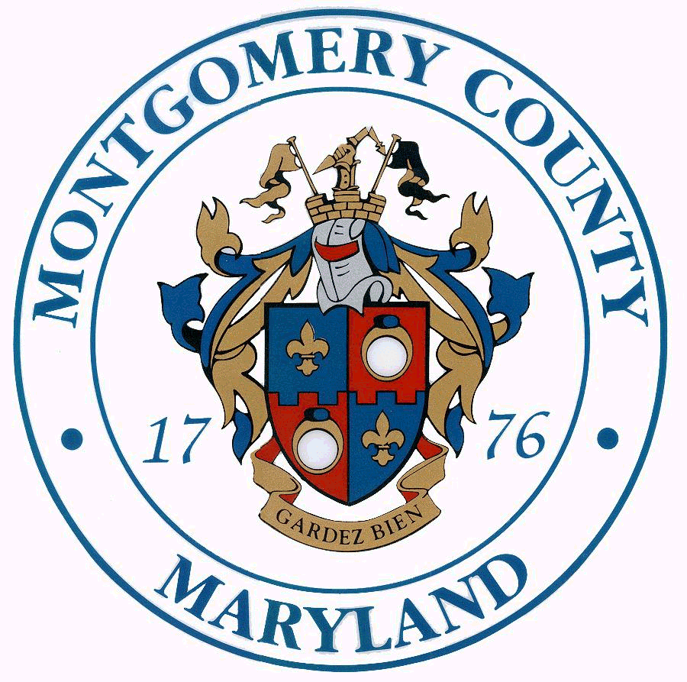 Isiah Leggett Ana L. van Balen
County Executive Director

2015 Wheaton Urban District Advisory Committee Awards
Awards will be presented at the Wheaton/Kensington Chamber of Commerce annual gala

Outstanding Business Leader of the Year
Recognizes a business that has made an outstanding contribution to the Wheaton Urban District as a leader in his/her field and in the community using the following criteria:
- Business Innovation
- Business Success
- Business Environment Impact
- Community Impact
- Contributed to Urban District Revitalization

Best Property Improvement of the Year
Recognizes a business or property owner who has improved their storefront/property within the following criteria:
- Façade
- Environmental impacts
- Innovation
- Lighting
- Landscape
- Contribution to Urban District revitalization

Nominee’s Name: _________________________Nominee’s Affiliation/Title (if any): _______________________

Nominee’s Address: _________________________City:___________________ State: _____ Zip: ____________

Phone: ____________________ Email: ____________________________________

Brief Biography of Nominee:

Is there a specific accomplishment or activity that makes your nominee particularly qualified for this
award? Please describe.

Your Name: ______________________________ Affiliation/Title: ____________________

Address: ___________________________ City: ____________________ State: _____ Zip: ________

Phone: ____________________ Email: _____________________________________

NOMINATIONS DUE MARCH 2nd, 2014 - Please email questions and nominations to: wudac@montgomerycountymd.gov

Prior Awardees of Business Leader Award
Limerick Pub owner Tom Stanton, 2014

Prior Awardees of Property Improvement Award
IHOP, 2014
The Shops at Amherst - 2013

