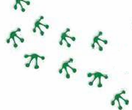
“Hop into a Healthy Lifestyle”
All residents of Kenton County welcome
When: Saturday, MARCH 14, 2015
9AM - 1PM
Where: Summit View Elementary & Middle School Campus
These opportunities and much more:

- Blood Pressure Screening
- Passport Health Plan
- Foot scanning
- St. Elizabeth Physicians
- Humana Vitality Checks
- Hospice of the Bluegrass
- Legal Aid of the Bluegrass
- YMCA
- American Cancer Society
- Let’s Immunize Northern Kentucky
- Assistance with Healthcare options
- North Key
- United Way 211
- Head Start
- Northern Ky Health Department
- Transitions, Inc.
- Vision Screening
- NKY Physical Medicine & Medical Weight Loss Center
- Dominach’s Taekwondo Academy
- Skool Aid
- Learning Activities for Kids

- Kidney Health Alliance
- Senior Services of Northern Kentucky
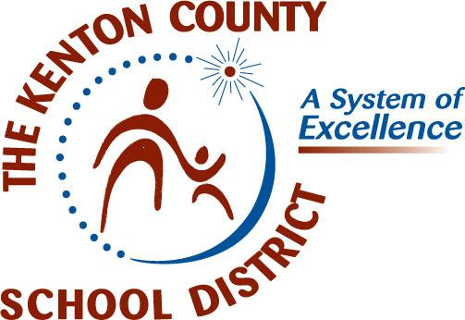
Sponsored by:
- Kenton County Alliance to Prevent Substance Abuse
- Stroke & CardioVascular Screening Unit (fee charged)
To learn more or make an appointment call (859)301-WELL (9355)

- Mobile Mammography Van (financial assistance available)
To learn more or make an appointment call (859) 655-7400

Enter to win a drawing for a free 60 minute massage & a $25 gift card

