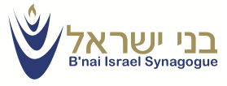
B’nai Israel Synagogue
Family Camp Weekend
Tamarack Camps
Butzel Conference Center
May 29-31, 2015
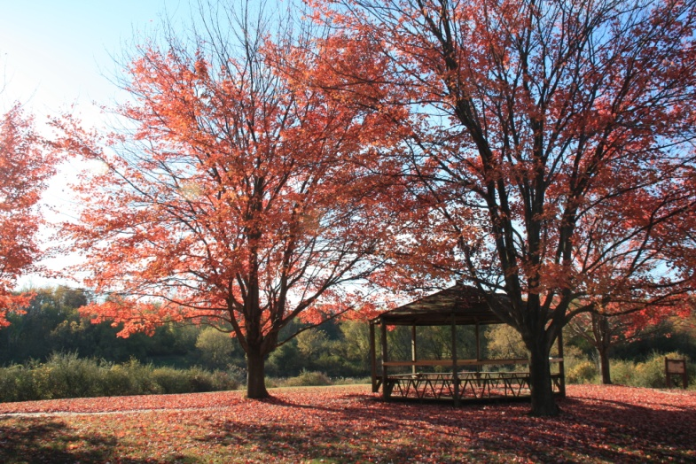
Family-friendly kosher meals, evening activities for adults, age-appropriate activities for kids, private rooms, camp fire & more!

Priority registration for current BI members, by March 15th. First come, first served. Receive $100 off your family’s registration fee if received by March 15th.

Contact Mechelle Bernard (mbernard1026@gmail.com) or Karen Rosenberg (eemakaren@hotmail.com) for more information.

REGISTRATION INFORMATION
Family Name:
Address:
Email:
Telephone:
Adult(s):
Child(ren) Name(s) and Age(s):

Please list any special dietary needs:
______________________________________________________
Please list any other special requests or needs:
______________________________________________________
BI Member Pricing Information:*
Family of 2 ($250) Family of 3 ($350)
Family of 4 ($425) Family of 5 ($500)
Family of 6 ($575)
Children 2 and under, no charge
* Prices reflect $100 early bird subsidy rate for BI members if received by March 15th. Prices increase by $100 after March 15th. Non-members are an additional $100.00
Final registration deadline, based on availability, is March 30, 2015. There are no refunds after that date. Payment and registration form should be mailed to:
B’nai Israel Synagogue 5085 Walnut Lake Road
West Bloomfield, MI 48323

