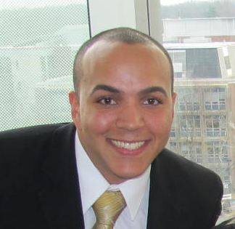
Mark Bergen, a Kean University senior with a double major in English and Special Education, is the 2015 recipient of the Outstanding Undergraduate Student Member of the Year Award presented by the Council for Exceptional Children (CEC). The award is given to one undergraduate student internationally who has made outstanding contributions to CEC and to exceptional children. CEC is the largest international professional organization dedicated to improving the educational success of individuals with disabilities.
Walt Oberwanowicz, adjunct professor and co-advisor of the university’s student chapter KUCEC, nominated Bergen for the award. “As an active member since fall 2012, Mark provided the much needed energy, enthusiasm, direction and spirit that rejuvenated this organization. Membership tripled under his leadership, even with a declining student enrollment in the College of Education. Currently 120 students participate in a myriad of activities: professional development; philanthropy; networking with other student leaders and campus units; volunteerism, and cultural, athletic, social events, on and off campus. Mark clearly makes a difference to his fellow classmates, many of whom would not have had these experiences, believing that as a student body comprised mostly of commuters, campus life was not an option”.
Under the direction of Kean University's Community Outreach Coordinator, weekly recreational activities are provided for approximately 50 adults with physical, cognitive & mental disabilities. The organization relies on student volunteers to make this happen. As a 2012-2013 volunteer, Mark observed firsthand the difficulty of soliciting the much needed manpower to staff the recreational activities. His first mission as president was forming a partnership with the coordinator and adopting the organization as an established service project, guaranteeing a volunteer corps of 20 members for each meeting. The first two months had a record participation of both, members and clients, which currently continues.

Mark also expanded the service project component of the KUCEC by partnering with other student leaders of campus organizations. This relationship provided the very much needed “student-power” for many service activities, (not only his own). This increased opportunities for students to accrue documented “community service hours” of a recognized professional organization requirement for students planning to attend professional schools after graduation.
As a senior, completing his student teaching internship this semester, Mark continues as an active member, promoting professional development activities for students majoring in special education, initially established under his leadership. Recognizing that he and his classmates shared a similar difficulty in finding the time to research, reference or network topics that were discussed in class so as to fully comprehend the subject content, Mark networked with department professors to provide more in-depth information on some of those topics. A minimum of three study sessions are offered each semester during the “college hour,” a commonly available break in the school day, coining the term, “In-an-Hour Workshops”.
On April 8, 2015, at the annual Council for Exceptional Children (CEC) Convention & Expo in San Diego, California, Bergen will be feted as this year’s recipient of the CEC Outstanding Undergraduate Award. He will also receive an invitation to the CEC President’s Reception and be recognized during the CEC Student Forum held at the convention, along with recognition at the CEC Headquarters and on the CEC website. Mark Bergen is the first NJ University student to receive this award, established in 1983.

