Greetings to you all in the name of our Lord and Savior Jesus Christ.

For those of you who did not get to follow my updates on Facebook during my time in Haiti, I will provide recap here.

First I thank God for all of you who were faithful to your commitment by praying for me and the team as we served over there. Also, for your faithful support throughout the years. I definitely felt God’s presence and His sovereign hand on the team. I was able to experience His working in the moment throughout the trip. It was and is very humbling and encouraging at the same time.

Some of the main accomplishments:
•
 | 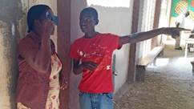 | 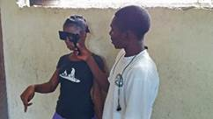 |  |  | 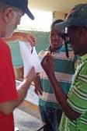
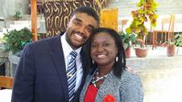
Vision screening for 700-800 people, about half students and half adults. The result was 357 appointments scheduled for week after next when the eye doctor and assistants arrive with glasses. Many older Haitians need reading glasses.
• Met with Pastor Lulu and his new wife Yudarlna. Pastor Yoyo is hiring Yudarlna to be the school administrator which will help tremendously in working out some of the 1by1 requirements for reporting. I was very encouraged by this development, but still work to be done here.
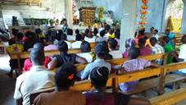
• Also met with Pastor Yoyo, Lulu, and the school principal to understand all the records and reports currently being done by hand now so we can work on design and development of the ACCESS database we hope to use for 1by1 reporting.
• Spent two nights in the Welcome Home orphanage, singing songs, sharing things of God, and playing with the boys. The boys had no trouble coming out of their shell and having fun with me. It was a good time of bonding.
•

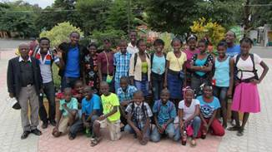
Some of the young men in high school level of Mechizedek asked me to teach them basketball. I was able to teach them the fundamentals culminating in a 5 on 5 scrimmage with two of the women from our team participating to make it 5 on each team. Great fun and I was able to share how a basketball team compares to the body of Christ in that each person has their gifts and roles.
• Met with the youth group from church on Sunday afternoon and shared a little about how God wants an intimate relationship with each of us. Again, I thank God for giving me the words.
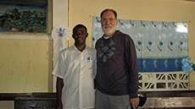
• Took all the orphanage children to the Domincan Republic border for an adventure. It was a very exciting day for all of them (except Nahomie who got so car sick, we dropped her at Ron & Janes in Hinche and picked her up on the way home). 12 hours round trip and rough roads, but the children’s spirits were high and I learned from them about joy over circumstances. Also met with a pastor in Thomassique along the way who wants his church to join with Converge.

Praises:

The team was in humble harmony the entire week. God put together a small but powerful team and I was blessed to be a part of this team.
With the exception of a team member with a cold, all stayed very healthy and strong.
The partnering with young men from the Oxygen English club in doing the vision screening was in line with mission objectives of working side by side with our Haitian brothers and sisters. It was a beautiful experience and I got to bond with my partner, Robenson, throughout the four days we did the screenings.
Relationships with Pastor Yoyo, Lulu, and his wife Yudarlna were strengthened.

Prayers:

I am overwhelmed with the responsibility of developing a database for school record keeping. My friend Bob is helping, but we both have not worked on databases for many years (although we both did it a lot years ago). We are looking for someone who knows MS ACCESS really well. Please pray for God’s perfect plan in this endeavor.
There are many organizational and operational needs at the school. Pray for God’s provision and man’s submission to these improvements.
Pray that the second team is able to provide the correct and necessary treatment to those who have eye appointments, and that they can accomplish a lot in a short amount of time.
Finally, that God would continue the work in Maissade of transforming lives for His glory. I am thankful to be a small part of that as we all run the race for Him.

In His Service,
Tim

Photos:
Top 3 are vision screening, both far and near vision
Pastor Lulu with his new bride Yudarlna
Youth service Sunday afternoon
All the children (and the rest that came with us) at a park in the Domincan Republic town of Banica
Pastor Jeantel in his church at Thomassique

