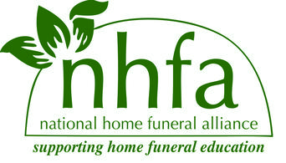

2015 NHFA Biennial Conference
October 2-4, 2015
Los Gatos, CA

Vendor & Exhibitor Guidelines

A. Exhibition table for Cashmere, Silk and Linen sponsors Free
B. Exhibition table for Cotton level sponsors $ 75
C. Exhibition table for the duration of the conference $150
D. Informational flyer or brochure to be included in registrant packets $ 25

- Vendors will not be charged a percentage of their sales.
- Tables will be available for set up Friday evening through Sunday noon.
- Vendors and exhibitors are responsible for their own goods and are advised to insure independently. The NHFA is not responsible for lost, damaged, or stolen goods.
- Flyers and brochures must be either hand delivered or mailed within one week of the start of the conference directly to the venue. We will notify you of the number needed and mailing address closer to the event.

Vendor/Exhibitor Application

Business or Organization Name
Address
Phone
Email
Website
Category of participation A. B. C. D.
Number of tables to reserve 1 2 3
Please send completed information to nhfa.paper@gmail.com. You may make your payment through PayPal on our website under donations (please make a note!) or send a check to NHFA, 11014 19th Ave SE, Ste #8, PMB #155, Everett, WA 98208 with your application. We will be in contact with you about details as the time comes closer. Thank you!

