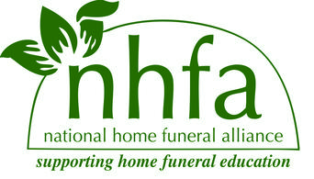
2015 NHFA Biennial Conference
October 2-4, 2015
Los Gatos, CA

Sponsorship Opportunities

Cashmere $1,000
- Full-page display ad in printed program
- Full conference registration for 2 people
- Exhibition table for the duration of the conference
- On NHFA website, with web link to your organization
- Sponsor’s name or logo on all conference literature
- Acknowledgement during Conference program

Silk $750
- Half-page display ad in printed program
- Full conference registration for one person
- Exhibition table for the duration of the conference
- On NHFA website, with web link to your organization
- Sponsor’s name or logo on all conference literature
- Acknowledgement during Conference program

Linen $500
- Quarter page ad in printed program (300 copies printed)
- Exhibition table for the duration of the conference
- Sponsor’s name or logo on all conference literature

Cotton $250
- Business card ad in printed program (300 copies printed)
- Sponsor’s name or logo on all conference literature
- Discounted vendor table for duration of the conference

Sponsor Application
Business or Organization Name
Address
Phone
Email
Website
Level Cashmere Silk Linen Cotton
Please send completed information plus a jpeg. of your logo to nhfa.paper@gmail.com. You may make your payment through PayPal on our website under donations (please make a note!) or send a check to NHFA, 11014 19th Ave SE, Ste #8, PMB #155, Everett, WA 98208. With your application. We will be in contact with you about details as the time comes closer. Thank you!

