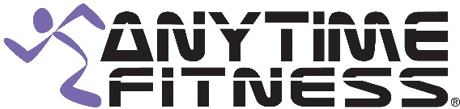
212 Elks Point Road, #550
Zephyr Cove, NV 89448
(775) 580-7266

CLASS SCHEDULE

MONDAYS

10:00am Yoga Alexxa Latta

TUESDAYS

10:00am Rock Your Body Leah Marino
12:00pm The Balance Challenge Shea Thomas
6:00pm Body Sculpt Leah Marino

WEDNESDAYS

5:30pm Get Your Stretch On Leah Marino

THURSDAYS

9:30am Body Sculpt Leah Marino
6:00pm Zumba Nancy Taylor

FRIDAYS

10:00am Cardio and Core Blast Shea Thomas

SATURDAYS

9:00am Zumba Nancy Taylor

Class Descriptions

Rock Your Body: Cardio based incorporating free weights.
Body Sculpt: Combination of spin, step, bosu, and weights.
Get Your Stretch On: Warmup followed by deep stretch.
The Balance Challenge: A wide range of challenging exercises and movements that improve balance and core strength, and reduce the fear of falling.
Core and Cardio Blast: A fun, challenging core strength building class, with cardio intervals to make you sweat and boost your metabolism.
Zumba: Latin and international music with a fun and effective workout system. Are you ready to dance!

