THE MONTEREY COUNTY
COMMISSION ON THE STATUS OF WOMEN

CELEBRATES

OUTSTANDING WOMEN
OF MONTEREY COUNTY 2015
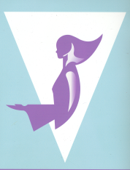

SAVE THE DATE
SUNDAY, MARCH 22, 2015 2-4:00 p.m.
Middlebury Institute of International Studies - MIIS
Irvine Auditorium, McCone Building
499 Pierce Street - Monterey, CA 93940

www.co.monterey.ca.us/csw

