A New Dredge for Rose City Yacht Club
( By Christian Steinbrecher, Columbia River Port Engineers)
Rose City Yacht Club is a private marina on the Columbia River near the Portland International Airport. Many years ago it was determined that in order to remain viable as a marina Rose City needed to dredge on an annual basis. Without the dredging effort the marina would soon silt in and RCYC would become a beach club. At that time a dredge was purchased and maintained the facility. The original dredge, old when it was purchased, was cable driven. It was upgraded to hydraulics over the years. These and other upgrade efforts were performed on as needed basis.
Approximately two years ago a survey was performed on the existing dredge to determine how much longer it could be expected to last. The result was that while it was still functional, there were a number of improvements that were needed to make it comply with current safety requirements and to extend its life. After undertaking a market survey it was determined that a new dredge would better meet RCYC’s needs both now and in the future. A cost benefit analysis showed that it was more cost effective to purchase a new dredge and operate it as opposed to bringing on contractors to dredge the facility on an annual basis.
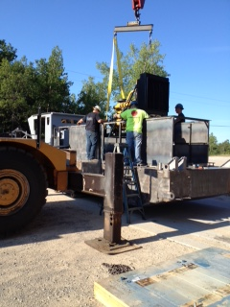
After extensive market research it was determined that best fit for RCYC’s purpose was an 8 inch Badger suction dredge manufactured in Michigan by DSC (Dredge Supply Company) located in Louisiana. Located in upstate Michigan, the plant is on the shores of Lake Huron. Following an initial sales effort, RCYC Dredge Acquisition committee members went on an investigation trip to the fabrication facility to see for themselves the dredges that were produced as well as to inspect the fabrication plant.
The major components of RCYC’s dredge include a 250 horsepower ACERT C7 Caterpillar diesel engine for primary power. This is connected to a Parker hydraulic pump which rotates a 30 inch cutter head through a Staffa hydraulic motor. The main dredge pump is a Matseo Minerals Pump rated at 160 TDH at 2,500 gallons per minute. It will pass a particle size of 4 inches. Rotzler hydraulic winches are used for raising the ladder and swinging the dredge. Winch capacity is 200 feet of 3/8” cable. The electrical system uses a 24 volt 95 amp alternator. Machinery guards are installed over all shafts. The paint throughout is a coal tar proxy. The engine and pump compartments are equipped with sliding doors for security. The roof is removable for major service for pump or diesel engines. The engine compartment is equipped with floodlights and there are also external floodlights for lighting up the work area.
After reviewing the standard equipment in detail, the fabricator was asked to make a number of changes to meet RCYC’s specific needs. Some of the changes included:
- Painting the inside of the floats for additional corrosion resistance. The existing dredge had been subjected to corrosion which reduced the metal thickness of the floats after a number of years.
- The cab was insulated with Sundown Lead Foam Insulation to ensure that the noise levels were substantially reduced over the old dredge. This would provide for the greater degree of operator comfort and increase productivity.
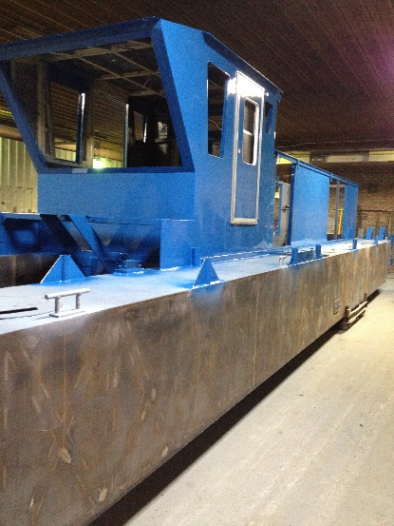
- While a GPS unit was considered, it was determined that this could be more effectively be added as an add-on after the dredge was delivered.
- A review of the cutter head indicated a need for teeth based on RCYC’s experience. The teeth allowed for cutting through rotten timbers.
- A fuel gauge was installed in the operators cab because multiple crews might be operating this equipment at different times.
- The service water sea chest was reconfigured to be square to allow for easier subsequent installation of valves for additional water - should that become necessary during operations.
- Valves at numerous locations were changed from ball valves to lever actuated to allow for easier operation and obvious indication of open/closed.
- Electrical cable runs were put in table trays to ensure better protection.
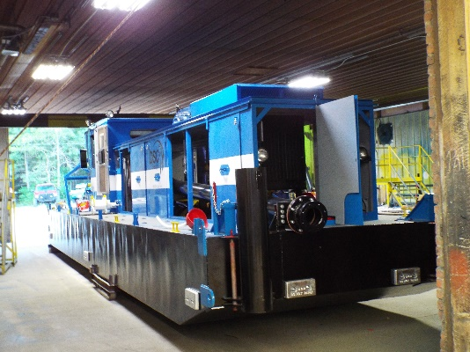
- Auxiliary water pump mounts were revised to ensure that subsequent adjustments for belt tension or replacement could more easily accomplished.
- In the interests of environmental containment a number of redundant catchment systems were installed to minimize the chances of accidental spillage into the Columbia River. This included drip pans under the engine as well as constructing a containment at the fueling location.
- An additional bilge pumps were added to ensure that there was redundancy to ensure that the bilge remained dry.
- The material selection for the trunnion pins was an important decision. The current design called for a 36 steel for all components. Based on experience the potential for galling, or freezing of the joint existed. As a result bronze bushings were substituted.
- A more sophisticated Shore Power System was installed. The system consists of a Progressive Dynamics new technology battery recharging device. This device performs several functions including charging the batteries and providing 24 volts for all subsystems while plugged in.
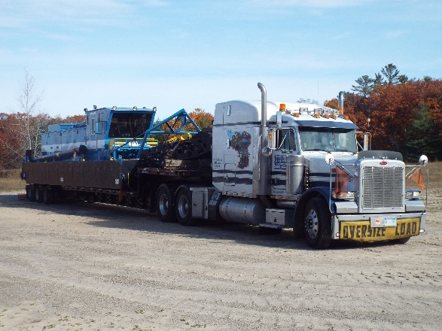
- An external EL 530 P shore power plug was installed on the side of the motor house.
The operating efficiencies of this dredge are substantial over the previous. In addition to a cleaner design it also allows for easier access to major components for repairs and adjustments. It will be more fuel efficient and provide for greater protection against unanticipated spillages. In addition it is small enough that it can be loaded on a flatbed truck and moved from the marina facility to a maintenance yard. It comes equipped with lifting eyes to allow for simpler launch and retrieval. The cost to the Club is on the order of $325,000.
Christian Steinbrecher of Columbia River Port Engineers provided oversight and support for this acquisition. The entire process from identification of need, budgeting, selection of vendor, negotiation, ordering fabrication and delivery was completed in about 11 months. He can be contacted at 503-482-7045 or at CFS@CaRPEngrs.com.

