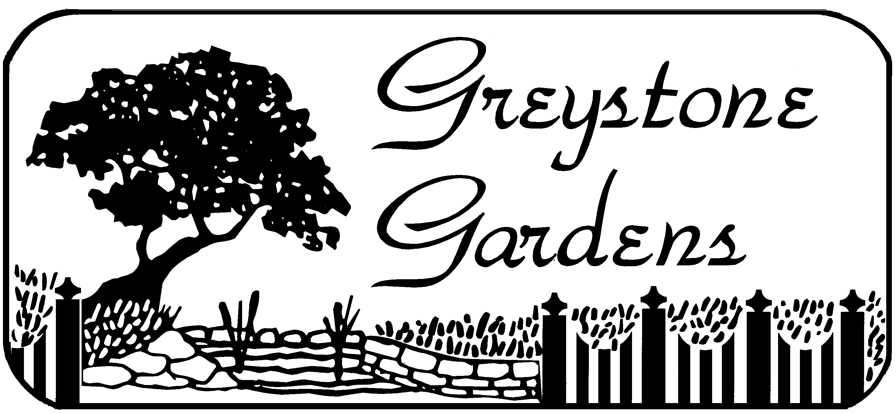

Deer Resistant Perennials
Plants usually available from Gardens Gardens
Name of plant | Our rating **good *** great | Notes
Aconitum - Monkshood | *** | Poisonous- mid summer/ fall varieties
Achillea---yarrow | *** | New colors available
Aquilegia canadensis--columbine | *** | Some will seed themselves
Allium-----chives Lots of varieties | *** | Early and late flowering
Amsonia -Blue milkweed | *** | Yellow fall color/ Smaller varieties
Artemesia----Wormwood | ** | Silver foliage. Some spread rapidly
Aruncus ------Goatsbeard | *** | Astilbe like/ smaller varieties
Ascelpias----Butterfly Weed | * | Fluffy flowers/ native
Astilbe pumila | ** | Needs shade/ moisture
Baptisia---False Indigo | ** | Easy to grow/ new varieties
Boltonia asteroides--Boltonia | * | Tall fall perennial
Buddleia davidii--Butterfly Bush | *** | Hardiness?
Centranthus Valerian | ** | Delicate flowers
Chelone--Turtle Head | * | Likes moist soil
Cimicifuga racemosa--Bugbane | ** | Lateflowers/stately foliage
Coreopsis spp. | *** | Threadleaf hardy –lots of new colors
Corydalis lutea | *** | Great foliage/ ever blooms
Dianthus spp.--Pinks | *** | Low growing
Dicentra | *** | Long blooming
Dictamus albus-- Gas Plant | ** | Don’t move
Digitalis | *** | Biennial/perennials
Echinacea purpurea--Cone Flower | * | Lots of new colors
Echinops--Globe Thistle | *** | Silver foliage blue flowers
Epimedium spp (Barrenwort) | *** | Great ground covers
Eupatorium spp--Joe -Pye Weed | ** | 6’ perennial/ smaller varieties
Ferns | *** | Excellent
Filapendula spp. Queen of the Prairie | * | Spreads in woodland
Gallium odorata | ** | Spraeds quickly
Geranium macrorhizum | *** | Fragrant foliage
Geum spp. | * | Orange or yellow
Helleborus—Hellebore | *** | May need winter protection
Herbs Mint,rosemary feverfew,oregano, lemon balm, chives | *** | Anything fragrant is good
Hesperis Dames Rocket | ** | Biennial / seeds itself
Heuchera (Coral bells) | ** | Huge variety
Hibiscus | *
Homulus Hops | * | Very aggressive
Hypericum spp (Some act as perennials) | *** | New varieties great
Iris (Siberian and Japanese) | ** | Don’t over fertilize
Lamium (dead nettles) | *** | Great ground cover
Lamiastrum | *** | Some varieties spread !
Lavandula spp--Lavender | *** | Needs sunshine
Ligularia | ** | Summer flowers
Liatris spicata--Spike Gayfeather | * | Watch for rodent damage
Limonium latifolium--Statice | *** | Cut flowers
Linum | *** | Not always long lived
Lupinus spp.—Lupines | * | Watch for snail damage
Lychnis | ** | Can re seed
Lysimachia Loosestrife | ** | Some can be invasive
Matteuccia--Ostrich Fern | *** | Great woodland foliage
Mitchella repens--PartridgeBerry | * | Not always easy to grow
Monarda didyma—Beebalm | *** | Spreads- needs moisture
Myostis---Forget Me not | *** | Biennial reseeds it self
Narcissus---Daffodil | ** | Plant thousands
Nepeta spp.-- Catmint | *** | Flowers all summer
Oenothera spp. --Evening Primrose | ** | Some are spreaders
Origanum spp--Oregano | ** | Fragrant herb
Papaver orientalis--Poppy | ** | Early summer flowers
Peony (garden/tree/intersectional) | *** | Lots of varieties
Perovskia | *** | Late blooms / drainage
Phalaris---Ribbon Grass | *** | Invasive in moist conditions
Phlox subulata | *** | Creeping phlox
Physostegia (Obedient Plant) |  | Miss manners
Polemonium caer.--Jacobs Ladder | *** | Under used gem
Pulmonaria--Lungwort | * | Early foliage and flowers
Ranunculus spp. --Buttercup | *
Salvia | * | Trim for rebloom
Saponaria spp.—Soapwort | * | Rock garden plant
Sedums Low varieties | ** | Great ground covers
Scilla spp--Scilla | *** | Will colonize
Solidago spp. Golden Rod | ** | Try the more ornamental!
Stachys byzantina---Lambs Ears | ** | Unbeatable silver foliage
Tanecetum tansy | *** | Yellow leafed varieties
Thalictrum Meadow rue | *** | Shade and nice ferny leaves
Tiarella | ** | Long blooming season
Tradescantia – spider wort | ** | Foliage and color
Trillium | *** | Native flower
Veronica Speedwell | ** | Many varieties
Viola labrador | *** | Spring flowers- reseeds
Grasses | *** | Great selection available
Greystone Gardens 829 Old State Road Clarks Summit

"Distinctive plants for Creative Gardener"

Phone 570 586 5493
Updated June 2016
More Information: www.GreystoneGardens.biz

