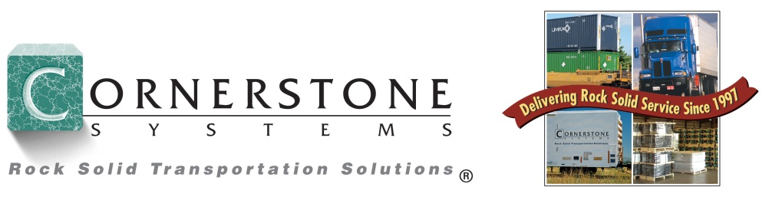

An Invitation to Join An Employee-Owned Organization

Sales - Operations - Pricing - Accounting - Information Technology - Administrative

Employee-Centered Corporate Culture

“We have always believed that the best way to care for our customers is to care about each employee and their families. People are what make Cornerstone Systems valuable to its customers. People doing their jobs, being involved and caring about our customers’ freight is what we are about. We are all in this together and what sets us apart from our competitors is our focus on the customer and our employees.”
Rick Rodell, Founder/Chairman
Cornerstone Systems

Compensation and Benefits

- ESOP (Employee Stock Ownership Plan) / Employee Owned Company

- Medical / Dental / Vision Insurance
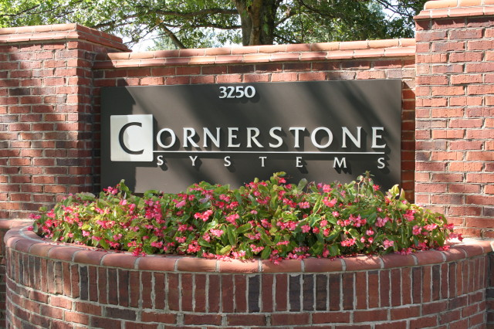

- Life Insurance

- Long Term Disability Insurance

- 401(k) Savings Plan

- Credit Union Benefits

- Paid Holidays / Vacation / Personal Time / Sick Leave

Interested in a career with Cornerstone Systems? If so, we would love to hear from you. Email your resume to careers@cornerstone-systems.com.

We are an equal opportunity employer. Applicants are considered for positions without regard to race, religion, sex, national origin, age, disability, or any other consideration made unlawful by applicable federal, state, or local laws.

