Colonial Preparatory Academy
2199 5th Street SW
Akron, Ohio 44314

Dear Parents/Guardians:

We thank you for your interest in. We take our responsibility in serving your children very seriously.

As you requested, enclosed are the enrollment forms for the 2013-2014 school-year. Please complete the attached forms and bring in or mail them to at 2199 5th St SW, Akron, Oh 44314.

If you have any additional questions, you can call us at 330-752-2792. We’re looking forward to serving you and your children.

Thank you,

Tony Cardinal, Principal

Enrollment Documentation Checklist
Student Name: ___________________________ Date of Birth: _______________________ Grade: __________
Required Paperwork

Completed Enrollment Packet | Valid Birth Certificate | Social Security Number (required: at least last four digits) | Parent or Student Driver’s license or State ID | Emergency Medical Authorization Form
2 Proofs of Residency (must provide one proof of residency dated within 30 days of enrollment)  Lease Agreement  Rent Receipt  Mortgage Statement  Voter Registration  Utility Bill  Bank Statement | Media Release Form  Sports and Activity Authorization Form | Proof of immunizations (Note: Immunization requirements must be met or student will be excluded from school on the 15th day of school) | Last Report Card (or transcript from previous school) | Free and Reduced Lunch Form/Income Verification Form
Possible Additional Paperwork
IEP or 504 Plan Information | Home Language Survey (if applicable) | Caregiver Forms | Double Affidavit (if not living in parents residence or living with grandparents) | Custody Guardian Papers/Temporary Custody orders
Request for Records | Transportation Form (Cleveland schools only) | Other:

- The Student meets all requirements of residency, guardianship, immunizations and age (birth certificate).

- The Guardian must provide proof of immunization within 14 days.

Deadline Date: _______________________

- The Student does not meet all requirements, and must do the following prior to admittance
Provide birth Certificate Provide proof of custody/guardianship
Provide proof of residency Follow-up call back, within 72 hours.
Other:__________________________________

Deadline Date ______________________

Data Manager:________________________________________________________________________________

Enrollment Application

Enrollment Date_______________ Re-enrollment New enrollment Grade Enrolling ______
Name of Student_______________________________________________________________________________________
(First) (Middle) (Last)
Address________________________________________Apt. #_______City_________________________Zip Code_____________
Primary Phone #_________________________Cell Phone #_______________________Email:______________________________
Social Security #:_______-_______-_______ Birth Date: ________________________ Gender: Male Female
Student Birth Place ___________________________________________________________________________________________ (City) (State) (Country)
Name of parents/legal guardians with whom student resides:
___________________________________________________________________________________________________________
(First) (Middle) (Last) (home phone #) (work phone#)

____________________________________________________________________________________________________________
(First) (Middle) (Last) (home phone #) (work phone#)
Who does the child live with? (Circle all that apply)
Mother Father Grandmother Grandfather Step-Father Step-Mother Surrogate Guardian Guardian Ad Litem Other: _____________________________ (Name and relationship to the student)
Who has legal custody of the student? Both Parents One Parent (Mother or Father) Other: ________________________
Name and address of CUSTODIAL PARENT NOT residing with student: ________________________________________________
Please list any CUSTODIAL ISSUES: ____________________________________________________________________________
A complete set of custody and/or guardianship papers must be on file with the school office if applicable.
The following information is required to be reported by the United States Department of Education and is a US Department of Agricultural Federal requirement. If any of these are not answered the student will be coded on a visual basis, per government reporting regulations.
Ethnicity: Is the student of Hispanic/Latino Origin? Yes No
Race: White Black Hispanic Asian American Indian/Alaskan Native Pacific Islander
Multi-racial If Multi-racial, please circle one of the following:
White Black Hispanic Asian American Indian/Alaskan Native Pacific Islander
Native Language:
1. Is a language other than English used in the home? Yes No If yes, what language _____________________________
2. Does the student have a first language other than English? Yes No

3. Does the student most frequently speak a language other than English? Yes No If yes, what language _______________
4. If student speaks a language other than English or was born outside of the United States, please give the month and year the student FIRST entered the United States:_________________________________________________
If the student was born outside of the United States, in which country was he/she born? _______________________
If the answer to the questions above is a language other than English indicate the native language in EMIS and proceed to assess the student’s ELP

I agree my child may be physically released only to the following person(s). These person(s) may also be called in the event of an emergency. Proof of identification, in the form of picture ID is required when picking up child(ren). Changes of any release/ contact selections must be received in written form.
Name | Relationship to Student | Primary Contact Number | Address
Students Previous Education:
Does the student have a current or active Individual Education Plan ( I.E.P.)? Yes No
Did the student ever have an I.E.P.? Yes No
If yes, please provide a copy of the student’s I.E.P. and Evaluation If yes, what school year? __________________
Does the student have a current or active 504 Plan? Yes No
If yes, please provide a copy of the student’s 504 Plan

Public School District of Residence: _______________________________ Previous School Phone #:_________________________
Name of Last School Attended: _______________________________ Withdrawal date from previous school: __________________
Previous School Address:_______________________________ How long did student attend previous school district? ____________
Last grade attended at previous school: _______________ Has student officially withdrawn from previous school? _______________
Did the student attend pre-school? Yes No
How long did student attend pre-school? ____________________
List any additional information that would be helpful to the school: _____________________________________________________ ____________________________________________________________________________________________________________________________________________________________________________________________________
Additional Children under 18 living in the home
Name | Age | School Attending

This form constitutes withdrawal from: _____________________________________________________ Date: _________________
Parent Signature: _______________________________________________________________________ Date: _________________
By signing below I agree that my child will abide by and support the Academy rules and regulations. I further confirm that the information provided in this document is true and correct. I am the legal guardian or custodian of the above student.
Parent/Guardian Signature: ______________________________________________________________Date: __________________
If required, translation services were provided by: _____________________________________________________________
(Signature) (Date)

Emergency Medical Authorization Form
Purpose: To enable parents and guardians to authorize the provision of emergency treatment for children who become ill or injured while under school authority, when parents or guardians cannot be reached. This information will be shared, as necessary, with teachers, bus drivers, administrative staff, health personnel including student nurses, and other school personnel. ORC 3313.712
Student Name __________________________________________________________________________Grade: _____________
(First) (Middle) (Last)

Date of Birth: ___________________________ Home Phone #: ___________________________
Mother’s Name: ____________________________________________Contact #’s : _______________________________________
Father’s Name: _____________________________________________Contact #’s :_______________________________________
Home Address: City: Zip:___________________

Emergency Contacts
Name | Relationship to Student | Daytime Phone | Cell Phone
Provide ANY pertinent medical history or information about existing conditions that may affect your child at school.
Medical Information:____________________________________________________________________________________
Medications:___________________________________________________________________________________________
Allergies:_____________________________________________________________________________________________

PART I OR II MUST BE COMPLETED
PART I: TO GRANT CONSENT |  | PART II: REFUSAL TO CONSENT
I hereby give consent for the following medical care providers and local hospital to be called: | Phone Number | I do NOT give my consent for emergency medical treatment of my child. In the event of illness or injury requiring emergency treatment, I wish the school authorities to take the following action:
Doctor |  | Signature or Parent/Guardian
Dentist
Medical Specialist |  | Date
Local Hospital/Emergency Room

In the event reasonable attempts to contact me have been unsuccessful, I hereby give my consent for:
1) The administration of any treatment deemed necessary by above named doctors, or, in the event the designed practitioner is not available, by another licensed physician or dentist:
2) The transfer of the child to any hospital reasonably accessible. This authorization does not cover major surgery unless the medical opinions of two other licensed physicians or dentists, concurring in the necessity for such surgery, are obtained prior to the performance of such surgery.
Signature or Parent/Guardian  Date |  | Signature or Parent/Guardian  Date

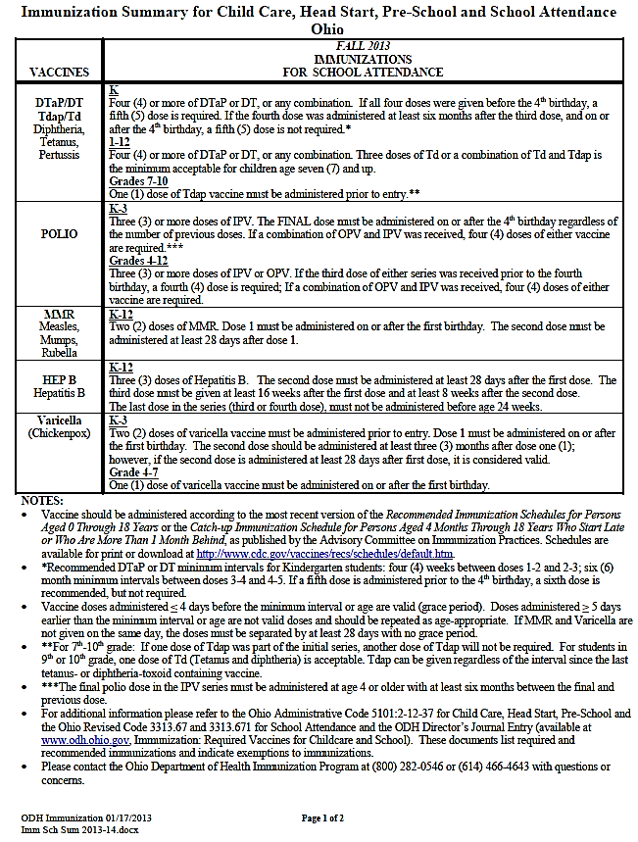

Media Release Form

Please provide all the information asked for below.

Student Name __________________________________________________________________Grade: _____________
(First) (Middle) (Last)

Date of Birth: ___________________________ Home Phone #: ___________________________

Mother’s Name: _____________________________________Contact #’s : ___________________________________

Father’s Name: ______________________________________Contact #’s :___________________________________

Home Address: City: Zip:______________
I, Parent/Legal Guardian of (child’s name) __________________________________________ hereby grant permission to West Preparatory School, its agents and assigns, to use above named child’s photo or video, and likeness for the purpose of promotion West Preparatory School for all forms, media and manners, for the following, but not limited to, news releases, photographs, video, audio, website, marketing, advertising, trade, promotion, exhibition for an indefinite period of time.

I give unrestricted permission for images, videos, and recordings of the child to be used in print, video, digital and internet media. I agree that these images and/or voice recordings may be used for a variety of purposes and that these images may be used without further notifying me.

I further acknowledge that I will not be compensated for these uses and the West Preparatory School owns all rights to the images, videos, and recordings, and to any derivative works created from them.
I waive any right to inspect the uses of any printed or electronic copy. I hereby release West Preparatory School and its agents and assigns from any claims that may arise from these uses, including without limitation claims of defamation or invasion of privacy, or of infringement of moral rights or rights of publicity or copyright.
This Release expresses the complete understanding of the parties.

Signed: _________________________________________________________________ Date: ____________________

Printed Name:_____________________________________________ ________Relationship: _____________________

Activity Authorization Form

I hereby authorize the release and disclosure of the personal health information of _______________________________ ("Student"),
as described below, to ____________________________________ ("School").
The information described below may be released to the School principal or assistant principal, coach, physical education teacher, school nurse or other member of the School's administrative staff as necessary to evaluate the Student's eligibility to participate in school sponsored activities, including but not limited to interscholastic sports programs, physical education classes or other classroom activities.

Personal health information of the Student which may be released and disclosed includes records of physical examinations performed
to determine the Student's eligibility to participate in school sponsored activities, including but not limited to the Pre-participation
Evaluation form or other similar document required by the School prior to determining eligibility of the Student to participate in
classroom or other School sponsored activities; records of the evaluation, diagnosis and treatment of injuries which the Student
incurred while engaging in school sponsored activities, including but not limited to practice sessions, training and competition; and other records as necessary to determine the Student's physical fitness to participate in school sponsored activities.

The personal health information described above may be released or disclosed to the School by the Student's personal physician or
physicians; a physician or other health care professional retained by the School to perform physical examinations to determine the
Student's eligibility to participate in certain school sponsored activities or to provide treatment to students injured while participating in such activities, whether or not such physicians or other health care professionals are paid for their services or volunteer their time to the School; or any other EMT, hospital, physician or other health care professional who evaluates, diagnoses or treats an injury or other condition incurred by the student while participating in school sponsored activities.

I understand that the School has requested this authorization to release or disclose the personal health information described above to
make certain decisions about the Student's health and ability to participate in certain school sponsored and classroom activities, and
that the School is a not a health care provider or health plan covered by federal HIPAA privacy regulations, and the information
described below may be re-disclosed and may not continue to be protected by the federal HIPAA privacy regulations. I also understand that the School is covered under the federal regulations that govern the privacy of educational records, and that the personal health information disclosed under this authorization may be protected by those regulations.

In understand by its nature, participation in interscholastic athletics includes risk of injury and transmission of infectious disease such as HIV and Hepatitis B. Although serious injuries are not common and the risk of HIV transmission is almost nonexistent in supervised school athletic programs, it is impossible to eliminate all risk. Participants have a responsibility to help reduce that risk. Participants must obey all safety rules, report all physical and hygiene problems to their coaches, follow a proper conditioning program, and inspect their own equipment daily.

I understand that in the case of injury or illness requiring transportation to a health care facility that a reasonable attempt will be made to contact the parent or guardian in the case of the student-athlete being a minor, but that, if necessary, the student-athlete will be transported via ambulance to the nearest hospital.

I also understand that health care providers and health plans may not condition the provision of treatment or payment on the signing of this authorization; however, the Student's participation in certain school sponsored activities may be conditioned on the signing of this authorization.

I consent to the use of the herein named student’s name, likeness, and athletic-related information in reports of contests, promotional literature and other materials and releases related to interscholastic athletics.

This authorization will expire at the conclusion of the present school year.

____________________________________________________________________________________________________________
Student’s Signature Birth date Grade in School Date

___________________________________________________________________________________________________________
Parent/Guardian Signature Contact Information Date

