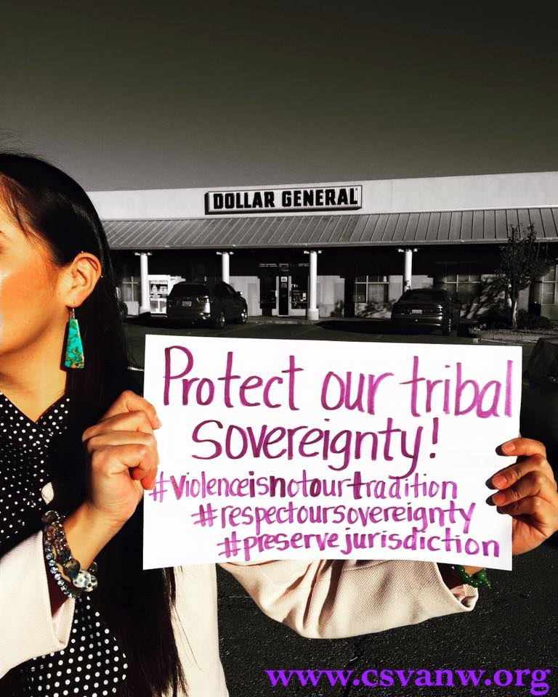

Dollar General vs. Mississippi Band of Choctaw
CSVANW proud to support the National Indigenous Women's Resource Center, the Indian Law Resource Center and all of the amazing advocates who are taking a stand in support of tribal jurisdiction over non-Indians who assault our women and children on tribal lands.
In 2003, 13 year old Choctaw student was repeatedly molested by the store manager Dale Townsend at a Dollar General Store like many tribal job placement programs, the young boy was placed at Dollar General on the reservation. The young boy’s parents pressed charges and sued Townsend and Dollar General for physically and emotional damages in Choctaw Tribal court, however the tribe failed to prosecute Townsend for his criminal actions, but not for suing the man and the multi-billion dollar corporation. The case of Dollar General has gone through judicial systems and has unable to convince the courts since the corporation willingly operated businesses on tribal lands. Currently the case has worked its way up to the Supreme Court and many tribal advocates are at the front lines collecting quilt pieces from tribal members, organizations, and advocates across the country who are in support with Mississippi Band of Choctaw.
Dollar General ignored the human rights of the Choctaw boy who was molested repeatedly on his own tribal lands. Indian children across the country rates of trauma is three times more than the national average. The scale of suffering that Native youth face today is similar to the returning veterans from Afghanistan and Iraq.
Dollar General signed a contract to build and make profit off of Indian land and had no complaints to build on Indian land. Dollar General is completely ignoring the tribal sovereignty and the reality of violence against Indian women and children.
CSVANW supports the Mississippi Band of Choctaw Indians right to land sovereignty and right over our own bodies.

https://www.aclu.org/legal-document/dollar-general-v-mississippi-band-choctaw-indians-amicus-brief
http://www.slate.com/articles/podcasts/amicus/2015/12/the_supreme_court_takes_up_native_american_sovereignty.html
https://www.youtube.com/watch?v=YKLV-QldI8M

