MBQIP
Medicare Beneficiary Quality Improvement Project

The Medicare Beneficiary Quality Improvement Project (MBQIP) is a quality improvement activity under the Federal Office of Rural Health Policy’s (FORHP) Medicare Rural Hospital Flexibility Grant (Flex) program. The goal of MBQIP is to improve the quality of care provided in critical access hospitals by increasing voluntary quality data reporting and then driving quality improvement activities based on the data.
MBQIP

MBQIP is a required activity of the MT Flex Grant. To receive benefits from Flex Grant funds, MT CAHs will need to report all MBQIP measures each quarter. During the 2015-2016 Flex Grant Year, Flex Grant staff will be providing guidance and assistances to all MT CAHs to get to this level of reporting.

Required MBQIP Measures (begins with Q3 2015 data)
Report to: | Measure:
CART/QNet | OP-1: Median time to fibrinolysis
CART/QNet | OP-2: Fibrinolytic therapy received w/in 30 minutes
CART/QNet | OP-3: Median time to transfer to another facility for acute coronary intervention
CART/QNet | OP-5: Median time to ECG
CART/QNet | OP-20: Door to diagnostic evaluation by a qualified medical professional
CART/QNet | OP-21: Median time to pain management for long bone fracture
CART/QNet | OP-22: Patient left without being seen
NHSN | OP-27: Influenza vaccination among healthcare personnel (annual)
CART/QNet | Imm-2: Inpatients assessed and given influenza vaccination
Flex/PIN | EDTC-1: Administrative Communication for ED Transfer
Flex/PIN | EDTC-2: Patient Information for ED Transfer
Flex/PIN | EDTC-3: Vital Signs for ED Transfer
Flex/PIN | EDTC-4: Medication Information for ED Transfer
Flex/PIN | EDTC-5: Physician or Practitioner Generated Info for ED Transfer
Flex/PIN | EDTC-6: Nurse Generated Info for ED Transfer
Flex/PIN | EDTC-7: Test and Procedure Information for ED Transfer
Flex/PIN | EDTC-All: All 7 measures (above) are included in the medical record for ED Transfer
Vendor | HCAHPS-1: Communication with Nurses
Vendor | HCAHPS-2: Communication with Doctors
Vendor | HCAHPS-3: Responsiveness of Hospital Staff
Vendor | HCAHPS-4: Pain Management
Vendor | HCAHPS-5: Communication about Medication
Vendor | HCAHPS-6: Discharge Information
Vendor | HCAHPS-7: Care Transitions
Vendor | HCAHPS-8: Cleanliness of Hospital
Vendor | HCAHPS-9: Quietness of Hospital
Vendor | HCAHPS-21: Overall Rating of the Hospital
Vendor | HCAHPS-22: Willingness to Recommend

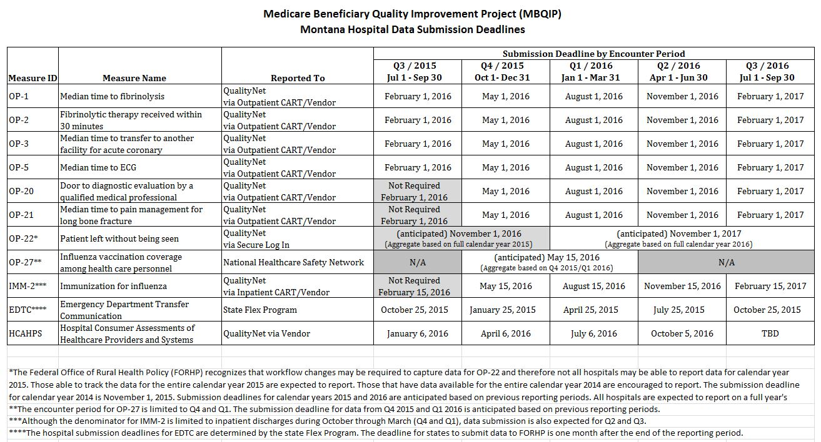
HCAHPS
Hospital Consumer Assessment of Healthcare Providers and Systems

HCAHPS data is submitted to Quality Net (CMS) by a third party vendor.
HCAHPS
The hospital must “opt-in” to have their survey data reported to Quality Net. Data from the surveys includes

Report to: | Measure:
Vendor | HCAHPS-1: Communication with Nurses
Vendor | HCAHPS-2: Communication with Doctors
Vendor | HCAHPS-3: Responsiveness of Hospital Staff
Vendor | HCAHPS-4: Pain Management
Vendor | HCAHPS-5: Communication about Medication
Vendor | HCAHPS-6: Discharge Information
Vendor | HCAHPS-7: Care Transitions
Vendor | HCAHPS-8: Cleanliness of Hospital
Vendor | HCAHPS-9: Quietness of Hospital
Vendor | HCAHPS-21: Overall Rating of the Hospital (0-10 rating)
Vendor | HCAHPS-22: Willingness to Recommend

HCAHPS Vendor List:

Custom Survey Solutions
406-932-6565

Avatar International
800-282-8274

Beacon Technologies
877-909-1480

Fields Research
513-821-6266

Healthstream Research
615-2247-1550

MN Rural Helalth Cooperative
507-423-5300

NRC+Picker
800-428-7455

Press Ganey Associates
800-232-8032

Professional Research Consultants, inc
800-426-7455

Rural Comprehensive Care Network
888-917-3772

Rural Wisconsin Health Cooperative
800-885-2531

