CULTURAL ADVENTURES PRESENTS
A TASTE OF JAMAICAN CUISINE

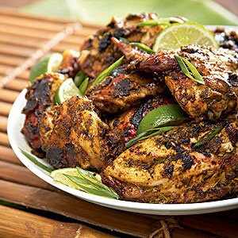
BY CHEF AnneZette
WHEN: Tuesday, June 28th
TIME: 4:30 - 6:00pm
HELD AT: Aimhi at 950 Kerry Street
WHERE: Bistro and Kitchen

Refreshments and drinks provided
FREE ADMISSION!!!!!!!!!!
Contact for info: 250-564-6408 Ex: 316

