CULTURAL ADVENTURES PRESENTS

SPECIAL GUESTS FROM JAMAICA
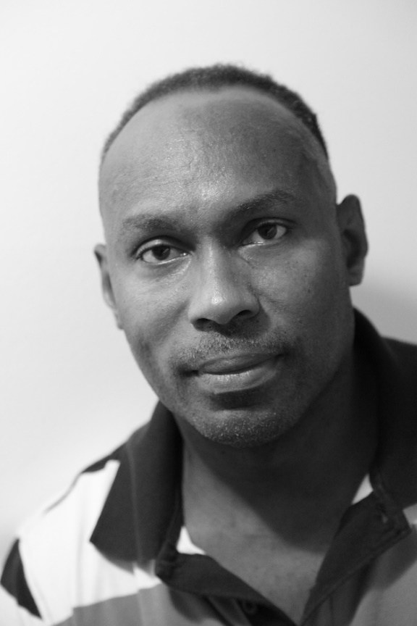
Live Music & entertainment BY
Edwin Menzies: Singer, Song Writer, Author of recently published book “ Encrypted “
& Guest speaker Annazette Ofulue who is called
“Island Girl “will be performing Jamaican dance
When: Tuesday 7th June 2016
Time: 4:30 - 6:00pm
Held at: Aimhi Gym, 950 Kerry Street
Refreshments and drinks provided FREE ADMISSION!!!!!!!!!! Contact for info: 250-564-6408 Ex: 316

