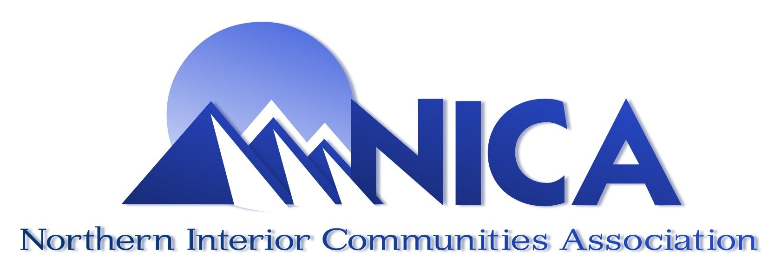
Community Gaming Grant Workshop

Saturday April 30, 2016 9:00am - 12:00pm

1600 3rd Ave. Prince George Native Friendship Centre
In the Power of Friendship Room

Contact: Curtis Mayes – 250-562-2553 or
Email - coordinator@northernica.org to pre-register

The workshops will focus on how to write successful applications for the BC Community Gaming Grants program.

The workshop is free, and open to anyone who would like to attend on behalf of their non-profit or charity.

Coffee and tea will be available.

