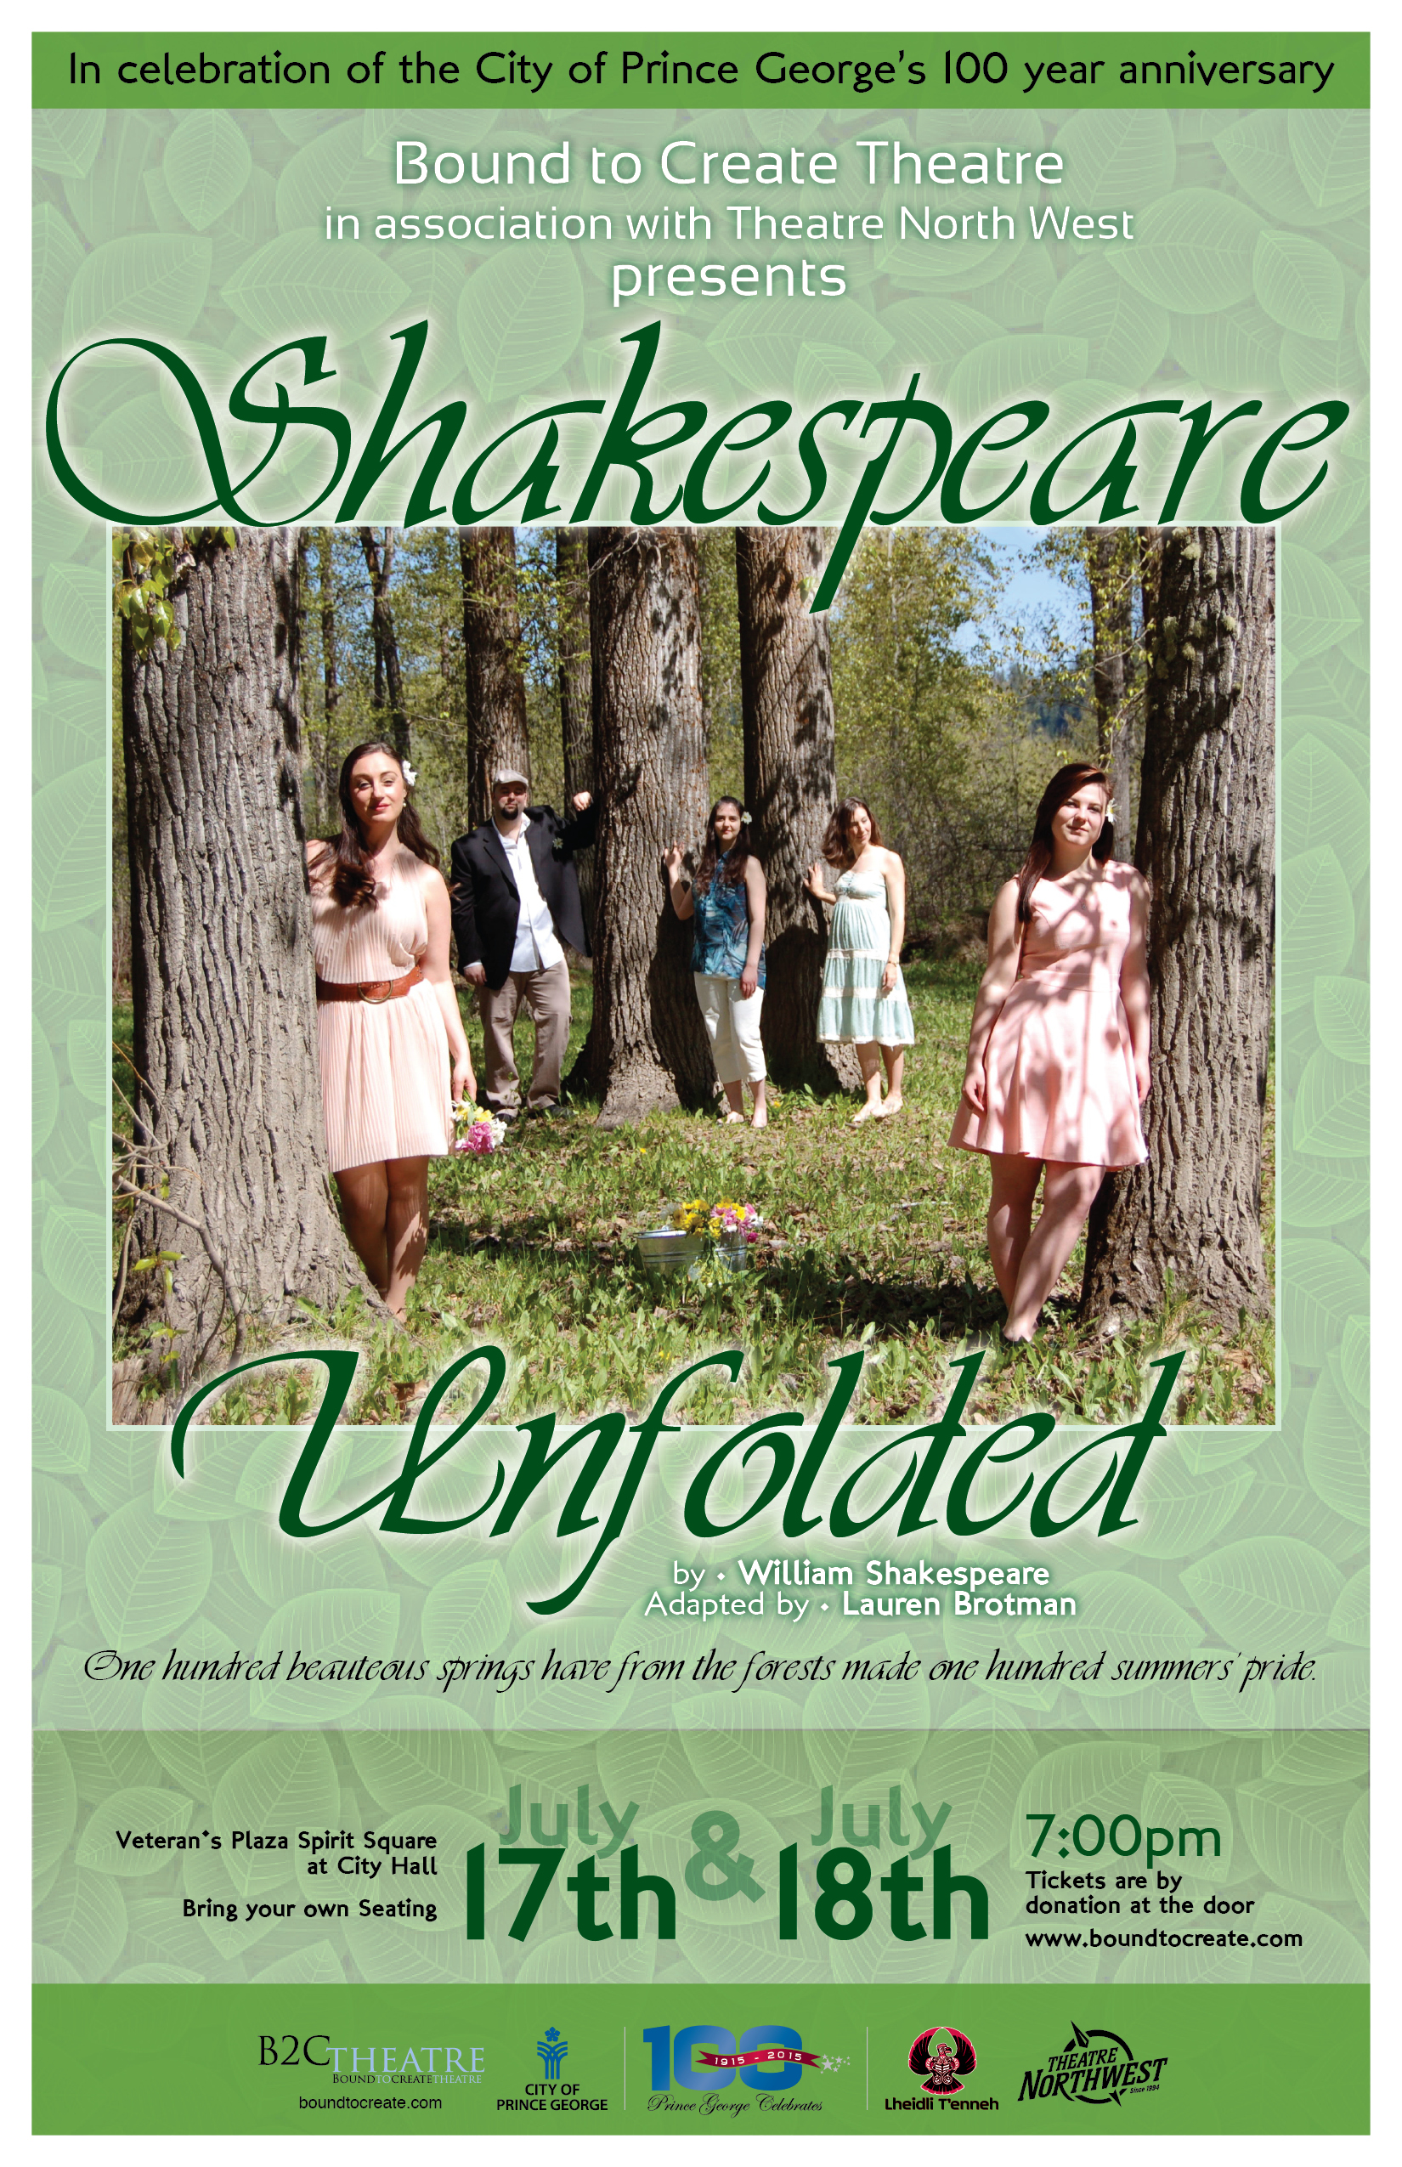
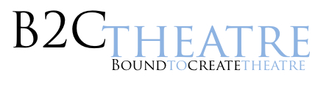

For Immediate Release
June 22nd, 2015

Prince George, B.C.

Shakespeare Unfolded presented by Bound to Create Theatre

One hundred beauteous springs have from the forests shook one hundred summers’ pride.
Bound to Create Theatre presents the premiere of Shakespeare Unfolded in association with Theatre North West, a new play conceived and adapted by Lauren Brotman, as part of the 100 Year Anniversary Celebrations of Prince George.
In honour of Prince George’s 100th Anniversary, Shakespeare Unfolded celebrates the magical surroundings of our city and the heart of our natural resources; our trees, our paper and our community. In this hilarious, accessible and often moving story, a company of actors joins forces to celebrate the 100th Anniversary of Prince George through some of Shakespeare’s most beloved sonnets, love scenes and live music.

Set outdoors on the grounds of our historic Veteran’s Plaza Spirit Square at City Hall, this midsummer-madness delight, told completely through Shakespeare’s words, brings together a community of players and audience alike, to celebrate and reflect upon our history, our people, our sacred natural landscape, the human experience and our connection to Nature.

Told through Williams Shakespeare’s words, this new play created by B2CTheatre’s Co-Artistic Director Lauren Brotman will be presented by an entirely local group of artists: Lauren Brotman (The Secret Mask, Theatre North West and Christopher Plummer Fellowship Award recipient), Assistant Director Melissa Glover (Bemused and All Shook Up, Theatre North West), David Leach, Emily MacLise and Paige Marriott (Beatrice & Benedict, Fraser Lyric Opera) and others.

When we moved to PG last summer, I was immediately struck by the beauty of the surroundings, and the openness of the community, says Brotman. With the 100th Anniversary fast approaching, I was inspired to make an offering to our new city that celebrates our new home and I knew that an outdoor Shakespeare production was the way to go since so many of Shakespeare’s plays celebrate and reflect upon the two very things that have given me inspiration during my hours of walking along the Nechako and Fraser Rivers with my young infant: Nature and Love.

Coupled with the production, Brotman is creating a live installation at SummerFest, The Memory Tree, where the community will be invited to write a significant memory they've experienced in PG on a piece of paper which will be tied to one of the tree branches in Veteran’s Plaza Spirit Square at City Hall. As the branches fill up, the history of the community unfolds, until finally we and the paper, fully unfolded, return back to the earth to begin a new cycle of life, newness and growth, a new centennial, as we enter our next 100 years.

Both events are themed by Trees, Paper and People, and remind us of the physical landscape we are a part of; our paper and pulp mill industry that thrives because of the trees that encircle us, and the people who ensure that our natural resources are used to further the vibrancy and growth of our city. Unfolded (Shakespeare Unfolded and The Memory Tree) celebrates the magical surroundings and vitality of our city and the heart of our natural resources; our trees, our paper and our people.

Bound to Create Theatre was formed in 2003 by award winning theatre artists Lauren Brotman and Jack Grinhaus. B2C engages audiences with familiar and relevant themes presented in unfamiliar ways. Our aim is to ‘provoke and charge the soul’ by creating intense and visceral productions that have a modern, social, and artistic relevance to the world today.

Bound to Create Theatre presents Shakespeare Unfolded by Williams Shakespeare
in association with Theatre North West
Created by: Lauren Brotman
Assistant Directed/Associate Produced by: Melissa Glover
Stage Managed by: Lorranna McCoy
Featuring: Lauren Brotman, David Leach, Emily MacLise, Paige Marriott, Anna Russell with Curtis Abriel
Sound Design and Original Composition by: Curtis Abriel
Production Designed by: Jordanna McCoy

Friday July 17th and Saturday July 18th at 7:00pm
Tickets are by Donation at the Door
Veteran’s Plaza Spirit Square at City Hall
Bring Your Own Seating

Media Contact: Lauren Brotman at info@boundtocreate.com
Visit www.boundtocreate.com for more details.

Promo shots and event poster attached. Production stills coming soon.
###

