16 we together - March 2016
AiMHi
ONE COMMUNITY - ONE VISION

Family Film Festival
Cineplex

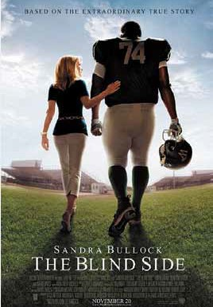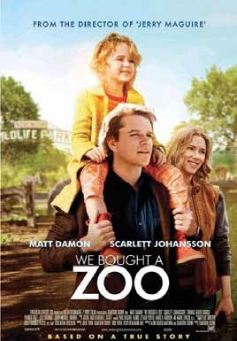Admission $5 per person. Tickets available at door at  on Sunday April 3 Advance tickets: Studio 2880

We Bought a Zoo:

Set in Southern California, a father moves his young family to the countryside to renovate and re-open a struggling zoo.

Stars: Matt Damon, Scarlett Johansson,
Thomas Haden Church

start time 9:40am

Blindside:

The story of Michael Oher, a homeless and traumatized boy who became an All American football player and first round NFL draft pick with the help of a caring woman and her family.

Stars: Quinton Aaron, Sandra Bullock, Tim McGraw

start time 9:30am

BONUS! A selection of Short Films from Sprout Film Festival will be shown before each movie

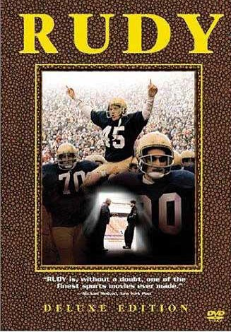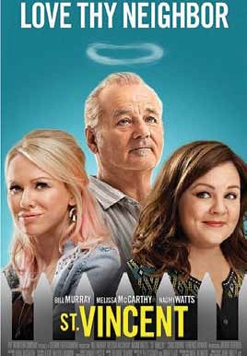

Rudy:
Rudy has always been told that he was too small to play college football.
But he is determined to overcome the odds
and fulfill his dream of playing for Notre Dame.

Stars: Sean Astin, Jon Favreau, Ned Beatty

start time 9:50am

St Vincent:
A young boy whose parents have just divorced finds an unlikely friend and mentor in the misanthropic, bawdy, hedonistic war veteran who lives next door.

Stars: Bill Murray,
Melissa McCarthy, Naomi Watts

start time 10am
The proceeds from the festival will support expansion of the Children’s Summer Camp program.

Proudly brought to you by:
we PEOPLE HELPING PEOPLE

One community One vision

4 we together - March 2016
AiMHi
ONE COMMUNITY - ONE VISION

AiMHi presents its own film festival

Following in the footsteps of an already very success- ful film festival,AiMHi will presenting its own film festival in Prince George April 3.
The local festival mirrors the Sprout Film Festival, hosted by Inclusion B.C. and the B.C. Self Advocacy Foundation, last year in New Westminster.The AiMHI festival will, in fact, be larger than the Sprout in that it will be presenting more films.
Held at the Cineplex in Prince George, the AiMHi festival will give movie-goers a choice of our movies to
countryside to renovate and re-open a struggling zoo.

Rudy (starts at 9:50 a.m.)
Rudy has always been told that he was too small to play college football. But he is determined to overcome the odds and fulfill his dream of playing for Notre Dame. The inspirational movie stars Sean Astin as
Rudy.

St.Vincent (starts at 10 a.m.)
memorable films featuring people with intellectual and developmental disabilities. (See listing of short films this page.)
Admission to the AiMHi Film Festival is $5.Tickets are available at Studio 2880 or you can get them at the door at Cineplex on Sunday,April 3.
Proceeds from the AiMHi Film Festival will support expansion of the Children’s Summer
Camp program.
So mark Sunday,April 3 on your

watch:

Blindside (starts at 9:30 a.m.)
Sandra Bullock won a best actress Oscar in the film, which is the story of Michael Oher, a homeless and traumatized boy who became an All American football player and first round NFL draft pick with the help of a caring woman (played by Bullock) and her family.

We Bought a Zoo (starts at 9:40 a.m.)
A young boy whose parents have just divorced finds an un- likely friend and mentor in the misanthropic, bawdy, hedonistic war veteran who lives next door, played by Bill Murray. Me- lissa McCarthy plays the mother in this award-winning movie.
Before each feature-length
movie, a couple of short films will
For more on the Film
Festival, turn to page 16.
calendar and take in one of the great films being offered during the AiMHi Film Festival here in Prince George. You’ll support a great cause, and you’ll see some great films. For more on the Film Festival, turn to page 16.

Starring Matt Damon and Scarlett Johannsen, it’s the story of a father who moves his young family to the
also be shown.These are the films from
the Sprout Festival and are entertaining and



