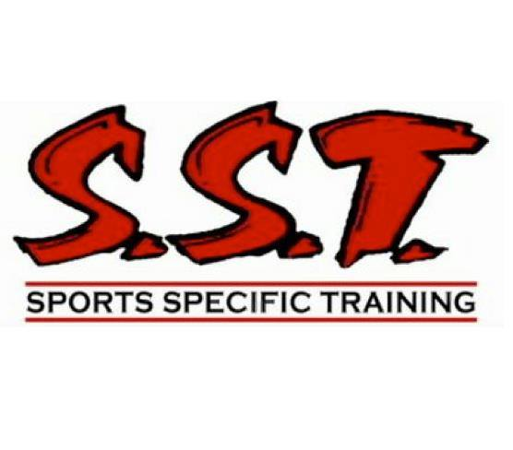

SST Stretching for Athletic Performance Blog Series

Part I
Stretching for Athletic Performance: The Upper Body
This series on how to incorporate static stretching to improve athletic performance was begun a couple of months ago. The reasons behind this series are simply that, over the last few years, static stretching has gotten a bad rap in strength and conditioning circles and to show how we can use static stretching to enhance performance rather than detract from it. The first two parts of this series looked at the basic guidelines of a static stretching routine and stretches for the lower body. In this final installment, we will cover static stretching for the upper body.
Just to recap, the purpose of static stretching is not to warm-up for athletic activity; it is to lengthen those muscles that were shown to be overly short at the conclusion of our initial assessment at SST. It is important to note that we do not incorporate a shotgun approach and static stretch every single muscle group. Depending on the areas of tightness of the individual, stretches for only a single muscle group might be prescribed.
With our recap complete, let’s get into the common trends and then the actual stretches!
Common Trends:
- Tight pectoralis major
- Tight latissimus dorsi
- Tight upper traps/levator scapulae
Tight Pec Major
The pectoralis major muscle has two main functions: to horizontally adduct the arm and to internally rotate the humerus, so in order to stretch it we need to both horizontally abduct the arm and externally rotate it. The most commonly used stretch involves placing your outstretched arm on a doorway and then rotating your chest away from your arm. The main problem here is that not all the muscle fibers are oriented at the same angle, so by just placing your arm at one position (shoulder height, for example) you only get a good stretch in those fibers that run with the same orientation as your arm (in this case, straight across the muscle belly which are in the mid to upper portion of the pectoralis major muscle). To stretch all the fibers, you will need to perform this stretch with your hand above shoulder height (think 45 degrees), at shoulder height, and below shoulder height (again, think 45 degrees). Hold each position for 10-15 seconds.
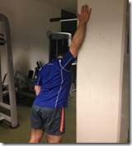

Part II
Stretching for Athletic Performance: The Upper Body
This series on how to incorporate static stretching to improve athletic performance was begun a couple of months ago. The reasons behind this series are simply that, over the last few years, static stretching has gotten a bad rap in strength and conditioning circles and to show how we can use static stretching to enhance performance rather than detract from it. The first two parts of this series looked at the basic guidelines of a static stretching routine and stretches for the lower body. In this final installment, we will cover static stretching for the upper body.
Just to recap, the purpose of static stretching is not to warm-up for athletic activity; it is to lengthen those muscles that were shown to be overly short at the conclusion of our initial assessment at SST. It is important to note that we do not incorporate a shotgun approach and static stretch every single muscle group. Depending on the areas of tightness of the individual, stretches for only a single muscle group might be prescribed.
With our recap complete, let’s get into the common trends and then the actual stretches!
Common Trends:
- Tight pectoralis major – PART 1
- Tight latissimus dorsi – Part 2
- Tight upper traps/levator scapulae

Tight Latissimus Dorsi
Tight lats are a common problem area for much of the same reason as the pecs: they’re internal rotators of the upper arm. Yes, they also produce other movements such as shoulder extension, adduction, and scapular downward rotation, however their role as internal rotators is the main issue because of typical “computer guy” posture. Notice your posture right now as you’re reading this. There’s a good chance that you are both internally rotated (this is due to the nature of typing/using a mouse) and protracted (shoulders rounded forward). When you add to this the fact that you spend hours of each day in this position at school or playing video games, the result is that your pecs and lats will become shortened. To stretch the latissimus dorsi, bend over at the waist and grab onto a vertical pillar structure with one or both hands. Then simply shift your weight right back to your heels and lean back a little (push your butt back). You will feel the stretch in the muscle belly. Again 10-15 second holds, relax, and go back into the stretch again but lean back a little farther. Do a total of 2-3 reps depending on how tight you are.
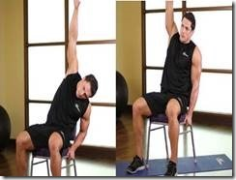

Part III
Stretching for Athletic Performance: The Upper Body
This series on how to incorporate static stretching to improve athletic performance was begun a couple of months ago. The reasons behind this series are simply that, over the last few years, static stretching has gotten a bad rap in strength and conditioning circles and to show how we can use static stretching to enhance performance rather than detract from it. The first two parts of this series looked at the basic guidelines of a static stretching routine and stretches for the lower body. In this final installment, we will cover static stretching for the upper body.
Just to recap, the purpose of static stretching is not to warm-up for athletic activity; it is to lengthen those muscles that were shown to be overly short at the conclusion of our initial assessment at SST. It is important to note that we do not incorporate a shotgun approach and static stretch every single muscle group. Depending on the areas of tightness of the individual, stretches for only a single muscle group might be prescribed.
With our recap complete, let’s get into the common trends and then the actual stretches!
Common Trends:
- Tight pectoralis major Part 1
- Tight latissimus dorsi Part 2
- Tight upper traps/levator scapulae
Tight Upper Traps/Levator Scapulae
The upper traps and levator scapulae are two different muscles which get tight under the same general conditions, again associated with poor seated posture. First, the upper traps are easily found at the upper back to either side of the spine. The levator scapulae, on the other hand, is neither as well known nor easily found; it lies deeper than the traps and the superficial neck extensor muscles.
To stretch the upper traps, simply pull the shoulder blade, on the side you want to stretch, down towards your butt and then lean your head (or gently pull it with your opposite side arm) diagonally towards the non-stretch side armpit (think chin to armpit).
To stretch your levator scapulae, take a similar set-up as the upper trap stretch, placing the stretch side hand behind your lower back and depressing the shoulder blade. With the other hand, gently pull the head towards the non-stretch side armpit (again, think chin to armpit). Like the other stretches; 10-15 seconds, release, and perform another 1 or 2 reps.
