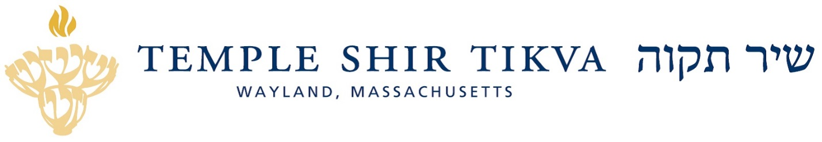

Temple Shir Tikva Self-Study - Multiple Opportunities for Participation!

As we embark on the next steps of our journey toward finding a senior rabbi for the temple, it is critical that we follow best practices, as well as embrace this unique opportunity to come together as a community, by conducting a self-study in which we listen to one another and assess who we are and what we want in our future leader. There are many ways for us to gather this information, and I want to alert you to all of them.

First, there will be two congregation-wide meetings. The first is on Sunday April 10 at the temple from 5 - 7:00 p.m. with a schmooze beginning at 5:00 p.m. The meeting will begin promptly at 5:30 p.m. The second will be on Monday, May 2 from 7 - 9:00 p.m. with a schmooze beginning at 7:00 p.m. The meeting starts promptly at 7:30 p.m. Skilled facilitators will help guide the conversation.

In addition to these meetings, Community Conversations will be taking place throughout the month of April for congregants with common interests. Specific dates and times will be made available as they are confirmed.

Finally, for the entire congregation, and especially for those unable to participate in person, a congregation-wide survey will be distributed with questions for you to share your thoughts.

Thank you all for your continued partnership as we proceed to this next opportunity for getting to know ourselves and one another more intimately. On behalf of the Rabbi Search Committee, together with the Congregational Engagement Committee, I look forward to learning with you.

Click here to let us know you will be attending either meeting

L'shalom,
Julie Kniznik
Temple President

