HUMAN SERVICES AGENCY & DEPARTMENT OF AGING AND ADULT SERVICES
DAAS BENEFITS AND RESOURCES HUB
GRAND OPENING

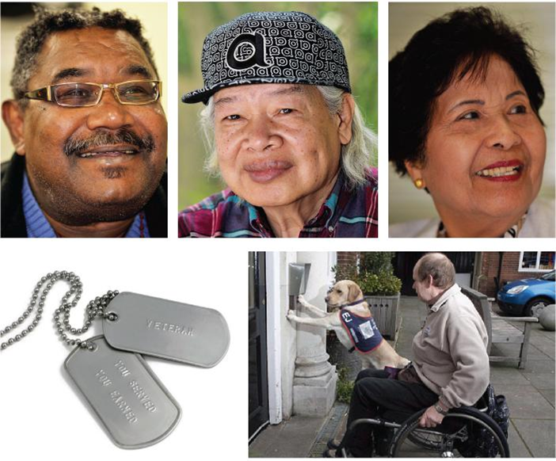
Wednesday, April 13, 2016, 10:00am; 2 Gough, SF CA

You’re Invited!

Join residents, elected officials, city staff and advocates to celebrate the opening of the DAAS Resource & Benefits Hub. Learn about services, meet staff, and get information.

April 13; 10:00am
2 Gough (at Otis)
San Francisco, CA 94103

Intake Services
+ Adult Protective Services
+ In-Home Supportive Services and
Home Care
+ Meal sites, home delivered meals, and pantry sites
+ Case Management Services
+ Information & Referral to Community Services:
+ Legal & Eviction Prevention Services
+ Money Management
+ Mental Health/Substance Abuse
Services
+ Senior Centers/Adult Day Health Care
+ Medical/Dental Items and Services
+ And More...
Benefits
+ CalFresh (formerly Food Stamps)
+ Medi-Cal Information

Veterans Services
+ Benefits Review
+ Disability Benefits (i.e. Pension,
Compensation, Aid and Attendance)
+ Income Verification
+ Educational Benefits
+ College Tuition Fee Waiver
+ Healthcare Information
+ Home Loans & Life Insurance
+ Military Discharge Information
+ Burial Benefits
+ Survivor & Widow Benefits
For more information about the event or the DAAS Hub call: 415-355-6700

