CLC Mondays at 360 Valencia in December

Open Lab and Tutoring in December

Monday, December 7 – 9:00 am to 2:30 pm

Monday, December 14 - 9:00 am to 3:00 pm

Monday, December 21 - 9:00 am to 3:00 pm

Monday, December 28 – Closed for the Holidays*

Share Your Stories - The History Project
Most every Monday, from 11:00 to 3:00*, we will offer “hands on” support for individuals using The History Project platform. Join us to learn more about this new way to tell your “stories” and preserve your memories. Learn more at www.thehistoryproject.com. Then bring ideas, pictures, questions to 360 Valencia Street on Mondays and we will help you get started.

December Classes
PHOTO CARDS FOR THE HOLIDAYS – December 7, 1:00-3:00 pm
We will use our Point Shoot Share program and create personalized holiday cards with your own photos on them

FREE MUSIC AND MOVIES ONLINE – December 14, 1:00-3:00 pm
An overview of the best sites on the internet for free music and free movies – from ancient to contemporary to jazz to classical to hip hop - includes learning how to use YouTube to watch or to post your own thoughts, photos, and tapes as well as legally download songs and videos.

HELP DESK AND LUNCH– December 21, 10:00 am
Do you know the difference between AT&T and Verizon? Should you get a smart phone? Do you need help with your high tech gadgets? Bring your tech toys and questions – get answers – and join us for turkey sandwiches at Noon.

See reverse side for other sites where CLC is teaching special “On The Road” classes and hosting weekly open computer labs
For more information about computer classes, healthy aging workshops, and other activities in your neighborhood, call the Community Living Campaign at 415-821-1003 or go to www.sfcommunityliving.org

CLC’s Free Weekly Computer Classes & Tutoring
30th Street Senior Center* | Wed., 1 to 3 | 1 to 1 Tutoring, Classes | 225 30th St.
360 Valencia St. | Mon., 9 to 3 | 1 to 1 Tutoring, Classes | 360 Valencia St.
Aquatic Park | 1st & 2nd Wed., 1 to 3 | 1 to 1 Tutoring, Classes | 890 Beach St
Centro Latino* | Tues. & Wed., 10 to 12 | 1 to 1 Tutoring, Classes | 1656 15th St.
Curry Senior Center | Fri., 1:30 to 3:30 | 1 to 1 Tutoring, Classes | 315 Turk St.
Laguna Honda Hospital | 1st & 3rd Wed., 1 to 3 | 1 to 1 Tutoring | 375 Laguna Honda
Mission Neighborhood Center* | Mon., 10 to 12 | 1 to 1 Tutoring, Classes | 362 Capp St.
Telegraph Hill Neighborhood Center | Tue. 9:30 to 12:30 | 1 to 1 Tutoring | 660 Lombard St.
Richmond Senior Center# | Tues. & Thurs., 1 to 3 | 1 to 1 Tutoring | 6221 Geary Blvd.
We teach people how technology and social media are new tools to help individuals and groups reduce isolation and reweave community. You can find the Community Living Campaign’s
* Training in Spanish # Bilingual training available in English and Chinese (Cantonese and Mandarin)
Many Centers close for one or more days for the holidays. Please check in advance.
Community Connectors and Trainers in computer labs and senior centers across the city.
Facebook | Wed. Dec. 2 | 1:00-3:00 | Laguna Honda Hospital  First Floor | 375 Laguna Honda Blvd
Ins and Outs of email | Wed. Dec. 9 | 1:00-3:00 | Aquatic Park Senior Center | 890 Beach Street
Help Desk & Personal Projects | Thu. Dec. 10 |  | Curry Senior Center | 315 Turk Street
Technology Tools Help | Fri. Dec. 11 | 11:00 | IT Bookman | 446 Randolph Street
Holiday Photo Cards | Tue. Dec. 15 | 10:30 | Laguna Honda Hospital  Mezzanine | 375 Laguna Honda Blvd
Genealogy | Wed. Dec. 16 | 1:00-3:00 | Laguna Honda Hospital  First Floor | 375 Laguna Honda Blvd
Help Desk & Personal Projects | Fri. Dec. 18 | 11:00 | IT Bookman | 446 Randolph Street
Intensive Gaming | Wed. Dec. 23 | 1:00 – 3:00 | Aquatic Park Senior Center | 890 Beach Street
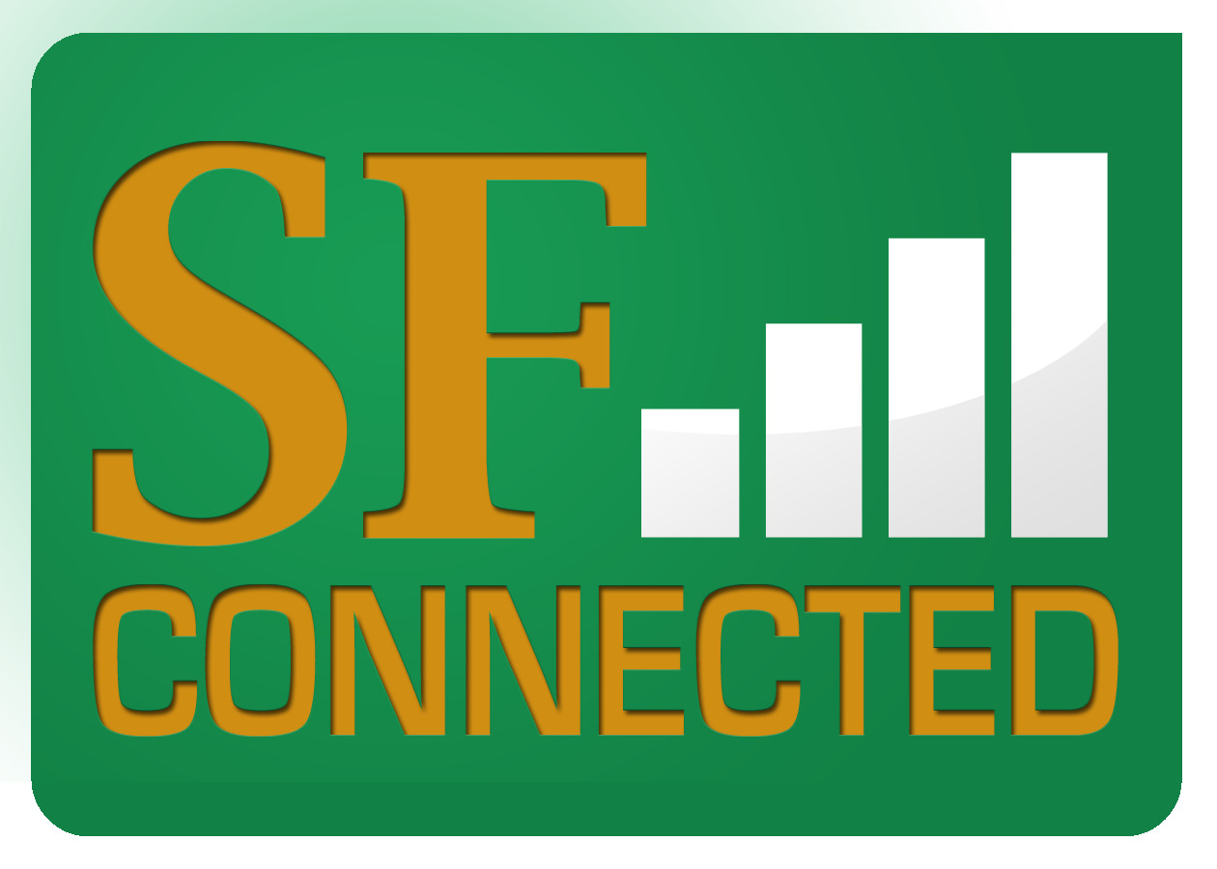
Community Technology Network, Self-Help for the Elderly, Conard House, and Reliatech also offer computer classes and support. To see a calendar of all free classes or for more information, go to www.sfconnected.org or call (415) 355-3555.
For more information about computer classes, healthy aging workshops, and other activities in your neighborhood, call the Community Living Campaign at 415-821-1003 or go to www.sfcommunityliving.org

