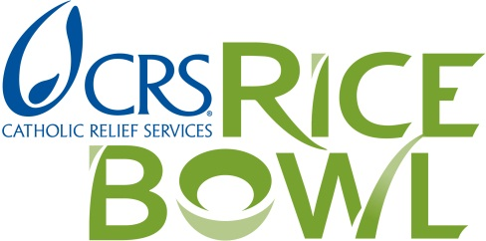
PARISH ORDER Form
for Lent 2016

IF YOU ORDERED CRS Rice Bowl Materials for Lent 2015, the SAME order will be shipped for 2016.
If necessary, please revise/update the information below to CHANGE your order of information.

IF YOU DID NOT PLACE AN ORDER for Lent 2015,
Please complete the CONTACT INFORMATION in the table BELOW.
Complete the FORM by filling in YOUR DESIRED QUANTITIES FOR LENT 2016.

Return this form to the Office for Catholic Social Justice Ministry BY October 20th.

RETURN BY MAIL: OR FAX to:
Office for Catholic Social Justice Ministry (OCSJM) (203) 776-3233
Attn: CRS Rice Bowl
81 Saltonstall Avenue OR EMAIL to:
New Haven, CT 06513 info.ocsjm@aohct.org

Please complete ALL fields; PRINT CLEARLY. Thank you!

 | 2015 Contact Information
PARISH NAME
CITY
SHIP TO:
PARISH or SCHOOL
CONTACT PERSON
STREET
CITY/STATE/ZIP
CONTACT E-MAIL
2016 CRS RICE BOWL Materials | LENT 2016 Order: Please enter quantities needed.
See enclosed list for descriptions. |  | 2015 ORDER | 2016 ORDER
Rice Bowl with Lenten Calendar (English) | Minimum: 25
Educator Guide – Grades 1-8 (English) | Maximum: 15
Youth Reflections– Grades 9-12 (English) | Maximum: 10
Community Reflections –Young Adult/Adult (English) | Maximum: 10
Plato de Arroz con Guía Espiritual (Español) | Minimum: 25
Guía para Educadores (Español) | Maximum: 15
Reflexiones para la Pastoral Juvenil Hispana-Youth/Young Adult (Español) | Maximum: 10
Poster/Cartel (English/ Español)
Display/Recipiente | 1 per order/por pedido | 1 | 1
Coordinator's Guide and DVD  La Guía para Coordinadores y el DVD | 1 per order/por pedido | 1 | 1
THANK YOU FOR YOUR SUPPORT OF CRS RICE BOWL!

