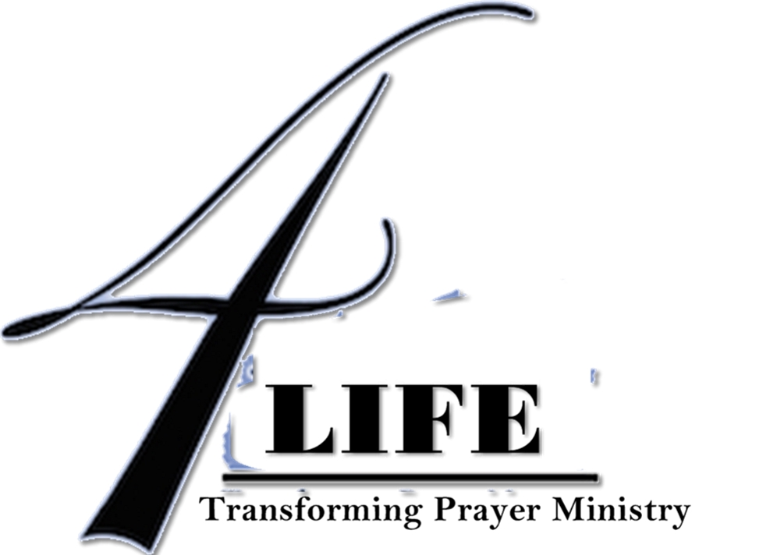

* Small group of 4 – 6
* Weekly application of SOZO tools
* Confidential, Safe, Learning Environment
* Gain more freedom

## USE THE TOOLS

## 8 Week Sozo Intensive

## Sign Up Now

Register now for a Small Group Intensive

$40/8wk session

Due at Registration

Time and Date TBD by the group

GROUPS ARE RUN 4 TIMES/YR

JAN*APRIL*JULY*OCT

Register at [4lifetpm@gmail.com](mailto:4lifetpm@gmail.com) OR

Text (316)650-4301

**Pre-Requisites:**

*You need to have had a sozo prior to being in this group

*Been to a Basic Training OR watched the Basic DVD’s

Small Group Intensive

**www.4-LIFE.US**

SOZO INTENSIVE

Designed for those who want a regular use of the Sozo tools, while at the same time bringing healing. Experience an environment where questions are answered as we go. Everyone benefits from the healing power of GOD in these sessions.

This group experience requires all participants to be present to obtain the fullest value. Thus an up front commitment and fee is due prior to the group beginning.

4-Life Transforming Prayer Ministry

Beginning September 2015