Watershed Report Card
& Goals 2015

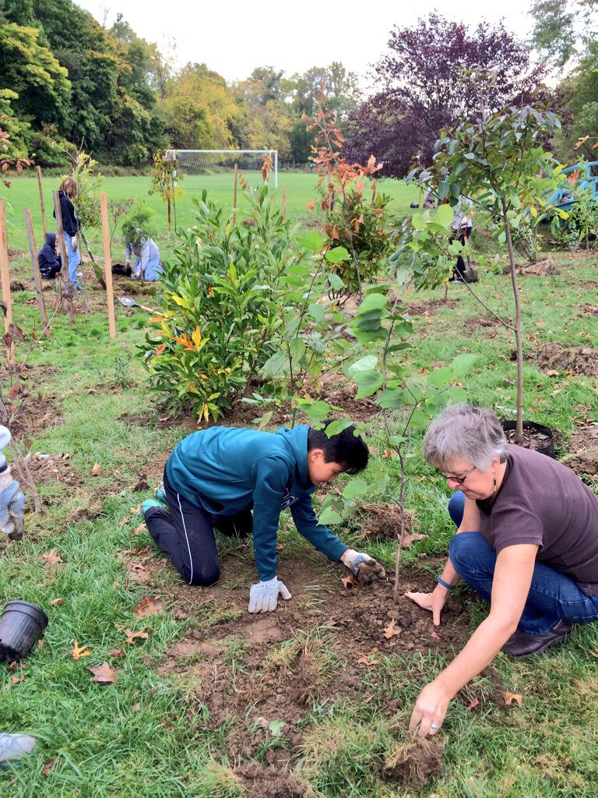

October 22, 2015

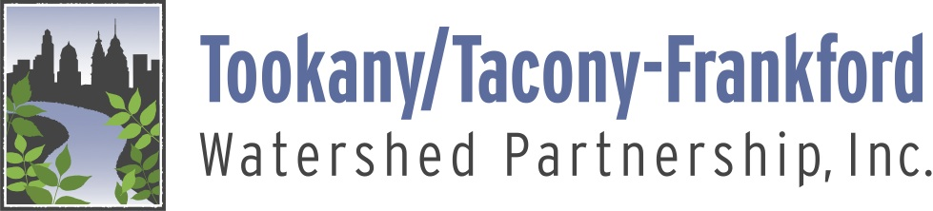

Introduction

The Tookany/Tacony-Frankford Watershed Partnership was founded in 2000. We have developed this Report Card & Goals 2015 to review progress and efforts underway, and to recommend strategies for continued watershed improvement. This report includes a summary of:

- Watershed Planning
- Municipal Policies
- Progress to Date
- Proposed Goals & Strategies.

In addition, this report includes a watershed Map, and information on Municipal Polices and Upstream Projects.

Thank you to the TTF Planning & Policy Committee for reviewing and providing input, and to the municipalities for providing information.

TOOKANY CREEK WATERSHED

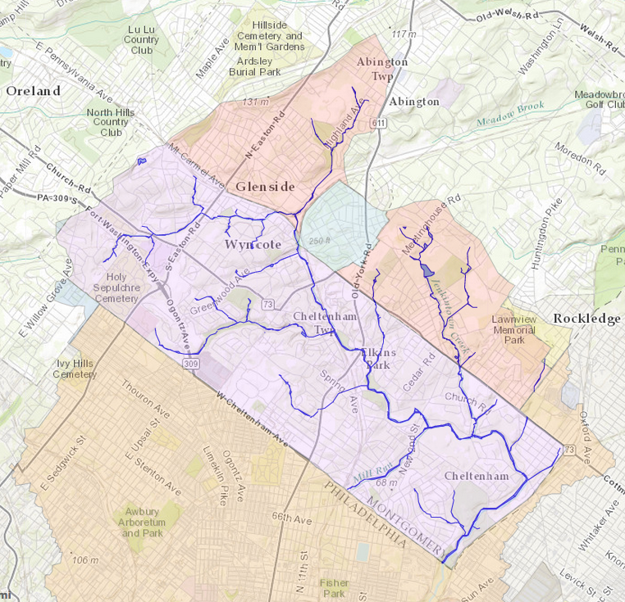

The Tookany Creek Watershed is the upstream portion of the Tookany/Tacony-Frankford Watershed. It includes the headwaters of several named and unnamed tributaries as well as the Main Stem of the Tookany Creek in five Montgomery County municipalities: Abington, Cheltenham, Jenkintown, Rockledge, and Springfield.

Watershed Report Card & Goals 2015
Tookany/Tacony-Frankford Watershed Partnership

Introduction
The Tookany/Tacony-Frankford Watershed Partnership (TTF) has undertaken a review of progress towards restoring the Tookany Creek, its tributaries and the riparian environment over the past 15 years. The upstream area of our watershed in Montgomery County has been the focus of study and planning during this time, as well as being part of a number of federal, state and local policy initiatives. In addition, creek restoration efforts have been ongoing as a result of these initiatives. Of course, the challenge for all of our communities is the budgetary reality of a lack of funding to support these plans.

The health of the Tookany Creek has been of concern to its communities for decades. Like many of our region’s watersheds, the loss of tree cover and natural floodplains along the streams, together with uncontrolled runoff, has led to severe degradation of the water quality in the Tookany Creek and its tributaries. Every section or “reach” of the Tookany Creek and its tributaries has been listed as “Impaired” by the Pennsylvania Department of Environmental Protection (PADEP). Habitat loss and fragmentation have been widespread. Periodic flooding has led to millions of dollars in property damage.

Over the past 15 years, the six watershed municipalities, together with their partners, have invested significant time and resources to begin to reverse this deterioration and restore the health of the Tookany watershed. TTF was founded in 2000 by the Philadelphia Water Department, Cheltenham Township, and the Pennsylvania Environmental Council to serve as the catalyst to bring municipalities, environmental organizations and other stakeholders together to protect, enhance, and restore the beneficial uses of the waterways and riparian areas. TTF became a non-profit organization in 2005 and has since played a vital role in education, stewardship, restoration and advocacy across the watershed.

Two significant efforts will strengthen TTF’s role and effectiveness in working with its municipalities and stakeholders to improve our watershed: our inclusion in the William Penn Foundation’s Delaware River Watershed Initiative (DRWI) as a member of the Upstream Suburban Philadelphia Cluster and Pennsylvania Department of Environmental Protection (PA DEP) increased oversight and more stringent requirements for Municipal Separate Storm Sewer System
(MS4) programs including the development of Pollution Reduction Plans. TTF has an excellent opportunity to strengthen its role as the convener of municipal partners around overall watershed issues and the implementation of these varied plans.

This review asks: How is the Tookany Creek doing? What level of progress is being made? What efforts are underway or gearing up? What remains to be done? It presents a summary of work in three areas: Watershed Planning, Municipal Policies, and Progress to Date. It concludes with recommended Priorities and Strategies designed to bring about significant and comprehensive improvements to the watershed over the coming years.

Watershed Planning
Upstream Planning
From 2000-2003, upstream communities, led by Cheltenham, developed the Tookany Creek Watershed Management Plan TCWMP), funded through the Pennsylvania Department of Conservation and Natural Resources (DCNR) River Conservation Program and PA DEP’s Coastal Zone Management Program. This planning process brought together the 4 suburban municipalities and multiple other stakeholders, and led to the development of overall Management Options and Goals to guide watershed restoration. Each municipality also developed its own implementation strategy. The TCWMP was an action plan designed to begin the long process of comprehensive creek restoration in the Tookany watershed. The plan has served as the primary blueprint for subsequent efforts by these municipalities to improve the watershed in their communities.

The stated Goals for Implementation of the TCWMP are:
- Improve the Health of the Riparian Corridor Area
- Enhance Recreation Opportunities and Economic Development
- Develop Public Outreach and Education Programs
- Develop and Implement Land Acquisition and Preservation Strategies
- Improve Watershed Communication

Watershed-Wide Planning
The Philadelphia Water Department (PWD) pursued extensive additional studies within the entire watershed over the same time period and beyond. The Tookany Creek becomes the Tacony-Frankford Creek in Philadelphia, flowing into the Delaware River south of the Betsy Ross Bridge. Philadelphia draws about 70% of its drinking water from the Delaware River. The city also contributes extensively to pollution in the creek through direct runoff and Combined Sewer Overflows (CSOs) from its overburdened Combined Sewer system.

PWD completed a Comprehensive Characterization Report (CCP) in 2005. This report was an in-depth look at water quality, geo-morphology, and the habitat of the entire creek system. PWD also completed the Tookany/Tacony-Frankford Integrated Watershed Management Plan (TTFIWMP) in the same year, incorporating recommendations of the upstream TCWMP and the deeper analysis provided by the CCP into a broader, 20 year plan for restoring the entire watershed through targeted, coordinated investments by all the municipalities. This Integrated Plan is one of the principal components of Philadelphia’s Long Term Control Plan submitted to the U.S. Environmental Protection Agency and DEP in 2011.

The Green City Clean Waters program is Philadelphia's Long Term Control Plan to reduce stormwater pollution currently entering our Combined Sewer System through the use of green infrastructure. CSO is the primary source of pollution flowing into the Tacony and Frankford Creek portions of the watershed. The plan focuses on managing stormwater runoff, which cause the overflows. Through the green infrastructure approach, the city will reconnect many urban neighborhoods to restored stream corridors, and transform large areas of vacant and underutilized land into new open space and sustainable development projects.

Green City Clean Waters has led to extensive use of many varying green stormwater technologies that could be used successfully in upstream areas. This comprehensive, innovative strategy has accelerated the understanding of best solutions for many challenges occurring throughout the watershed. It has also spurred the growth of an experienced contractor and consultant base. The Philadelphia model is thus a valuable resource for upstream communities.

It is important to note that the implementation of Green City Clean Waters will also eventually resolve the combined sewer impact on Rock Creek, which will lead to water quality improvements in this creek and further downstream.

Both the TCWMP and TTFIMP are key documents for upstream communities. One question is the extent to which upstream municipalities rely on these plans to guide their restoration strategies. DCNR periodically makes implementation grant funding available for communities and watersheds that have completed a River Conservation Plan such as the TCWMP. Cheltenham Township has been especially active in pursuing these, as well as PA DEP Growing Greener grants for streambank restoration and repair/replacement of sewer infrastructure.

Delaware River Watershed Initiative
Our watershed will benefit from the Delaware River Watershed Initiative’s expansive monitoring program to assess water quality and project impact. Researchers from the Academy of Natural Sciences as well as Villanova and Temple Universities, and TTF staff and citizen scientists regularly gather data to measure the impact of water quality investments. In addition, PWD’s ongoing monitoring efforts will be a source of valuable information for tracking progress.

Municipal Policies
Since 2000, upstream municipalities have taken significant steps forward in adopting new Municipal Codes and policies. (Refer to Municipal Policies) They have been active in updating their municipal codes, driven primarily by the need to comply with State and Federal requirements, but also responding to the local priority to protect and enhance their watersheds. The three primary areas for these updates are Act 167 Planning, MS4 programs, and Land Use code changes. All three areas were included in TCWMP recommendations.

Funding through the Delaware River Watershed Initiative to support a planner has enabled TTF to provide qualified input to our municipalities as they consider code updates as well as to comment on the impact of development proposals on watershed health.

Act 167: Stormwater Management Planning and Ordinances
Pennsylvania has mandated watershed-level planning for stormwater management through the Act 167 program. In 2007, PWD contracted for the preparation of an Act 167 Plan for the Tookany/Tacony-Frankford watershed. The plan was coordinated with Abington, Cheltenham, Jenkintown, Rockledge and Springfield, and was adopted by Montgomery County. The plan sets standards for controlling development runoff, promoting infiltration, and protecting water quality and includes a model stormwater ordinance.

Between 2010 and 2014, the plan and the related Stormwater Management Ordinances were subsequently adopted by all of the upstream municipalities and the City of Philadelphia. The ordinances typically appear as the Stormwater Management Ordinance (or Watershed Stormwater Management Ordinance in Cheltenham) in each municipal code. This has created a coordinated mechanism to ensure that new development and redevelopment throughout the watershed will not exacerbate stormwater runoff. The stormwater management ordinances enacted by each municipality also enable them to regulate development to promote groundwater recharge, habitat preservation, and low impact development.

MS4 Program (NPDES permits)
The TCWMP was developed at the same time as PA DEP itself was implementing (under an EPA mandate) new stormwater regulations that became effective in 2003, affecting all of the upstream communities. These municipalities were required to have a permit for discharge of stormwater into waterways and to develop an MS4 program (Municipal Separate Storm Sewer System) with specific control measures and benchmarks for improvement in managing and cleaning stormwater discharges. The 6 Minimum Control Measures lay out specific strategies to be implemented over the course of the 5-year permit duration. All of TTF’s municipalities received their first permit in 2003; these were extended thorough 2012, and then renewed for 5 years in 2013.

Many municipal actions are driven by requirements to comply with MS4 program permit requirements. Major steps forward were made in the early permit years, including mapping of stormwater infrastructure, identification of polluted outfalls, post-construction stormwater management for new development, and development of education and outreach plans. In many respects, the MS4 program requirements have received more focus in the past 12 years than implementation of the TCWMP, with significant overlap between the MS4 program and the plan.

Land Use/Development Codes
The municipal codes regulating land development are critical components of a proactive approach to watershed improvement. Jenkintown updated its Zoning Code in 2010. Both Abington and Cheltenham have undertaken comprehensive updating/revision process of their Zoning Codes over the past several years. As of this date neither of these communities have finalized and adopted new codes. The draft updated codes vary, but all reflect additional protection of sensitive environmental features, incorporation of additional greening, cluster development that preserves open space, etc. Cheltenham’s zoning code includes the Riparian Corridor Conservation District (2013) and Abington’s proposed code revision includes a comparable overlay. Steep slope areas also receive protection in these codes, but none specifically protect headwaters and wetlands as a separate feature.

The Subdivision and Land Development Ordinance (SALDO) is the other major piece of the municipal code which impacts development within the watershed. Only Rockledge and Springfield have implemented major SALDO updates since 2000. There is significant lack of coordination in the other communities between the SALDO and other code provisions, especially the Stormwater Management Ordinance and the Zoning Code. Updated SALDOs can ensure that the design and implementation of development projects will minimize impacts on streams, vegetation, and other natural features, and that projects meet overall community goals.

Additional measures enacted or being considered by municipalities include:
- Enhanced tree and habitat protection measures
- Cluster ordinances and other Zoning Code measures to guide sustainable, lower impact development.
- Incentives to increase sustainable features in developments, including green stormwater management.

Progress to Date
TTF’s upstream municipalities have taken significant steps forward to begin to implement watershed improvements, and to better regulate impact on the creeks and overall watershed. These overall efforts to date are only the beginning steps in reversing the severe damage to the watershed that occurred over the past 300 years. Restoration of the Tookany Creek and its tributaries will involve complex strategies and extensive coordination, as well as significant capital investment and continuing policy improvement over the coming decades.

Most of the municipal action taken so far has been driven by State and Federal regulations, especially the MS4 program and Act 167. The issue of funding is of course a serious concern for our upstream communities. Controlling and managing flooding is another of the top priority issues driving investment in upstream communities, especially Cheltenham and Abington. Replacement of deteriorating sanitary sewer infrastructure has become one of the most costly of these issues related to regulatory compliance. It is thus of critical importance to consider these additional issues in future planning for coordinated watershed restoration.

Municipal Coordination
Currently, there is a lack of comprehensive coordination among our upstream municipalities around implementing watershed improvement. Cheltenham, Abington and Jenkintown coordinate wastewater flows and treatment with the City of Philadelphia through a contractual agreement. However in terms of restoration, implementation of stormwater control measures and other key opportunities, each municipality appears to follow its own local priorities and respond to DEP mandates separately.

The TCWMP planning process was led by a Steering Committee of community representatives from Cheltenham, Abington, Jenkintown and Rockledge, plus the Montgomery County Planning Commission, Montgomery County Conservation District, PWD and PECO. Municipal staff also participated in and supported the work.

The establishment of TTF was a critical strategic step to ensure that an organization would take the lead and adopt the plan as its blueprint for action. Additionally, TTF serves as the agent for communication about the impact upon the watershed of the Green City Clean Waters plan, and its use of green stormwater infrastructure to improve water quality by managing runoff.

Through a variety of programs, including tours of green stormwater features targeted at local stakeholders, TTF has begun to educate upstream policy makers about the benefits and costs of green stormwater infrastructure. In fact, an upcoming rain garden project along East Baeder Creek on the grounds of the Abington Junior High School was conceived by the Abington School District Director of Facilities after participating in a TTF tour.

TTF’s participation in the unprecedented DRWI as a member of the Upstream Suburban Philadelphia Cluster is a milestone step in facilitating efforts to improve the TTF watershed. In addition to supporting a planner and a water quality monitoring program, it connects TTF to scientific institutions for support including The Academy of Natural Sciences of Drexel University, Temple University Center for Sustainable Communities, and the Villanova Urban Stormwater Partnership.

Through this program, TTF has secured its first significant funding for stream restoration and green stormwater infrastructure from the National Fish and Wildlife Foundation for projects along the Jenkintown Creek in Abington. Four projects have been funded – at Abington Friends School, the Sisters of Saint Basil the Great, Abington Monthly Meeting, and McKinley Elementary School.

TTF has an excellent opportunity to strengthen its role as the convener of municipal partners around overall watershed issues and the implementation of these varied plans.

Water Quality
It will take many years to see measurable results in water quality. Several large-scale infrastructure projects, if successfully implemented, will have a positive impact on water quality. These include: sewer interceptor replacement and lining in Cheltenham and Abington; ongoing Infiltration and Inflow work throughout the joint public sewer systems serving these municipalities; sewer lateral and roof drain connection inspections and corrections; the Army Corps of Engineers flood control project, if approved and constructed, may reduce streambank erosion and streambed scouring, leading to improved water quality along much of the Main Stem. In addition, increased pollution reduction requirements in Pennsylvania’s MS4 permits are designed to help restore and repair existing problems.

Riparian Corridor Improvements
Over the past 15 years, there has been significant progress in this area. (Refer to Upstream Projects) Much more remains to be done to extend these improvements and restore stream health. TTF itself has planted buffers along almost 1,500 lineal feet of stream, totaling 54,000 square feet on park, school, and residential properties. Last fall, TTF implemented an exciting model residential buffer program, planting buffers on the creekside properties of 5 Cheltenham homeowners.

- Cheltenham has pursued streambank stabilization and rebuilding along the Tookany Main Stem as one of its primary strategies. Since 1999, the township has invested over one million dollars in grant funds and township capital in restoration projects on thousands of linear feet of streambank, primarily using log sills with native plantings. This work has been concentrated on the 2.5 mile Tookany Creek Greenway and Trail, at High School Park, and around Ralph Morgan Park. The projects have had varied success.

- TTF has worked with Cheltenham Township and the School District as well as the Abington School District, and Cheltenham has worked on its own and through its EAC to plant riparian buffers along tributary streams and the Tookany Main Stem. However, there are still hundreds of private and institutional properties with creeks that could benefit greatly from riparian plantings.

- Cheltenham received grant funds for the construction of a wet pond bio-filtration system for its leaf-recycling yard, at the headwaters of the Upper Tookany.

- TTF is moving forward with the Jenkintown Creek restoration projects mentioned above as part of its first tributary restoration strategy.

Stormwater Management Improvements
Stormwater management improvements to date have primarily come through stormwater permitting requirements that impact all new development and redevelopment activities. These requirements have become more stringent with the adoption of the Act 167 Plan and stormwater ordinances. The greatest positive benefit for stormwater management has come through school construction, private development, and limited institutional construction activities.

However, the majority of the upstream watershed is built-out, so there are no major opportunities for stormwater improvements through new construction and redevelopment alone. Municipalities have not invested substantially in retrofitting existing infrastructure, such as street and parking lot drainage, or roof runoff. The MS4 requirements since 2003 have not mandated any specific reductions of stormwater volume, even though stormwater is the primary cause of the impairment of the creeks. Since there is no TMDL for the Tookany Creek, municipalities are currently only required to implement the 6 Minimum Control Measures, not an actual pollution reduction plan with targets for volume reduction. Funding such infrastructure projects is a continual challenge for municipalities, especially without an ongoing, dedicated funding source for projects.

PA DEP recently proposed increased oversight and the imposition of more stringent requirements for the MS4 programs for the next round of permits (2018). According to the proposed regulations, upstream communities will now be required to develop Pollution Reduction Plans (PRPs) that will incorporate strategies to reduce stormwater impacts from the existing system over the life of the permit.

Proposed Goals and Strategies
As TTF moves into our next decade of work in the watershed, we recommend the following strategies to increase the pace and scope of watershed improvement.

- Support municipalities through the establishment of a municipal task force to:
- Promote increased opportunities for collaboration and coordination among municipalities for improvements and financing
- Review progress and identify opportunities for green stormwater infrastructure and stream restoration
- Assist with the adoption of funding mechanisms for stormwater management projects
- Assist with the development and implementation of municipal MS4 programs including the development of pollution reduction plans and the public input process.

- Develop and pursue a comprehensive tributary strategy to target restoration efforts and funding, and to partner with both private and public creekside stakeholders.

- Provide input to the process of updating land use codes to consistently guide development that protects streams, wetlands and other natural features, while reducing stormwater flow.

- Build upon successful education and outreach strategies to develop a comprehensive watershed communications plan.

TTF Watershed Report Card– Municipal Policies
Policy or Code | Abington | Cheltenham | Jenkintown | Rockledge | Springfield | Philadelphia
Act 167 Plan Adoption for TTF Watershed | Yes – 2014 | Yes - 2010 | Yes - 2011 | Yes – 2013 | No – pending (Wissahickon) | Yes - 2008
LID (Low Impact Development) recommendations | In Act 167 | In Act 167 | In Act 167, modified | In Act 167 | No | In Act 167 & PWD Stormwater Regulations
Stormwater Permit—NPDES or DEP-13 General Permit | General | General | General | General | General | NPDES & Stormwater
- Date of existing permit | 2013 | 2013 | 2013 | 2013 | 2013  Renewal Anticipated | 2007 & 2005
Zoning Code Revision | Currently Underway | Currently Underway | 2010 | 1990 | Reaffirmed 2007 | 2012
SALDO- last major update | 1991 | 1974 | 1970 | 2005 | 2007 | 2012
Riparian Buffer Protection-  Municipalities implementing the Pennypack Act 167 Plan require planting of a 50’ native buffer in all development where a stream crosses the property. | Stormwater Ordinance for both TTF and Pennypack | Zoning Overlay- applies to streams on the official map for the ordinance | Stormwater Ordinance for both TTF and Pennypack | Stormwater Ordinance for both TTF and Pennypack | No | Philadelphia Zoning Code. § 14-704(5)
Riparian Buffer Width | 50’  (75’- proposed overlay) | 100’ | 50’ | 50’ | NA | 50’
Steep Slope Protection | Zoning Overlay | Zoning Overlay | No | No | No | Zoning Code
Woodlands Protection | Proposed zoning ordinance has increased protection in landscaping section | Tree ordinance strong limits on tree removal in development | N/A | Minimal protection of mature trees in development of Tree Code |  | Zoning Code contains strong limits on heritage tree removal. Also contains provisions for park & watershed parks.
Headwaters/ wetlands protection | Recommended in Open Space and Comp Plans, not in Zoning Code | Only through riparian buffer overlay leaves gaps | No | No | No
Floodplain Ordinance | Zoning- Conservation District | Zoning- Conservation District | Zoning- Conservation District | No, some provisions in SALDO | Zoning- Conservation District | Philadelphia Code  §14-1606 & further defined in Zoning Code.
Pet Waste Ordinance | Yes | Yes | Yes | Yes | Yes | Yes

TTF Watershed Report Card- Upstream Projects 2000-2015
Property | Stream/River | Location | Municipality | Project Type | Length (ft.) | Area (s.f) |  | Project Sponsor | Year Completed
Copper Beach Elementary School | West Baeder Creek | 825 Easton Road Glenside | Abington | Retention basin |  |  |  | Abington School District | 2002
Tookany Creek Park | Tookany Creek | Intermittent sections from Ralph Morgan Park through Central Avenue | Cheltenham | Bank stabilization, invasive removal and replanting | 6400 |  |  | Cheltenham Township | 2003-2008
Waverly Road Composting Facility | Tookany Creek | Waverly Road | Cheltenham | Bioretention and bioinfiltration |  | 35,000 |  | Cheltenham Township | 2006
Grove Park | Unnamed Tributary | Lynwood Avenue Glenside | Cheltenham | Riparian buffer |  | 3,000 |  | Cheltenham Township | 2006
Curtis Arboretum | Rock Creek | Between Serpentine Lane and Widener Road | Cheltenham | Riparian buffer | 600 | 15,000 |  | Cheltenham Township | 2006
Wall Park | Tookany Creek | 600 Church Road Elkins Park | Cheltenham | Riparian buffer |  | 12,000 |  | Cheltenham Township | 2007
Ralph Morgan Park | Tookany Creek | Glenside Ave near Jenkintown Train Station | Cheltenham | Riparian buffer |  | 6,000 |  | Cheltenham Township | 2007
Parry Bird Sanctuary | Tookany Creek | Chelten Hills Drive Elkins Park | Cheltenham | Riparian buffer |  | 15,000 |  | Cheltenham Township | 2008
Perley Bird Sanctuary | Tookany Creek | Glenside Ave. and Rice’s Mill Road, Glenside | Cheltenham | Riparian buffer |  | 12,000 |  | Cheltenham Township | 2008
Glenside Elementary | Tookany Creek | Limekiln Pike, Glenside | Cheltenham | Riparian buffer | 200 | 10,000 |  | TTF | 2009
Coventry Park | Mill Run | Coventry Avenue and New Second Street | Cheltenham | Riparian buffer | 400 | 10,000 |  | Cheltenham Township | 2010
Cedarbrook Middle School | Rock Creek | Below Ogontz Avenue | Cheltenham | Riparian buffer | 125 | 8,000 |  | TTF | 2011
Glenside Elementary School | Tookany Creek | Limekiln Pike Glenside | Cheltenham | Storage and infiltration galleries, bioretention basin, pervious paving. |  |  |  | Cheltenham School District | 2011
Property | Stream/River | Location | Municipality | Project Type | Length (ft.) | Area (s.f) |  | Project Sponsor | Year Completed
Parkview Park | Unnamed Tributary | Melrose Park | Cheltenham | Riparian buffer | 2000 | 90,000 |  | Cheltenham Township | 2011-2014
Abington Junior High School | East Baeder Creek | Susquehanna Road Abington | Abington | Riparian buffer | 650 | 24,000 |  | TTF | 2011, 2013
Rock Lane Park | Rock Creek | Rock Lane, Serpentine Lane to Widener Road | Cheltenham | Riparian buffer | 500 | 12,000 |  | TTF | 2014
Backyard Buffer A | Leech's Run | 1424 Juniper Avenue | Elkins Park | Riparian buffer | 50 | 750 |  | TTF | 2014
Backyard Buffer B | Mill Run | 7222 Chestnut Street | Melrose Park | Riparian buffer | 75 | 1,875 |  | TTF | 2014
Backyard Buffer C | Tookany Creek | 327 Hewett Road | Wyncote | Riparian buffer | 50 | 750 |  | TTF | 2014
Backyard Buffer D | Tookany Creek | 313 Oak Road | Glenside | Riparian buffer | 50 | 750 |  | TTF | 2014
Backyard Buffer E | Tookany Creek | 534 General Pattison Drive | Glenside | Riparian buffer | 150 | 2,750 |  | TTF | 2014
Arcadia University GSI | Tookany Creek and unnamed tributary | Multiple sites on campus | Cheltenham | Bioinfiltration, rain garden, retention and infiltration galleries, porous pavers |  |  |  | Arcadia University | 2005-2015
Sisters of St Basil Property | Jenkintown Creek | Fields at corner of Fox Chase and Cedar Roads | Abington | Woodland restoration, stormwater detention, bioinfiltration swales trenches in pastures |  | Several acres | Montgomery County Conservation District, NCRS |  | 2015
Abington Junior High Rain Garden | East Baeder Creek | Junior High property, adjacent to Buffer Phase I | Abington | Rain garden to treat driveway runoff |  | 2,000 | TTF |  | To be installed fall 2015
Property | Stream/River | Location | Municipality | Project Type | Length (ft.) | Area (s.f) | Project Sponsor |  | Year Completed
JENKINTOWN CREEK TRIBUTARY INITIATIVE
Sisters of St Basil property | Jenkintown Creek | Behind Convent property on Fox Chase Road | Abington | Parking lot bioinfiltration, riparian buffer |  | .4 acres | TTF |  | To be installed fall 2015
Abington Friends School | Jenkintown Creek | Abington Friends School property north of Meetinghouse Road | Abington | Riparian buffer and rain garden | 500' buffer | .35 acres -rain garden | TTF |  | Buffer planted fall 2014. Rain garden fall 2015
Abington Monthly Meeting | Jenkintown Creek | Abington Meeting property north of Meetinghouse Road, below AFS | Abington | rain garden, meadow planting, bioinfiltration | 350' of streambank |  | TTF |  | Funded by NFWF for 2016
Ethel Jordan Park | Jenkintown Creek | Jenkintown Road between Cadwalader and Osceola | Abington | Riparian Buffer, park tree planting | 350' of streambank | 10,500 sf of buffer | TTF |  | 2015
McKinley Elementary School | Jenkintown Creek | Rear of school property | Abington | Bio-engineered bank stabilization, construction and rehabilitation of vernal ponds, riparian planting | 300' of streambank | 20,000 sf project area | TTF |  | Funded by NFWF for 2016

