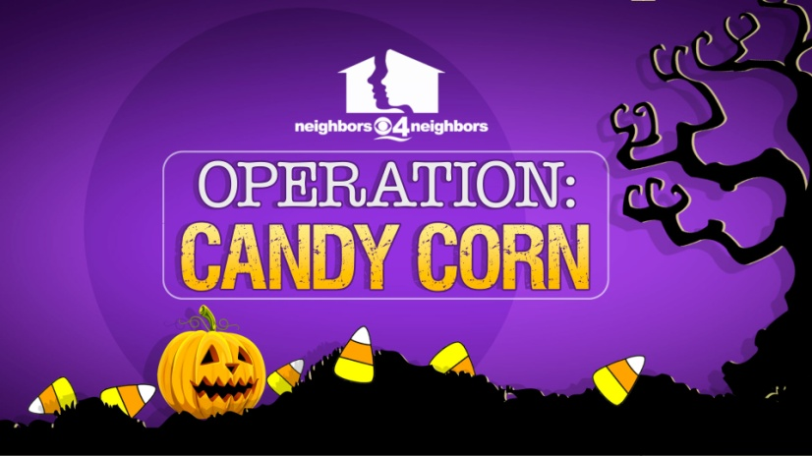
Halloween Costume Drive
2015
DONOR FORM

Date_____________________________________

Name_____________________________________________________________________

Company/Agency___________________________________________________________

Address___________________________________________________________________

City State Zip______________________________________________________________

Phone_______________________________Mobile________________________________

Email_____________________________________________________________________

Any idea what age group most of your costumes will fit? _______________________________________________

If you can deliver the costumes, it is greatly appreciated by our nonprofit partners who have limited resources. However, we do have partners with that capability, so just call us at 305-597-4404, if you need pick up. We will always try to match you with a nearby partner.

We will contact you to let you know which of our non-profit agencies we have matched you with so you can contact them directly to deliver your costume collection.
How would you prefer to be contacted email or phone?_____________

