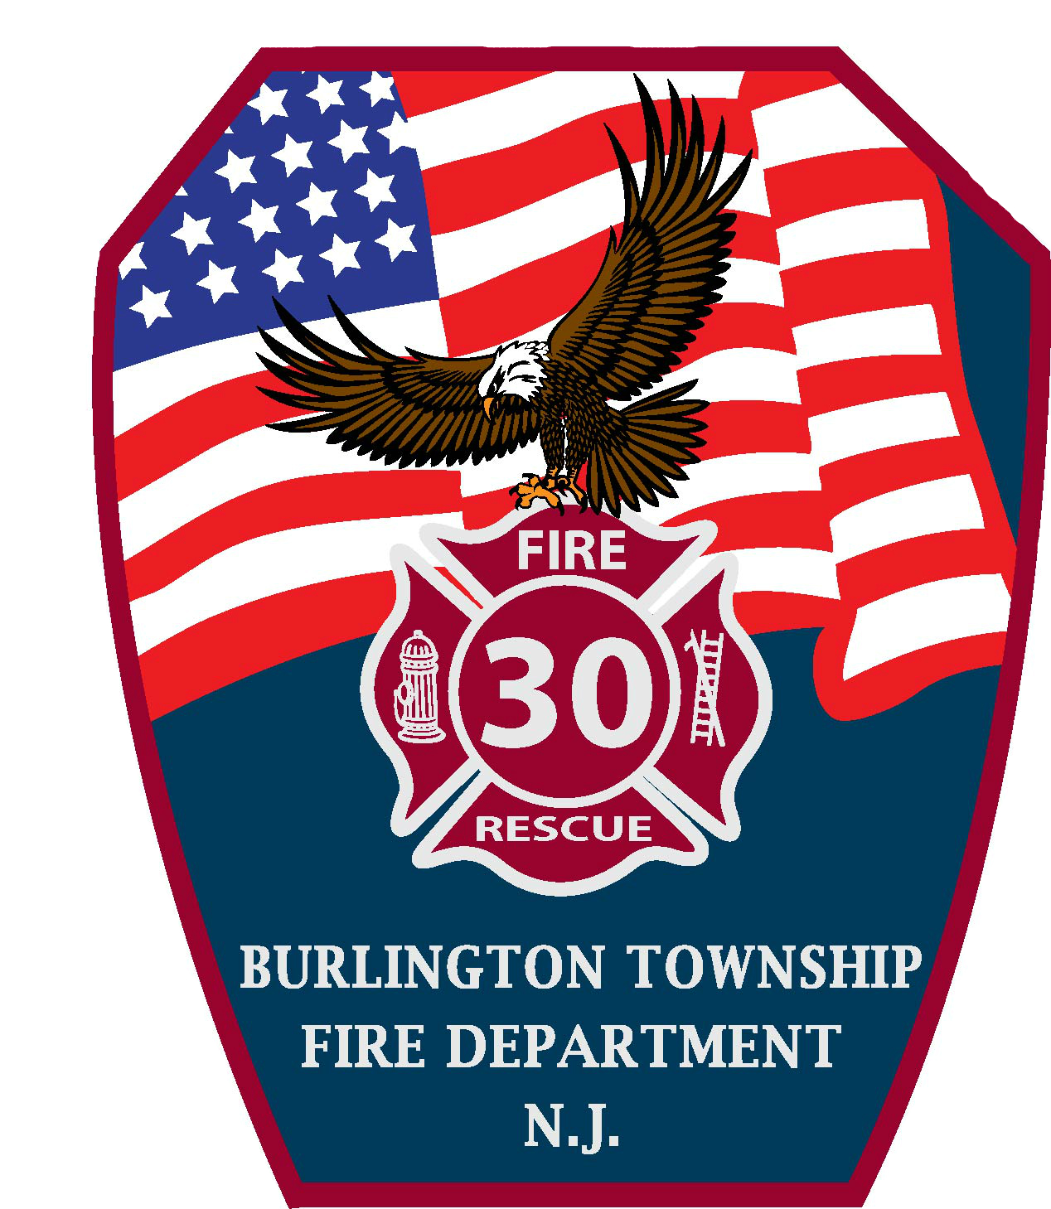 | Burlington Township Fire Department  1601 Burlington Bypass Burlington Twp., NJ 08016  www.btfd.org www.btfireprevention.org  Office: 609-239-5850 Fax: 609-386-0008

PERMISSION SLIP
BURLINGTON TWP EMERGENCY SERVICES SAFETY CAMP

I hereby give permission for my child, _______________________________ to participate in the Burlington Twp. Emergency Services Safety Day Camp on Friday, July 10 and Saturday, July 11, 2015. I understand that as a participant in the program, my child must be at the Independent Fire Station (1601 Burlington Bypass) by 8:00 am on Friday, and we will be departing the Station at 8:30am en route to the Burlington County Fire Academy located in Westampton. We will release your child back at the fire Station at 4:00pm. On Saturday my child must be at the YMCA of Burlington (302 Commerce Square Blvd, Burlington City) by 8:15am and will be released by 1:00pm at Beverly Road Fire Company (1001 Beverly Rd.).
My child and I understand that this is an orderly, structured program and in addition to classroom instruction there will be various activities involving light exercise. Participants will wear the Safety Camp T-Shirt provided to them, along with sneakers and comfortable clothing for the time of year. The Safety Camp will be held at a working fire station and fire academy with volunteer personnel preparing for emergencies in Burlington Township. With this in mind, courteous behavior and cooperation from the participants are mandatory. My child and I understand that disorderly behavior will not be tolerated and may result in dismissal from the Safety Camp. PLEASE REMEMBER TO PACK A LUNCH FOR FRIDAY and we will provide the snacks. ALSO REMEMBER TO BRING YOUR BICYCLE AND HELMET TO THE YMCA ON SATURDAY.

In order to prepare for your child’s participation in our Safety Camp, we will require some additional information, which includes:
Name of Participant (please print): __________________________________________ Male/ Female

Name of Parent of Guardian: _________________________________________________________

Relationship to Participant: __________________________________________________________

Signature of Parent: ________________________________________________________________

Home Phone# : _________________________________ Emergency # _______________________

e-mail address : _______________________________________________

Address: _________________________________________________________________________

Signature of Participant: _____________________________________________________________

Medical conditions or disabilities: ______________________________________________________

Special dietary needs, if any: _________________________________________________________

How many Family Members will be attending closing ceremonies: ______ (Maximum of 2)

Children’s T-Shirt Size (circle one): S M L XL
* * ALL PERMISSION SLIPS MUST BE RETURNED TO THE MAIN OFFICE NO LATER THAN 6/2/2015 * *

