BURLINGTON TOWNSHIP RECREATION
2015 SUMMER/FALL SPORTS REGISTRATIONS
Mailing Address: 851 Old York Road, Burlington, NJ 08016 Physical Location: 1101 Lake Ave., Burlington, NJ 08016
Phone: 609-387-2775 Fax: 609-387-1109 Email: btrecdept@comcast.net

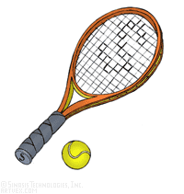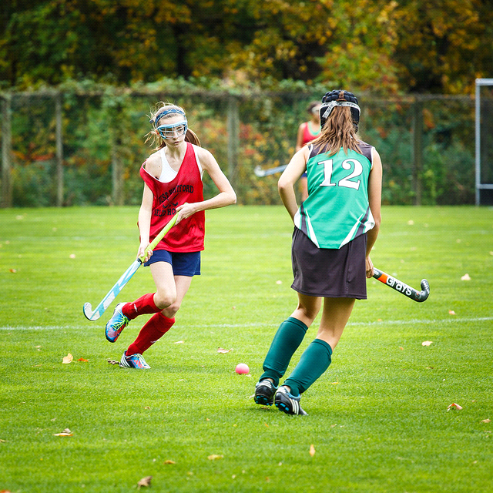
SATURDAYS: APRIL 11th & 25th from 10 AM – 2 PM
(FOOTBALL REGISTRATIONS OPEN ON ARIL 25, 2015 & FORM WILL BE AVAILABLE AT THAT TIME)

Register in person at the Recreation Building, 1101 Lake Ave., on above dates or Monday-Friday 8:30 to 3:30 after April 11, 2015. A drop box is now located at the Rec Office for after business hours, only if the registrant has previously participated in our sports programs and all uniforms/equipment have been returned.
**FIRST TIME REGISTRANTS MUST REGISTER IN PERSON DURING ABOVE HOURS. A COPY OF CHILD’S BIRTH CERTIFICATE &
PROOF OF RESIDENCY ARE REQUIRED.**
*Note: Late registrations could be placed on a wait list.*
NOTE: As of 1/1/09, a registration processing fee will be charged per individual, per program, per season at the time of registration, except for “clinic” programs. Only money orders or checks to “Burlington Twp. Rec. Dept.” will be accepted; NO CASH.
Once the registration is accepted, refunds/credit will only be made in limited circumstances, as defined by policy.

NAME___________________________________________________________________________________
(FIRST) (MIDDLE) (LAST)

ADDRESS_____________________________________________PHONE____________________________

E-MAIL _____________________________________________________________________ SEX________

GRADE (FALL 2015)_______ BIRTHDATE_____________MEDICAL CONDITIONS_______________

PARTICIPATION IS LIMITED TO (2) PROGRAMS PER SEASON, PER CHILD, EXCLUDING CLINIC PROGRAMS.
A CHILD CANNOT REGISTER FOR BOTH FOOTBALL & NON-TRAVEL SOCCER.
*PLEASE NOTE ATTACHMENT WITH PROGRAM DESCRIPTIONS*

SUMMER PROGRAM:
______TENNIS (FEE $30) – AGES 5 TO 15

FALL PROGRAMS:
______AEROBICS (FEE $30) - COED 18+ _______R&B LINE DANCING (FEE $30) – COED 18+
______BASKETBALL (FEE $30) – ADULT 18+
______BABE RUTH (TRAVEL) (FEE $60) – AGES 13 THRU 15 (AGE BY 4/30/16)
______BASEBALL (TRAVEL) (FEE $30) - AGES 9 THRU 12 (AGE BY 4/30/16)
______CHEERLEADING (TRAVEL) (FEE $30) – GRADES 1 THRU 8
______FIELD HOCKEY (TRAVEL) (FEE $30) – KINDERGARTEN THRU 8th GRADE
_____*SOCCER (TRAVEL) - SOUTH JERSEY (FEE $60 after tryouts) - 3RD THRU 8TH GRADE (Born 8/1/2001 to
7/31/2007) *All must register by May 1, 2015 to attend tryouts. No payment needed until after tryouts.*
SOCCER (TRAVEL) – FRIENDSHIP (FEE $30) - 3RD THRU 8TH GRADE (Born 1/1/2001 to 7/31/2007)
SOCCER (NON-TRAVEL) (FEE $30) AGE 5 by 10/1/15 - 5TH GRADE
_____SOCCER CLINIC (NO FEE) – AGE 4 by 10/1/15
_____VOLLEYBALL - YOUTH (FEE $30) - GRADES 6 - 9 _____VOLLEYBALL – ADULT (FEE $30) – COED 18+

SIGNATURE OF PARENT OR LEGAL GUARDIAN:_______________________________________________________
(By Signing This Form You Agree To Return All Equipment/Uniforms Issued for Participation As Soon As The Program Is Completed).
OFFICE USE ONLY
Check or Money Order
#_________________
Amount____________
Date Rec.____________
PARENTS INTERESTED IN: COACH: ______HEAD ______ASST. ONLY
CAN YOUR EMAIL ADDRESS BE RELEASED TO THE BTSC FOUNDATION _____YES _____NO

PLEASE DO NOT RETURN THIS FORM TO SCHOOL

EXPLANATION OF REGISTRATION FEES

The $30.00 registration processing fee is accepted by Burlington Township and is deposited in its general fund for future use as a means of paying for a variety of the Township’s expenses. In 2011, Burlington Township began assessing additional fees for some travel programs due to their ever-increasing costs, namely: Babe Ruth Baseball, Football, South Jersey Soccer, and Basketball. Senior Babe Ruth and High School Age Soccer will also incur additional fees. The money generated from these programs’ fees will be deposited in a dedicated rider account and allocated strictly and specifically for the payment of the officials’ fees associated with those programs, as opposed to being paid from the annual operating budget of the Recreation Commission. For example: If paying a $60 fee for a particular travel program, $30 will go into the general fund and $30 will be placed in the rider account.

SUMMER PROGRAM DESCRIPTION

TENNIS

The program will probably be divided into two age groups: 5-10 and 11-15. The class will run for six weeks starting the second week of July. There will be 1-2 sessions per week.

FALL PROGRAM DESCRIPTIONS

ADULT PROGRAMS

These programs are held two evenings per week starting in September through mid-June: Aerobics (Tuesdays & Thursdays), Basketball (Tuesdays & Thursdays), Volleyball (Mondays & Wednesdays), and R&B Line Dance (Mondays & Wednesdays).

BASEBALL/BABE RUTH - Website: www.leaguelineup.com/btbca

The Fall Baseball/Babe Ruth program will start after Labor Day and consists of three divisions: Minors, Majors, and Babe Ruth. It is strictly a travel program. Children ages 9-12 will play in the Minor and Major Divisions and children ages 13-15 will play in the Babe Ruth Division. Baseball age is used to assemble teams, NOT SCHOOL GRADE. Besides the registration processing fee, participants may incur additional costs (approx. $50-$75 per person) for tournaments, league operating costs (Balls, Umpires, Uniforms, etc.)

CHEERLEADING

The 2015 Cheerleading program will be split into two participation options: a game only team and a game/competition team. Participants will register for cheerleading on the registration form and then make the choice of which team they would like to participate on at a mandatory parent meeting to be held during the Summer. At that time, both subprograms will be described and any questions will be answered. The only team which will vary from these two descriptions will be the 65 lb. cheerleading squad which will do games and two exhibition performances at the Burlington Twp. Friends and Family Night and the High School Cheer Fest. This will expose the 65 lb. squad to both aspects of cheerleading without competing and allow them to make a decision about which team they would like to participate on in the years to follow.
The financial requirements for the 65 lb. squad are the same as the game-only team. The game-only participants will cheer at all regular season and playoff football games. They will do chants, cheers and halftime dances at all games. Participants in this program will be required to purchase crop top, bloomers, and warm-ups, as well as all white sneakers to wear to games. The game/competition participants will cheer at games also and will be required to purchase the items listed under game only participants. In addition to games, these cheerleaders will be learning age appropriate routines which they will perform at competitions. The competition season begins in late October and ends in early December. Children will compete in 2 to 6 competitions. In addition to the game only requirements, competition participants will be responsible for purchasing competition sneakers, cheer bow, and competition socks. They will also need to pay competition and transportation fees. Any questions will be answered at the parent meeting.

FIELD HOCKEY

Field hockey practices will be held two nights per week with games on weekends. Currently, the teams are broken down by Kindergarten - 2nd, 3rd - 5th, 6th, 7th, and 8th grade. The grade level(s) for each team can vary from year to year depending upon the amount of participants for each grade level or the amount of teams per grade level. The Kindergarten - 2nd grade team is designed as more of a developmental program to teach the players the fundamentals of field hockey and the importance of playing as a team. They will play instructional games against other local town programs of similar age and skill level. The rest of the teams compete against other programs in the Burlington County Youth Field Hockey League. Each team will host one home game during the season with the rest of the games being played throughout Burlington County. Participants will need a stick, shin guards, and a mouth guard. Sneakers, turf shoes or cleats can be worn depending upon the type of field. The Recreation Dept. will supply game jerseys, which will be returned upon the end of the season.

SOCCER – Website: http://btsoccer.homestead.com

NON-TRAVEL – This program is designed to teach the basic elements of soccer in a friendly, non-competitive environment. In the Fall, games are typically played on Saturday for the younger ages and Sunday for the older ages. In the Spring, to allow children the opportunity to experience other sports, games are typically played on Sunday for the younger ages and Saturday for the older ages. Practices are once a week. Practice dates and schedules are not available until the start of the season and are set by the availability of the volunteer coaches and field space. Special requests are not taken. Shin guards are required to participate. The Fall program for 4 year olds will be an instructional program with skills, drills, and small-sided games. We hope this format will help these young players develop their skills and knowledge of soccer while having some fun. The Clinic is held once a week for a 4 to 5 week period, usually starting towards the end of September.

TRAVEL - The Burlington Twp. Soccer Coaches Assoc. (BTSCA) helps implement the Township’s travel soccer program and believes that all participants should have fun while learning the game. To maximize opportunities to learn, the BTSCA supports two variations of travel soccer:
Friendship League – Local recreational league play between towns primarily along the Delaware River or the Mt. Laurel/
Medford area.
Travel League Soccer:
Soccer through large regional leagues including South Jersey Soccer, MAPs, JAGs, etc.
Competitive play with higher and lower ability levels.
In addition to the registration processing fee, participants may be responsible for the following additional fees: uniforms ($30 and up) and tournaments ($25 and up).
*Note: Registrations for tryouts close on May 1, 2015. Tryouts will take place the week of May 4 or May 11 (dates subject to change). A child will not be allowed to tryout if not registered through the Recreation Dept.

VOLLEYBALL – YOUTH

This program is held two evenings per week starting in September through November.

INTERESTED IN COACHING? - Anyone interested in being a coach or assistant coach must obtain a “Concussion Certificate” either through the National Federation of High Schools at: http:www.nfhslearn.com/electiveDetail.aspx?courseID=15000 or the Center for Disease Control and Prevention at: http:www.cdc.gov/concussion/HeadsUp/online_training.html

**Would you like up to date information from the Recreation Dept. (i.e. field closures, registration date reminders, and Saturday hours), Police Dept., and Twp. of Burlington? If so, please log on to www.twp.burlington.nj.us and put in your email address to be added to the list.**

Want more information on the new Burlington Twp. Sports Club Foundation? Log on to: www.btscf.com Meetings are held at 7 pm at the Sylvan Lake Building Meeting Room.

