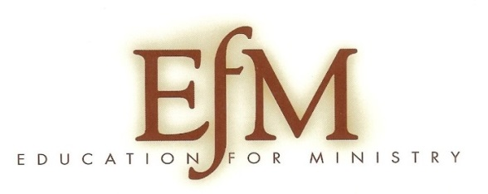

EfM Reunion
March 26, 2015
12:00 pm to 2:30 pm
“The Sanctuary” St. Matthews, 20 Union Street, Hallowell

An invitation for New EfM Participants and Graduates to come and share your journey, where you are, where you would like to go next in your Ministry.
For those who have not seen the new materials that we are now using, I will have copies on hand, And, we will do a new format of Theological Reflection together!
A soup and bread luncheon will be provided.
Please rsvp at this link: https://www.surveymonkey.com/r/T35GRS6
Or email me at patriciawelton@gmail.com.
Looking forward to meeting you!
Go in peace! To love and serve the Lord!

Patricia Buck-Welton
EfM Coordinator
Diocese of Maine

