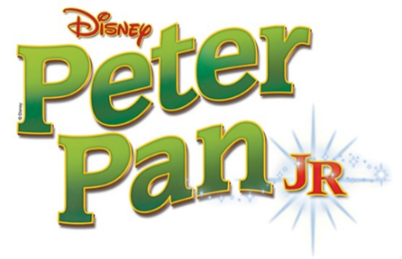
Fauquier Community Theatre
2 Week Musical Drama Camp
Culminating in a final production
Ages 8-15
Directed By Ken Wayne
June 20 - July 1, 2016
9:30 AM – 2:30 PM

Please fill out this form and mail it in with your registration fee made payable to FCT. This camp is first come, first served. You will receive an email confirming the receipt of your registration. All campers will have a part in the production and will receive a Peter Pan Show Tshirt. The final production of the show that the campers will work on for the 2 weeks will be held Friday, July 1 at 7:00 pm. The admission to the performance is free.

Name of Participant________________________________________________________________________
Gender and Age of Participant____________________________________________________________

T- Shirt Size (Please circle) ------ YS, YM, YL, AS, AM, AL, AXL

Parents Names_____________________________________________________________________________

Best Email(s) to Use________________________________________________________________________

Best Phone Number(s) to Use_____________________________________________________________

Mail Form and Check to:

FCT
Musical Drama Camp
PO Box 3046
Warrenton, VA 20188

Two Week Camp Registration Fee $300
Second child from the same family $250

The camp will be held at The Theatre at Vint Hill 4225 Aiken Drive, Warrenton, 20187. Please send any correspondence to PO Box 3046, Warrenton, VA 20188.
Please email the director, Ken Wayne at Kharperwayne@hotmail.com, with any questions.

