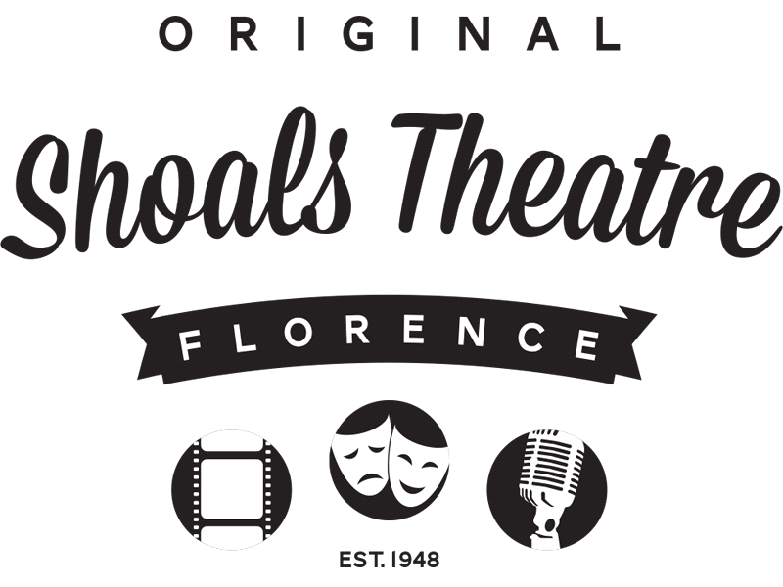
Contact Steve Price FOR IMMEDIATE RELEASE
Telephone 256-740-1700
Email steve@shoalstheatre.org
Website: www.shoalstheatre.org
Sweeney todd: the Demon barber of fleet street
Presented by Zodiac Players
Florence, AL, October 30, 2015 – The Zodiac Players continues their season with Sweeney Todd: The Demon Barber of Fleet Street, directed by Steifon Passmore, on-stage in the Shoals Community Theatre Nov. 19th – 22nd.
An infamous tale of Sweeney Todd, an unjustly exiled barber, who returns to 19th century London seeking vengeance against the lecherous judge who framed him and ravaged his young wife. The road to revenge leads Todd to the door of the resourceful Mrs. Lovett's failing pie shop, above which he opens a new barber practice. Mrs. Lovett's luck shifts sharply when Todd's thirst for blood inspires the integration of an ingredient into her meat pies. As the people of Fleet Street start lining up for the new taste, the carnage has only just begun!
"The team of people I have put together for this project are some of the most talented I know. They are as deeply committed to storytelling as I am, and I could have done none of it alone. This is honestly the most ambitious show I have ever done!" said Director Steifon Passmore.
The creative team includes Nicky Muphy (music director), Matt Upton (assistant director), Wesley Thompson (set design), Victoria McCoy (costume design), Cezan Mauter (visual design), Chad Farley ad Matthew Chesley (sound design), Jim Lake (lighting design), and Kristi Rich (stage manager).
Performance Schedule
Thursday, November 19th 7:30pm
Friday, November 20th 7:30pm
Saturday, November 21st 7:30pm
Sunday, November 22nd 2:00pm
Box Office and Tickets
Hours:
Monday – Friday 11:00am – 3:00pm
256-740-1700
Children’s tickets for ages 12 and younger are $7.00 in advance and $9.00 regular
Students: $9.00 in advance and $11.00 regular
Adults: $14.00 in advance and $17.00 regular
Advance sales end at 5:00 pm before the Thursday show. This is online and at the box office.
The price includes a $2 processing fee for all tickets!
Shoals Community Theatre is a non-profit 501(c)3 organization located in historic downtown Florence. Under the leadership of President David Heinze, Manager Steve Price, and a 12-member Board, Shoals Community Theatre’s mission is to provide an artistic home for the development and production of plays with substance and ideas that engage and challenge a diverse audience. For more information about us or any of our efforts, please contact Shoals Community Theatre at 256-740-1700 or steve@shoalstheatre.org
# # #
If you would like more information about this topic, please contact at or email at .

