Our class is reaching for the stars!
September 4, 2015
Love the Lord your God with all heart and with all your soul and with all your strength and with all your mind and, Love your neighbor as yourself. Luke10: 27
 | Important Dates and  Times | Sept 4 - ½ Day, dismiss @ 12:20 p.m.  Sept 7 - No school, Labor Day!  Sept 22 - Picture Day
 | Homework | www.ixl.com/signin/wvc  www.spellingcity.com
 | Bible Verse | Friday verse:  “The Lord saw how great man’s wickedness on the earth had become.” Genesis 6:5
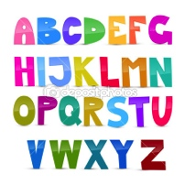 | Spelling  Unit 2 | - cone - kite  - cute - came  - kick - keep  - cake - cat  - come - I
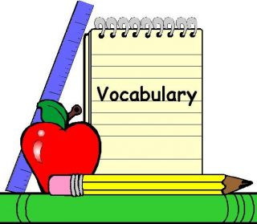 | Vocabulary  Words
 | Upcoming  Quizzes and Tests | Friday: Spelling Test, Memory test, Math speed drill, Bible Verse.
 | Important  Reminders | Please send a healthy morning and afternoon snack with your child even on the days they have school lunch.
 | Upcoming Trips
Scholastic
Book
Orders
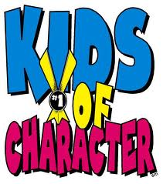 | Character  Counts | Every month we will be honoring a student from the class for a character award! This is a special award that will be given to the child(ren) deserving of the monthly character award. Our Character trait for September is LOVE
A Note from Your Teacher… We are changing the Friday go home mail packets.
The newsletter, Spelling words, and Bible Verse will go home in the Friday Mail.
The Homework Journal will be sent home on Monday, with the exception of holiday weekends then the journal will go home on Tuesday. This week IXl problems will be assigned to align with the skills being taught.
Please contact me anytime by emailing me at sallwardt @westvalleychristianschool.com

I am looking forward to an awesome year with your child! Have a great weekend

