Our class is reaching for the stars!
November 6th, 2015
Love the Lord your God with all heart and with all your soul and with all your strength and with all your mind and, Love your neighbor as yourself. Luke10: 27
 | Important Dates and  Times | No school Wednesday, November 11th: Veterans Day  November 13th, Book Report Due  Thanksgiving Vacation : November 23-27
 | Homework | www.ixl.com/signin/wvc  www.spellingcity.com
 | Bible Verse | Friday verse:  “Therefore, as we have opportunity, let us do good to all people.”  Galatians 6:10
 | Spelling  Unit 2 | - Book 2.look  3. good 4.foot  5.wood 6.shook  7.boot 8. food  9.loose 10.moon  11.room 12. roof  13.tooth 14.have  15. give
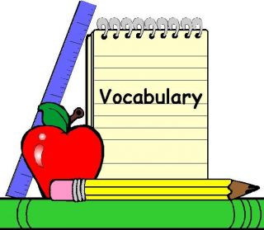 | Vocabulary  Words
 | Upcoming  Quizzes and Tests | Friday: Spelling Test, Memory test, Math speed drill, Bible Verse.
 | Important  Reminders | Please send a healthy morning and afternoon snack with your child even on the days they have school lunch.
 | Upcoming Trips
Scholastic
Book
Orders
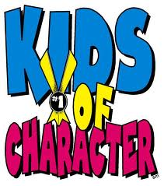 | Character  Counts | Every month we will be honoring a student from the class for a character award! This is a special award that will be given to the child(ren) deserving of the monthly character award. Our Character trait for November is Peace.  Congratulations to Tyler S. and Gavin G for receiving the award for JOY!
A Note from Your Teacher... Mrs. Allwardt
Cold weather is coming up and students have had to bring jackets and sweaters, please make sure that your child’s name is on their clothing. November is well underway and with only two weeks until Thanksgiving vacation Wow! Time flies in 1st grade. On Friday November 20th, we will be having a special Thanksgiving celebration with the 2nd Grade. We will have activities that have to do with how the Pilgrims and Native Americans lived. It is a fun filled day. If your child has a Native American costume or Pilgrim costume to wear that would be awesome! Please do not feel that you have to buy anything, a brown shirt and brown school pants work well for Native Americans and a white shirt and black pants or skirt work well for Pilgrims We will also make some items if needed. With our activities we will need some parent support

Parents: We will need some support and help with the crafts, games and luncheon. Please let me know if you are able to come and help Look for more information in Monday’s folder.
Thank you.

Please contact me anytime by emailing me at sallwardt @westvalleychristianschool.com

I am looking forward to an awesome year with your child! Have a great weekend

