A Call to Take a Stand
by
David Rowsome
More and more, Australians are being struck with a sad reality. Many of the values that have made Australia a great place to live are under serious threat. They are in danger of being undermined and eroded and even lost. The current push by the secular left to redefine marriage, which would result in the national tragedy of another stolen generation, is just one example.
The most recent edition of ‘Operation World – the Definitive Prayer Guide to Every Nation’ states “Australia is undergoing many changes, all of which place greater strains and tensions on the nation. … A traditionally Christian country, Australia is now characterized more by its diversity of religions under a secular rubric, with increasingly secular laws – especially regarding issues of sexuality, religion and sanctity of life”.
The Canberra Declaration is an 856-word statement which speaks to this challenging context. It highlights three vital areas that are alluded to by Operation World –
- Freedom of Religion,
- Marriage and Family and
- the Sanctity of Human Life.
As stated in the Canberra Declaration, these cherished Australian values are “in large measure founded on the Judeo-Christian belief system”. The Canberra Declaration therefore is a call to take a stand to protect Christian values in Australia. It was drafted by a cross-section of Christian leaders from Catholic, Orthodox, Pentecostal and Protestant traditions. Its three main visionaries were Dr Graham McLennan of the National Alliance of Christian Leaders, Warwick Marsh of Dads4Kids Fatherhood Foundation and Bill Muehlenberg of Culture Watch.
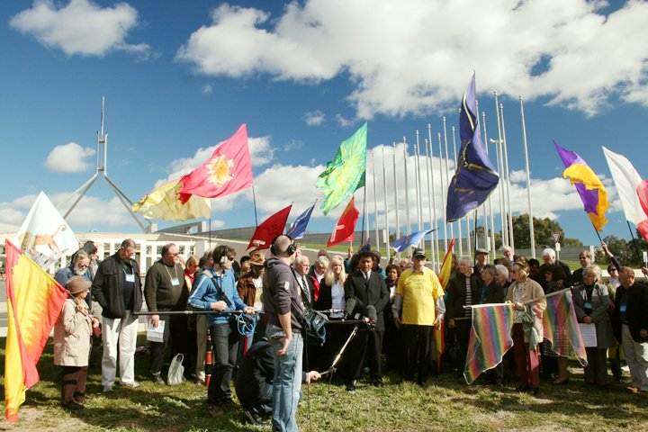
Because of threats to redefine marriage it was released with a sense of urgency just four weeks before the 2010 federal election. It was first read out on 23 July 2010 on the sunny lawns of Parliament House in Canberra. By Election Day the Canberra Declaration had received 9,925 signatures.
To date over 60,000 have become signatories to the Canberra Declaration. In doing so they have joined a growing community of Australian Christians who are willing to take a stand.
About once every fortnight the Canberra Declaration sends out a Good News Update. These speak out on selected issues of the day in the light of the truth of the Word of God. Signees are then asked to pray and take appropriate action. Often this is the contacting of political leaders or making short, even one-sentence, submissions to Senate inquiries. Many signees have volunteered to be members of fourteen different teams with fellow volunteers as team leaders. This includes 522 on the prayer team and 216 on the social media team!
The Canberra Declaration, as one of the main proponents of the National Day of Prayer and Fasting, encourages prayer and fasting for the revival and transformation of Australia. The Canberra Declaration maintains that such a spiritual awakening is crucial for Christian values to survive in Australia.
Another ideal of the Canberra Declaration is working alongside other Christian organizations - many of whom are signatories to the Canberra Declaration. In this way the Canberra Declaration hopes to become a rallying point for Christians all across Australia. Wherever they are they can take a stand -
- for the free expression of religious convictions in the public square.
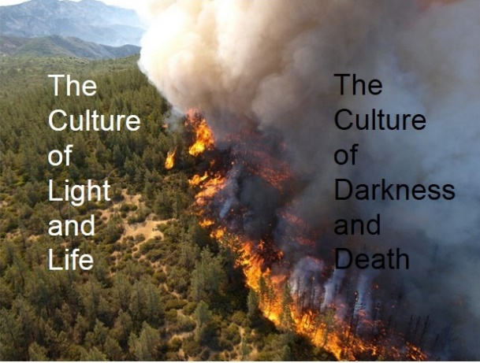
- for the protection of marriage as it is enshrined in the Marriage Act - the voluntary lifelong union of a man and woman to the exclusion of all others.
- for families where children can flourish under the nurture and protection of a mother and a father.
- for a culture of light and life which sees every person as made in the image of God with inherent value and dignity.
- for pushing push back a culture of darkness and death that negates life through abortion, euthanasia, human trafficking, pornography and the glorification of violence.
The last sentence of the Canberra Declaration calls all like-minded citizens to support and sign the Canberra Declaration “for the future of our nation, and for our children’s future”.
Last year the Canberra Declaration launched a Double Our Numbers Campaign with a target of 100,000 signatures by their fifth anniversary on 23 July 2015. We are in the process of releasing seven mini-strategies based on the suggestions of Canberra Declaration signees from an on-line survey last year. The aim is to encourage fellow citizens to read and sign the Canberra Declaration on-line at our website www.canberradeclaration.org.au More signatures means more people praying and acting in response to the many pressing issues that need to be addressed.
Although the Canberra Declaration community is only 0.23 percent of the population of Australia we are regularly encouraged to look to Jesus who said “the kingdom of heaven is like yeast that a woman took and mixed into a large amount of flour until it worked all through the dough” (Matthew 13:33).
The Canberra Declaration also receives a lot of inspiration from the story of David and Goliath. Whilst not large in the scheme of things, the Canberra Declaration community is able to punch far above its weight. For this we thank God who gives the increase. From small things big things grow!
Canberra Declaration
Email: with1accord@outlook.com
Website: www.canberradeclaration.org.au
Facebook: www.facebook.com/pages/Canberra-Declaration/140676265957734
Twitter: www.twitter/CanberraDeclara
Instagram: www.instagram.com/canberradeclaration

Jason Mandryk editor, “Operation World” (Seventh Edition), Biblica Publishing, USA 2010, page 119

