To Whom It May Concern:

Our records indicate that your property at, _____________, has experienced frozen water lines in the past. Frozen water lines typically occur beginning in November, and may remain frozen until the first signs of spring, usually in March or April.

Listed below are some practical preventative steps that a property owner can take to help reduce the possibility of experiencing frozen water lines during the winter months.

- Close all crawl space and basement vents.
- Remove any hoses from outside hose bibs left over from summer irrigation.
- Set your thermostat to maintain a minimum temperature of at least 55 degrees within your home or business if you are away for any length of time. This will help to reduce the chances of having any pipes that are located within exterior walls freeze. If you do have pipes that are located within exterior walls, such as your kitchen or bathroom, leave the cabinet door open to allow heat to enter.
- If you have a shallow water service line into your property (less than 5’ deep), or if your service line is located under a plowed driveway or sidewalk, or if your service line has frozen in the past, we recommend that you attach a hose to one of your outside hose bibs (faucet) and flow a small stream of water. The flow should be minimal, similar to slow soaking a tree. Place the hose away from your house, preferably near landscaping such as lawn, shrubs or trees. This should prevent your water service line from freezing, and will not place a burden on the sewer treatment plant as it would if you chose to circulate water inside your home through a toilet or sink. If you do not have an outside faucet or hose bib then you may need to set a sink or toilet to flow a pencil size stream of water this winter. If flowing water is an option that you are considering, we recommend that you begin as soon as possible.

In Ketchum, it is common for the frost to achieve a depth of 5 to 6 feet in plowed areas such as roads, driveways and sidewalks. It is the responsibility of the property owner to take the necessary preventative steps, and to ensure that their water line does not freeze. You have received this notification because your property has experienced frozen water lines in the past. If you would like to be removed from our reminder list, or need help in setting up a water circulation hose, please contact the Ketchum Utilities Department at (208) 726-7825.

Sincerely,
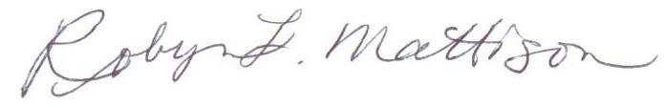
Robyn Mattison P.E.
Public Works Director / City Engineer
AS

