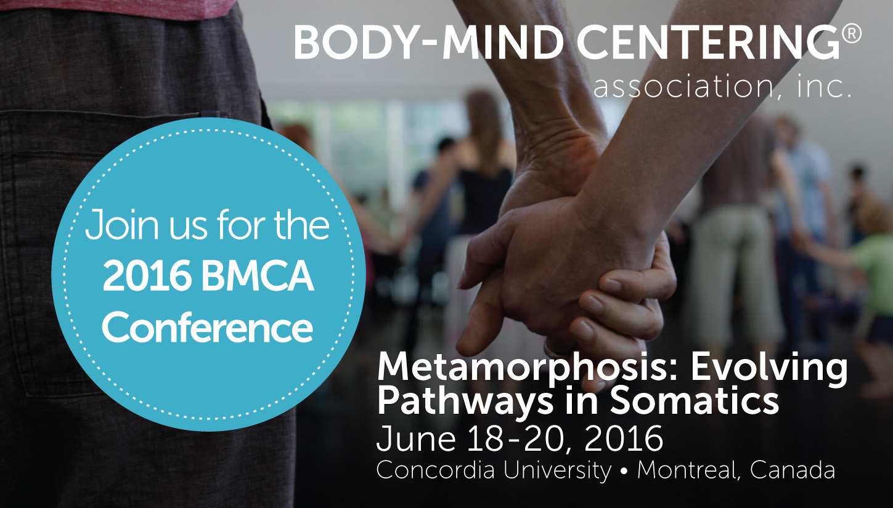

Welcome to the Conference!

www.bmcassociation.org/conferences

Please see some helpful suggestions and links below for your stay at Concordia University in Montreal, Canada.

Balance Payments for conference fees and accommodations are due by March 15, 2016. To pay your balance or adjust your registration, click the link in your email confirmation or click the registration link on the BMCA website (www.bmcassociation.org/conferences) and enter your email and password.
- PLEASE NOTE: WE WILL ONLY BE ACCEPTING CASH (both $US and $CAN) OR CHECKS ($US only) AT THE CONFERENCE. We will not be able to accept credit cards. If you prefer to pay for the conference or merchandise by credit card, please pay in advance via your registration form.

Check-in:
Check-in for the conference is on the 7th floor of the The John Molson Building at 1450 Guy in downtown Montreal.

The registration desk hours are as follows:
Friday, June 17 – 7:30AM to 6:00 PM
Saturday, June 18 to Monday, June 20 – 8:00 AM to 6:00 PM
Tuesday, June 21 – 8:00 AM to 1:00 PM
All conferees must check-in and be paid-in-full before attending any workshops.
- We recommend you arrive early to allow enough time to check-in and get oriented.
- At registration you will receive a swipe card that serves as your ID card on campus.
- WE WILL ONLY BE ACCEPTING CASH (both $US and $CAN) OR CHECKS ($US only) AT THE CONFERENCE. We will not be able to accept credit cards. If you prefer to pay for the conference or merchandise by credit card, please pay in advance via your registration form.
Weather:
The weather usually ranges from 70-80 degrees F/20-26 degrees C during the day and 55-65 degrees F/12-18 degrees C during the evening. Bring layered clothing as it can be cool in the morning/evening and in the indoor spaces. Umbrella and raincoat are recommended.
http://www.accuweather.com/en/ca/montreal/h2k/month/56186?monyr=6/01/2016

Cell phone coverage:
There is excellent coverage on and off campus. If you are traveling from outside Canada, we recommend you check the fees with your cell phone provider. Many offer low-cost extensions for travel outside of your home country.

Wifi and Computer Access:
Wifi is available campus-wide with BMCA’s log-in access code which will be in your check-in materials and at the registration desk. You can also find more information and wifi locations around the city by clicking on the following link: http://www.ilesansfil.org/welcome
Passport for travel:
Don’t forget your passport! If you live in the US and are traveling to Canada, you will need a passport, not just a US license, to cross the border.
What To Bring:
If possible, bring a yoga mat, water bottle, light blanket, sunscreen, light jacket for cooler nights, and any vitamins, supplements or medications you need. Wear comfortable clothes you can easily move in. Conferees will have access to the Concordia gym for $8 per day. Please note, the gym does not have a pool.
Please also bring items to donate to the Silent Auction! These could include: certificates for sessions, crafts, books, jewelry, music, art, hand-made items, and more.

Travel to and around Montreal and Concordia University:
Concordia University address:
Sir George Williams Campus
John Molson Building, 1450 Guy
Montréal, Quebec, Canada H3G 1M8
514-848-2424
Link to online, interactive campus map: http://www.concordia.ca/maps/sgw-campus.html

General travel Information - Airports, buses, and trains:
http://www.tourisme-montreal.org/Travel-Information/Getting-to-montreal

Air Travel
The Montréal–Pierre Elliott Trudeau International Airport (YUL) is about 20 minutes from downtown Montreal and the closest to Concordia University.
http://www.admtl.com/en

Prices and travel options from the airport:
- A taxi will cost about $40.00CAN one way. See a list of taxi companies under ‘Taxi services’ below.
- 747 Express bus from the airport to downtown Montréal runs 24 hours per day and costs $10.00CAN per 24-hour pass
http://www.stm.info/en/info/networks/bus/shuttle/more-about-747-aeroport-p-e-trudeau-centre-ville-shuttle
- Other options:
http://www.rome2rio.com/s/montreal-Airport-YUL/Concordia-University

Metro/Subway:
Montréal Metro - closest station to Concordia is Station Guy-Concordia (Green line):
http://www.stm.info/en
- A single ride on the metro costs $3.25 CAN
- 1-day unlimited passes are $10 CAN,
- 3-day unlimited passes can be purchased for $18 CAN.
- Weekly unlimited passes, which last from Monday to Sunday only, can be purchased for $25.50 CAN+$6 CAN for a refillable OPUS card.
- Metro service starts at 5:30 AM and stops at 0;30 AM on weekdays and Sunday (1:00 AM on Saturday).

Bike Rental:
Bike Rental – Montréal is very bike friendly with over 350 km of bike paths. Renting a bike will cost $5 CAN per 24-hour pass.
https://montreal.bixi.com
- This service enables citizens and tourists to borrow a bike from a station, travel to their destination and return the bike to any other station across the network. BIXI currently provides 400 stations and 5,000 bikes distributed in 8 of Montréal’s boroughs. $6.45 for 61-90 minutes / $5.00 for 24-hour access / $14.00 for a 72-hours access

Taxi services:
Champlain Taxi: 514-271-1111, http://www.taxichamplain.qc.ca/index.php/en/
Taxi Hochelega: 514-322-2121, http://www.taxihochelaga.com
Taxi Diamond: 514-273-6331, https://taxidiamond.com
Taxi Coop : 514-725-9885 http://www.taxi-coop.com/en/

Parking
Parking ranges from $13-25 CAN per day and can take some time to find in downtown Montréal. If you are driving, it is a good idea to leave some extra time to find parking. http://www.concordia.ca/maps/parking/sgw-campus.html
- Concordia University has two indoor parking sites open from 6:00 am until midnight: 1. 1453 Mackay Street in the Library Building (LB) 2. 1250 Guy Street in the Faubourg Building Maximum charge per day is $13.25 (cash, Visa or MasterCard). Public parking (paid and otherwise) is also available on the streets nearby.

Dining
Breakfast and lunch are available to purchase via the Conference registration form. All meals will be vegetarian with gluten-free and dairy-free options.
- You may purchase meals (CASH-ONLY) on-site at the registration desk, though we ask that you plan in advance as much as possible.
- You will also receive tickets for any meals you have purchased in advance.
- Breakfast will be served in the basement of the dorm (Grey Nuns Residence). Lunch and the shared dinner will be served on the 10th Floor of the John Molson Building.
- BMCA will host a shared dinner prior to the close of our annual Silent Auction on Sunday night. All are welcome to attend!

Breakfast $8US Served in basement of Grey Nuns Residence
Packed Lunch $15US Served on 10th FL of John Molson Building
Shared Dinner $25US Served on 10th FL of John Molson Building
- For local restaurants near campus, visit:
http://www.tourisme-montreal.org/Cuisine/Restaurants
- Restaurants close to Concordia
Restaurant | Type | ADDRESS
Al Taib | Libanais et pizza | 2125, rue Guy
Angela’s Pizza | Pizza | 1662, de Maisonneuve Ouest
Broadway Cheese Cake | Sandwichs, pizza, desserts | 1446, rue Ste-Catherine Ouest (coin MacKay)
Café Myriade | Great coffee | 1432, rue MacKay (coin Ste-Catherine)
Comptoir du chef | Ready to go meals | 2153, rue Guy
Coq-O-Coq | Rôtisserie chicken | 1625, de Maisonneuve Ouest
Crudessence | Organic raw vegan | 2157, rue MacKay
Dagwoods | Sandwiches, salads | 1627, rue Ste Catherine Ouest (coin Guy)
Double Pizza | Pizza | 1632, de Maisonneuve Ouest
Food Truck | Changes every day | Corner MacKay & Guy
Juliette et Chocolat | Coffee and pastry shop | 1626, rue Ste-Catherine Ouest (coin Guy)
Kaffein | Bistro cafe | 1429, rue Bishop
La Panthère Verte | Organic / vegan | 2153, rue MacKay
Le Paris | French cuisine | 1812, rue Sainte-Catherine Ouest
Mc Kibbin’s Irish Pub | Pub menu | 1426, rue Bishop
Mesa 14 | Mexican | 1425, rue Bishop
Starbucks | Coffee shop | 2000, rue Guy / 1616, rue Sainte-Catherine ouest
Tim Horton | Coffee shop | 2081, rue Guy /1611, rue Sainte-Catherine ouest
Jugo-juice | Smoothies, wraps | EV sub-basement
Contact Information and quick info sheet:

Concordia University main phone number: 514-848-2424

Ellen Ferris, operations@bmcassociation.org (preferred method)
BMCA Director Of Operations 413-552-8161 (cell)

Toni Smith, tsmith818@nycap.rr.com
Conference Committee Chair

Conference Location: John Molson Building, Concordia University,
1450 Guy, Montreal, Quebec, Canada

Location of breakfast: Basement of Grey Nuns Residence
7:30-8:30 AM 1190 Guy

Location of lunch: 10th Floor of John Molson Building
12:00 – 1:50 PM 1450 Guy

Concordia Dorms: Grey Nuns Residence
http://www.concordia.ca/campus-life/summer-accommodations.html/greynunsresidence/

Useful Tips about Montréal

What Language is spoken in Montréal?
French is Québec’s official language but English is widely spoken in Montréal. The city has more than 120 cultural groups and over 20% of the population speaks three languages.

Banks and Currency Exchange
Canadian currency is the dollar, which is divided into 100 cents. There are 5, 10, 20, 50, and 100 dollar bills. One and two dollar bills have been replaced by coins, sometimes referred to as "Loonies" (the bird on the $1 is a loon) and "Toonies" ($2)
There are numerous currency exchange offices for exchanging money into Canadian currency. Most exchange offices are open during regular business hours (9am-6pm) and Saturday from 10am-5pm.

Electricity
The electric current is 110V and the plugs are the same as what is found in the US. If you come from a country that uses 220V electricity, you will need a converter for any appliances you bring that require power (computers, charges, etc.).

What is the rule for tipping in Montréal?
Service is not included in restaurants, so it is customary to add a 15% tip to the total before taxes (if you’re with a group, 15% for service may be automatically added to your bill). Taxi drivers, hairdressers, etc. are also normally tipped 15%. Bellhops, porters, doormen, etc. generally receive at least $1 per suitcase or per service rendered.

Time Zones
Montréal is in the Eastern Daylight Time zone.

Using your mobile phone
There are many wifi connections available in the city. If you do not turn off your roaming or 3G connection charges to your mobile phone bill can climb high depending on whether or not you have a package that includes Canada.
You can also find out more information and wifi locations by clicking on the following link: http://www.ilesansfil.org/welcome

Lost and Found
Report lost objects at the following Concordia University security offices: EV Building (room 1.402), Hall Building (room 118), LB Building (room 121), MB Building (room 1.130), Grey Nuns Residence (room J.104).
For information Campus Security can be reached 24 hours a day by calling 514 848-3717, extension 2.

Emergency and Security
Concordia University Security can be reached by telephone at 514 848-3717. From within the University emergency telephones and elevator intercoms are available (dial 3717).

In case of emergency it is important to NOT to call 911 but instead to contact the security office directly. University Security Services will be in direct contact with the appropriate authorities.

Helpful links:

Concordia University: http://www.concordia.ca/
Sir George William Campus map: (MB is the BMCA Conference Building)
http://www.concordia.ca/maps/sgw-campus.html
What to do in Montréal: http://www.tourisme-montreal.org/What-To-Do/Events

Body-Mind Centering® and are registered service marks and BMCSM is a service mark of Bonnie Bainbridge Cohen, used with permission.

