Global Women’s Climate Justice Day of Action
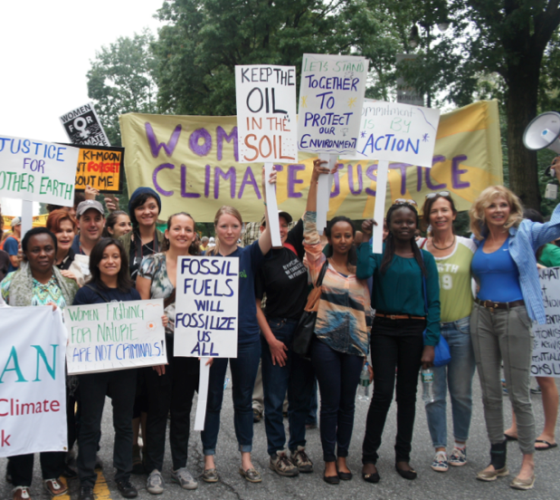
September 29, 2015
Photos by Emily Arasim
Organizing & Media Messaging Toolkit #1

www.wecaninternational.org/global-womens-climate-justice-mobilization
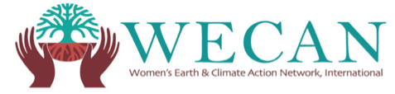

Dear Friends and Allies,

This Organizing & Media Messaging Toolkit provides resources for your use as we unite to engage our online and on-the-ground networks in the Global Women’s Climate Justice Day of Action – happening September 29, 2015.

Action steps:
- Share the Global Women’s Climate Justice Day of Action using the social media messages, graphics, press release, & other resources included in this toolkit.
- Take action on (or before) Sept. 29 & submit a photo/video/statement to the action portal: wecaninternational.org/international-day-of-action-submission
- Sign the Women’s Climate Declaration: wecaninternational.org/declaration Signatures will be delivered to world leaders at COP 21 in Paris.
- Send your organizations logo to emily@wecaninternational.org to show partnership for the Day of Action & with WECAN International’s ongoing efforts for women and climate justice.

We cannot thank you enough for your solidarity and commitment to action as we organize for this critical women’s climate justice mobilization.

Please contact emily@wecaninternational.org with your endorsement, questions, or any additional needs.
Included in this Organizing Toolkit:
- Global Women’s Climate Justice Day of Action Background
- Ideas for Participation in the Day of Action
- Sample Social Media Messages
- Sample Action Outreach Email
- Shareable Images
- Global Women’s Climate Justice Day of Action Press Release #1
- Additional Resources
- Day of Action Print-Outs
- Supporting Partners

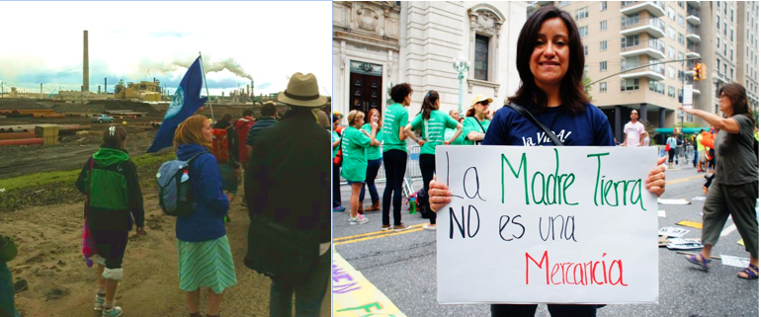

Global Women’s Climate Justice Day of Action Background

The September 29 Global Women’s Climate Justice Day of Action is an opportunity for women around the world to mobilize and show our resistance to environmental and social degradation, uplift stories about the climate impacts our communities are facing, and demonstrate the many real climate solutions that are just and effective. Women are central to climate solutions and we want to show this as powerfully and colorfully as possible.

The Day of Action has been called in light of the December 2015 United Nations COP21 climate negotiations, where world governments will work to finalize a climate agreement with major implications for our global trajectory and the health of people and planet. As a network of women for climate justice, we can and must stand up and act together to show public officials that the time has come to listen to the people’s call for equitable, immediate, and bold action on climate change.

Women and allies around the world are invited to hold decentralized local actions on September 29 (or before!) - ranging from holding up signs with messages to world leaders, to marches and demonstrations, protests at oil extraction sites, educational events, art projects, and other actions and statements to highlight local struggles and solutions being offered by communities.

Participants are asked to submit photos, videos, and statements to the Day of Action portal - wecaninternational.org/international-day-of-action-submission – allowing us to weave our stories together via social media, shared images/videos, and print and digital news.

As a collective action, allies around the world will also use September 29 as a rallying day to collect signatures on the Women’s Climate Declaration - a powerful climate justice manifesto that will be delivered with collected signatures to world governments at the UN COP 21 Climate Negotiations in Paris in December.

WECAN International will hold a hub event and action ‘Women Speak: Climate Justice on the Road to Paris & Beyond’ in New York City on September 29, while the UN General Assembly is in session across the street.

More information about the Global Women’s Climate Justice Day of Action: wecaninternational.org/global-womens-climate-justice-mobilization
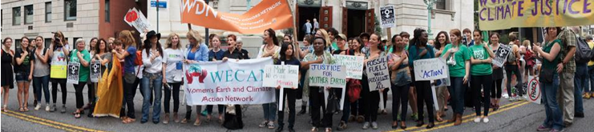

Ideas for Participation in the Day of Action
Please share these as part of any outreach efforts & in the development of your own action!
On September 29 (or before!) all actions should be added to the Day of Action portal: wecaninternational.org/international-day-of-action-submission

- Take a photo of yourself or a group holding up signs with a message about the climate impacts your community is facing, your solutions, a message to world governments, a reflection on why women are key to climate solutions, or another climate related statement that resonates with you. Some examples include: “Keep Fossil Fuels in the Ground”, "No Climate Justice, Without Gender Justice", “Water is Life”, “Climate Justice Now”, “Women for 100% Renewable Energy”, “System Change, Not Climate Change”. Submit a photo/video/statement to the Day of Action portal and share on social media using #ClimateWomenSpeak

- Write a statement or film a short video about the climate harms in your life and community, and/or solutions you or your community/organization are offering. We also welcome your messages and reflections on why women are key to climate solutions and need to be upfront at the UN COP21 negotiations. Submit to the Day of Action portal and share on social media using #ClimateWomenSpeak

- Organize a sit-in, march, demonstration, protest, educational event, or art display. Submit a photo/video/statement to the Day of Action portal and share on social media using #ClimateWomenSpeak

- Work in your community, such as putting in a community garden, installing a solar panel, or planting trees. Submit a photo/video/statement to the Day of Action portal and share on social media using #ClimateWomenSpeak.

- Sign the ‘Women’s Climate Declaration’ and organize to collect signatures. The collective women’s statement and signatures will be delivered to leaders at the UNFCCC COP 21 Climate Negotiations in Paris in December in conjunction with a collective signature campaign organized by GCCA- we already have an aggregate of over 6 million signatures! The Declaration is very powerful and you may want to read it out loud as part of your action on Sept. 29th. This Declaration has been signed by women worldwide including Jane Goodall, Vandana Shiva, Mary Robinson, Casey Camp-Horenik, Jody Williams, Patricia Gualinga, Sylvia Earle, Ted Turner and many others. Read and sign the Women's Climate Declaration (available in English, Italian, Spanish, French, and Arabic) here: wecaninternational.org/declaration

- Join WECAN International at our hub event and action in New York City on Sept. 29th, more information here: wecaninternational.org/wecan-nyc-september-2015. We will name and honor the organization and individuals taking action worldwide on this day during the hub event. If you would like your action to be listed, please inform via emailing at - emily@wecaninternational.org

- Read and share the ‘Women’s Climate Action Agenda’- a detailed analysis of why women are the most negatively impacted by climate change and environmental degradation, how women are key to solutions, and the actions that women worldwide are calling for in order to re-build a just and healthy world. There are many resources and solution examples in this document. Please download and share the Women's Climate Action Agenda here: wecaninternational.org/content_documents/WECAN-Agenda-Update-2-9-15.pdf

Sample Social Media Messages
Please share the sample messages below to get people involved in the lead up to the Day of Action – you are welcome to edit messages & add your groups statement/link/logo. We are using #ClimateWomenSpeak to tie our stories together across platforms, and are also encouraging the use of #KeepItInTheGround
Connect with WECAN International on Social Media:
twitter.com/WECAN_INTL @WECAN_INTL #ClimateWomenSpeak
facebook.com/pages/Womens-Earth-and-Climate-Action-Network/153704007991524

- Organize an action: Global #Women's #ClimateJustice Day of Action:Sept.29 goo.gl/yz0TkF #ClimateWomenSpeak WITH MULTIMEDIA IMAGE 1,2,or3

- Join us as we rise up! Global #Women's #ClimateJustice Day of Action:Sept.29 goo.gl/yz0TkF @WECAN_INTL WITH MULTIMEDIA IMAGE 1,2,or3

- #ClimateWomenSpeak: add your voice to the Sept.29 Global Women's #ClimateJustice Day of Action goo.gl/yz0TkF WITH MULTIMEDIA IMAGE 1,2,or3

- Sept29:Global Womens #ClimateJustice Day of Action.Add photo/vid/statement goo.gl/yz0TkF #ClimateWomenSpeak WITH MULTIMEDIA IMAGE 1,2,or3

- Global Womens #ClimateJustice Day of Action. Info&submission portal:goo.gl/yz0TkF #ClimateWomenSpeak WITH MULTIMEDIA IMAGE 1,2,or3

- Global Womens #ClimateJustice Day of Action-worldwide mobilization Sept29. Info& submission portal:goo.gl/yz0TkF #ClimateWomenSpeak

- #Women are on #frontlines of #climatechange& we are rising. Join Global Womens Climate Justice Day of Action: Sept.29 goo.gl/yz0TkF

- Whats ur climate story,solution,demand?Add voice:Global Womens ClimateJustice Day of Action-Sept29:goo.gl/yz0TkF #ClimateWomenSpeak

- #COP21 delegates-#women demand justice&solutions.Listen 2 our call:Global Womens #ClimateJustice Day of Action-Sept29 goo.gl/yz0TkF

- #Women r most impacted by #climatechange& key 2 solutions-join Global Womens #ClimateJustice DayofAction:goo.gl/yz0TkF @WECAN_INTL

- #Women call on world leaders to #KeepItInTheGround. 9/29: rise together for Global Womens #ClimateJustice DayofAction:goo.gl/yz0TkF

- Women protect & defend web of life! Join us as we stand for #climatejustice on Sept29: goo.gl/yz0TkF #ClimateWomenSpeak @WECAN_INTL

- Women call for 100% #renewableenergy now! Sept29,we rise together-Global Womens #ClimateJustice Day of Action:goo.gl/yz0TkF #100RE

- [Insert org/individual name] is/am joining Sept29 Global #Women's #ClimateJustice Day of Action- will you rise up with us/me? goo.gl/yz0TkF

- #ClimateWomenSpeak: [Insert your climate statement/demand ex 'Ban fracking', 'water is life']. Whats ur message? Join Global Women's #ClimateJustice Day of Action:goo.gl/yz0TkF

- [Insert your climate statement/demand ex 'Ban fracking','water is life']. Join Global Women's #ClimateJustice Day of Action, Sept29:goo.gl/yz0TkF @WECAN_INTL #ClimateWomenSpeak

- Women around the world are taking action to show resistance to environmental and social degradation, call for real action from world governments at COP21 climate negotiations, and bring to light the climate harms that our communities are facing and the just solutions that we offer. Add your voice to the Sept. 29 Global Women’s Climate Justice Day of Action. Information on how to participate available on the @Women’s Earth and Climate Action Network webpage: goo.gl/yz0TkF WITH MULTIMEDIA IMAGE 1,2,or3

- Join the Global Women’s Climate Justice Day of Action – Sept. 29, 2015. Women worldwide are organizing decentralized local actions – from marches and sit-ins, to educational workshops, art displays, and tree plantings. We are demonstrating the diversity and strength of the women’s climate justice movement, and calling for our voices are brought to the forefront of upcoming UN climate negotiations. Learn more and add your photo/video/statement here: goo.gl/yz0TkF WITH MULTIMEDIA IMAGE 1,2,or3

- Please join [YOUR INSERT ORG/GROUP NAME] and our allies at the @Women’s Earth & Climate Action Network in raising our voices as part of the Global Women’s Climate Justice Day of Action – happening Sept. 29, 2015. You can organize an action in your community, or simply upload a photo/video/statement about your climate concerns, struggles, and solutions. Explore more participation ideas and submit your action here: goo.gl/yz0TkF WITH MULTIMEDIA IMAGE 1,2,or3

- [Insert your individual or organizational message/statement/demand/solution on climate change – or a reflection on why women are key to climate solutions] – What is your climate story, struggle, demand, or solution? Organize a local action and add your voice to the September 29 Global Women’s Climate Justice Day of Action. More information and submission portal available on the @Women’s Earth and Climate Action Network webpage: goo.gl/yz0TkF WITH MULTIMEDIA IMAGE 1,2,or3

Sample Action Outreach Email
Please share this email to invite allies to participate in the Day of Action. If your group/organization is organizing a local action you can also tailor this letter to reflect your specific action message/location/time.

Dear [INSERT RECIPIENT NAME],

On September 29, 2015 women and allies across the world will rise up as part of the Global Women’s Climate Justice Day of Action. We will show our resistance to environmental and social degradation, tell our communities climate stories, demonstrate just and effective climate solutions, and call for action from world governments working to finalize a new global climate agreement at the United Nations COP21 climate negotiations in December. Please join [INSERT YOUR GROUP/ORG NAME] and thousands of allies across the globe in taking action as part of this critical women’s climate justice mobilization.

WHAT: Global Women’s Climate Justice Day of Action
WHEN: September 29, 2014
WHERE: Local, decentralized actions in communities across the world
HOW: visit the WECAN International webpage for a list of action ideas and a submission portal for photos, videos, and statements: wecaninternational.org/global-womens-climate-justice-mobilization

We need every single one of us to truly seize this moment and bring women’s voices to the forefront of the climate change conversation.

Thank you,
[INSERT YOUR GROUP/ORG NAME]

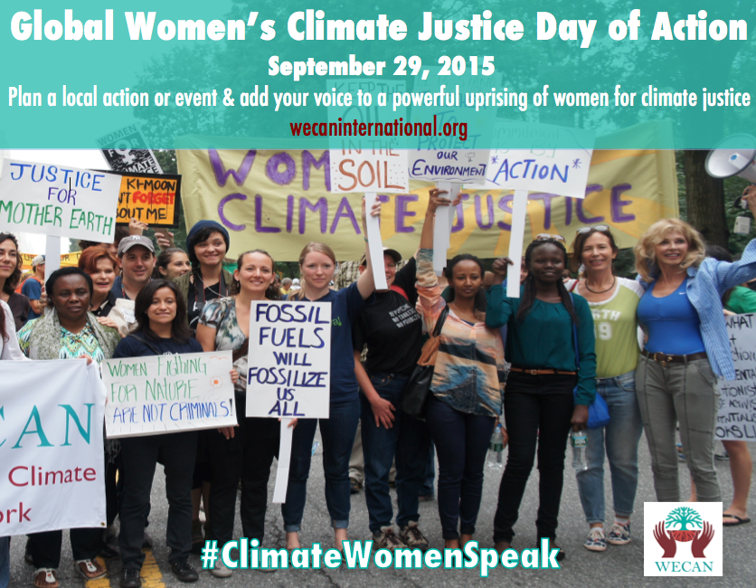
Shareable Multi-Media: Right-click and ‘Save as Image’ for sharing/full file size.
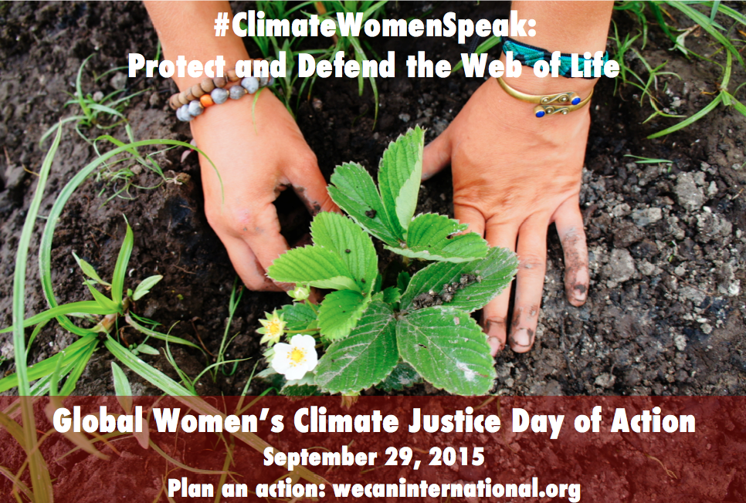

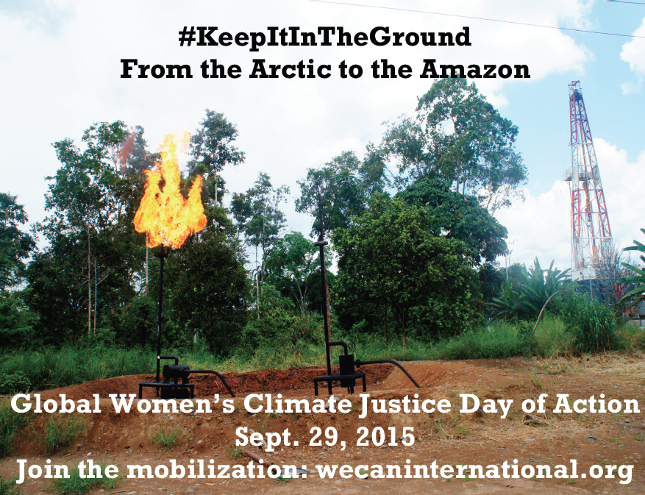
Global Women’s Climate Justice Day of Action Press Release #1
Please share this press release far and wide - add your organizations message or logo!

FOR IMMEDIATE RELEASE
Press Contact:
Emily Arasim
+1 (505) 920-0153
emily@wecaninternational.org

Global Women’s Climate Justice Day of Action Announced by WECAN International

MILL VALLEY, Calif., July 20, 2015 - On Sept. 29, 2015 women across the world will raise their voices to tell stories of the climate impacts felt by their communities, demonstrate solutions, and call for meaningful action on climate change from world governments meeting at the United Nations COP21 climate negations in Paris this December.

The ‘Global Women’s Climate Justice Day of Action’ has been called for by the Women’s Earth & Climate Action Network (WECAN International) for Sept. 29 due to the United Nations General Assembly taking place in New York City at this time. WECAN International will be on the ground in New York holding a hub action and event, ‘Women Speak: Climate Justice on the Road to Paris and Beyond’ at the U.N Church Center - wecaninternational.org/wecan-nyc-september-2015

Women across the world are invited to hold decentralized local actions on Sept. 29, including sit-ins at extractive industry sites, marches, educational events, art displays, and direct solution implementation such as planting a community garden.

Global Women’s Climate Justice Day of Action stories and mobilization efforts will be woven together via shared images, videos and statements collected from worldwide participants, with #ClimateWomenSpeak and #KeepItInTheGround used to tie women’s voices together across media platforms.

As part of the collective day of action women will also gather signatures on the Women’s Climate Declaration, a powerful climate justice manifesto written in five languages and signed by leaders including Jane Goodall, Vandana Shiva, Mary Robinson, Jody Williams, and Sylvia Earle. The Declaration, available at wecaninternational.org/declaration, will be delivered with compiled signatures to world governments at COP21 Paris.

“We are seizing the critical time in the lead up to the COP21 UN climate negotiations this December to show world leaders that the time has come to listen to women’s calls for equitable, immediate, and bold action on climate change and the unjust systems that perpetuate it,” explained Osprey Orielle Lake, co-Founder and Executive Director of WECAN International, “On September 29 we invite women to join us as we rise up as a global network of women for climate justice to call forth the world we want for all generations. The time for action is now, nature is not waiting.”

More information about the Global Women’s Climate Justice Day Of Action can be found on the WECAN International webpage, wecaninternational.org/global-womens-climate-justice-mobilization
#####
Additional Resources
- Women’s Climate Declaration – (available in 5 languages) Please sign and help gather signatures as part of Day of Action. All signatures will be delivered to the UN in December.- wecaninternational.org/declaration

- Women Speak: Climate Justice on the Road to Paris & Beyond – Sept. 29 hub event in New York City- wecaninternational.org/wecan-nyc-september-2015

- Women’s Climate Action Agenda –wecaninternational.org/content_documents/WECAN-Agenda-Update-2-9-15.pdf

- Global Women’s Climate Justice Day of Action Facebook Events Page- http://www.facebook.com/events/1604961533087198/

Day of Action Print Outs
You may wish to print these sample messages to display as part of your action, or write your own! Take a photo and submit to the action portal:
wecaninternational.org/international-day-of-action-submission
Women for
Climate Justice

Keep It In The Ground
From the Arctic to the Amazon

Climate Women Speak:
Protect & Defend the Web of Life

Women for 100% Renewable Energy

Stay below
1.5°

Supporting Partners

Thank you to our incredible worldwide allies. If you would like to add your group, organization, or individual name to the official list of Global Women’s Climate Justice Day of Action partners, please email emily@wecaninternational.org

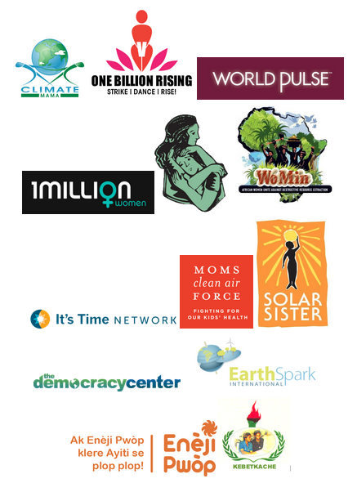

wecaninternational.org/global-womens-climate-justice-mobilization
Please contact emily@wecaninternational.org with questions

