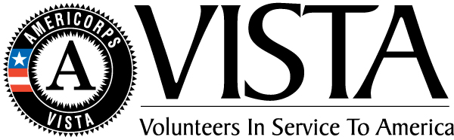
Hartford Thrive! Brings Two New VISTAS to Journey Home

AmeriCorps Volunteers in Service to America (VISTA) play a vital role in building capacity and developing sustainability for non-profits across the country. Beginning this April, a new project headed by Hands on Hartford will bring together 12 VISTAS in a common mission to end poverty and create opportunity for Hartford Residents. Two of them will be serving at Journey Home.
VISTA leader, Logan Singerman, will oversee the program entitled Hartford Thrive!, “I am excited for Hartford Thrive! because its name reveals the idea behind the project: that our goal is not mere survival. Instead, our goal is aiming above that, for citizens of Hartford to be able to thrive in all facets of their lives.”
The full-time volunteers will be addressing poverty on three levels: food, finances and housing. They will provide financial literacy education to 500 youth, more available food for 4,500 residents, transition 30 people into independent, permanent housing and establish a homeless outreach center.
Journey Home’s new VISTA’s will focus on accessibility to employment and disability income for those experiencing homelessness.
The majority of chronically homeless individuals are eligible for either Supplemental Security Income (SSI) or Social Security Disability Insurance (SSDI). For most, the monthly stipend of $700-$1000 can mean the difference between sleeping on the streets and keeping a roof over head. Unfortunately, homeless claimants are denied benefits at significantly higher rates than others, often for failure to negotiate the arduous application process rather than for a lack of impairments that meet the criteria.
To develop this project, Journey Home has been leading a collaborative planning team including representatives from Social Security Administration, Disability Determination Services, Value Options, Connecticut Health Network, Senator Blumenthal’s office, Senator Murphys’s office, CT Department of Mental Health and Addiction Services, Center Church, Reide and Reige, and Day Pitney law offices. Journey Home’s new VISTA will work with this team to develop the SSI/SSDI Outreach Access and Recovery (SOAR) program. This nationally recognized model helps expedite the process of applying for and obtaining SSI/SSDI benefits. In conjunction with Hartford Thrive! the SOAR VISTA will expand & strengthen partnerships, seek funding to fill gaps for the SOAR program, develop an outreach and referral system for potential clients and explore opportunities with healthcare providers to build capacity.
Journey Home’s second addition will be an Employment Training VISTA. During their year of service they will expand & strengthen workforce development & housing partnerships, work to finish the job of ending veteran homelessness, and recruit more employers, volunteers, and partners to participate in employment programs.
“Securing and maintaining employment while homeless is extremely difficult,” said Matt Morgan, Executive Director of Journey Home, “This new VISTA position will provide a bridge for those ready to move on and join the workforce.”
The variety of unique positions being offered in conjunction with Hartford Thrive! point to an invigorated focus on community and a new multifaceted approach to tackling poverty. Journey Home is thankful to be a part of this outstanding initiative and looks forward to welcoming our two new VISTA members in June.

